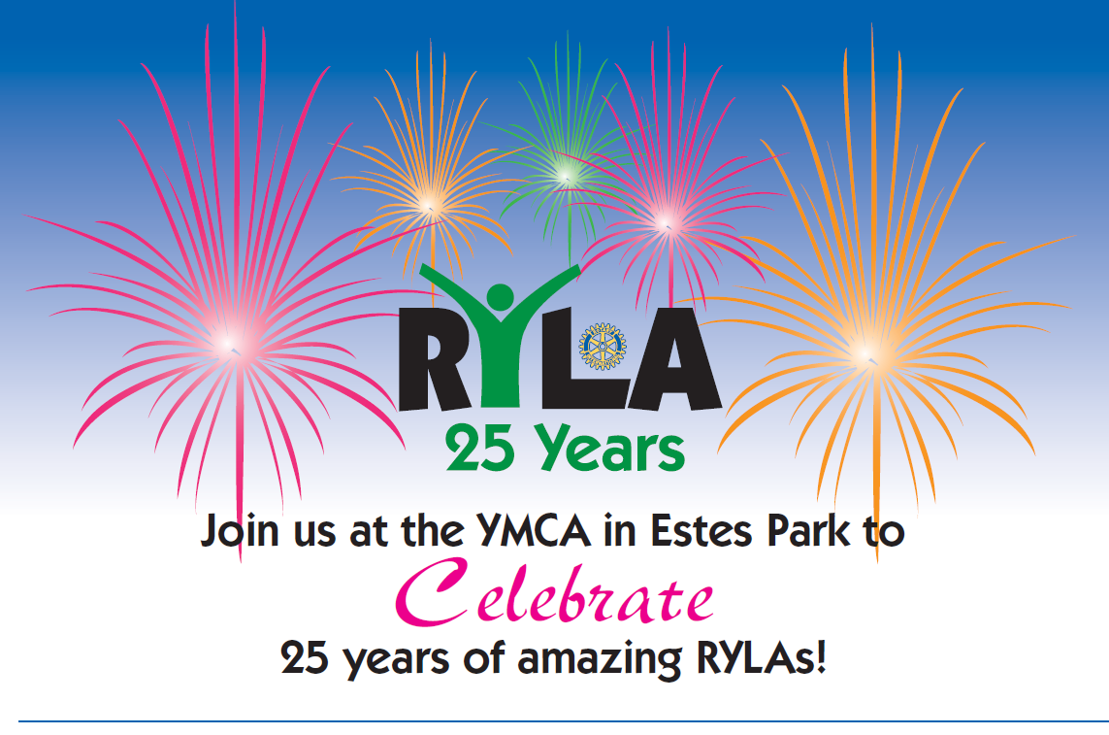

Willome Hall, YMCA of the Rockies
Saturday, July 16th 2011

4:00pm – Meet and Greet with all your fellow RYLA counselors!
5:30pm – 25 Years of Empowering Excellence in Youth Leadership!
6:00pm – Dinner – Enjoy the Bob and Tony’s Pizza Tradition!

Also, purchase a 25th anniversary commemorative polo for $18!

Register to attend ($12) at ryla25.org

There are a limited number of beds available at the YMCA to stay Saturday night.
Reserve your bed (and breakfast on Sunday) for $32 when you register.

