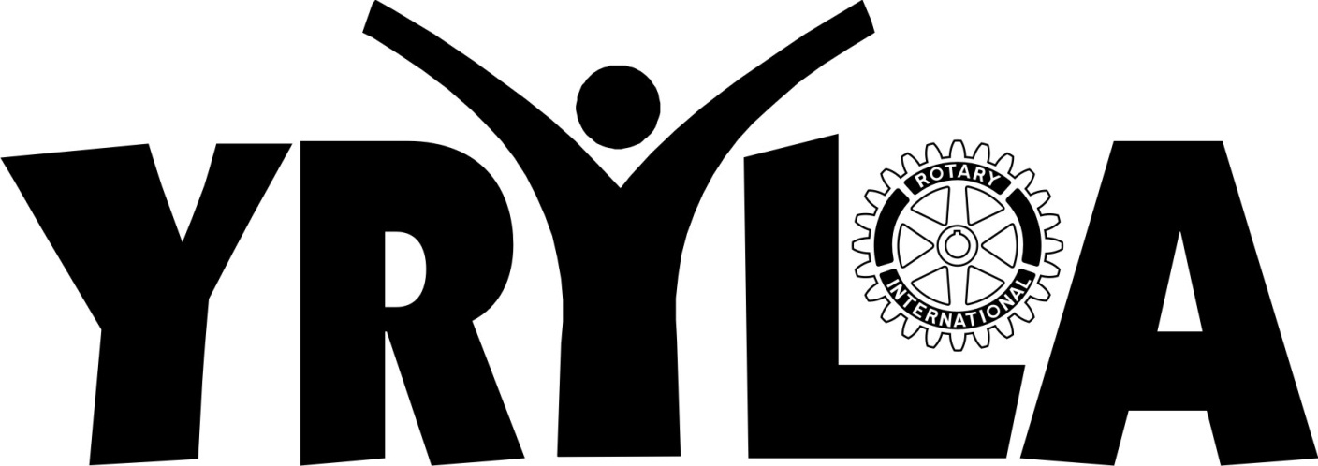

The Power of One!

Young RYLA (Rotary Youth Leadership Awards) Conference
Week 1: July 22nd – July 27th, 2012

