YRYLA Camp 2: 2012

Comparison of mean of all questions for camp as a whole on pre vs post evaluations
P value and statistical significance:
The two-tailed P value is less than 0.0001
By conventional criteria, this difference is considered to be extremely statistically significant.
Confidence interval:
The mean of 2012 Camp 2 Pre all Questions minus 2012 Camp 2 Post all Questions equals -1.447
95% confidence interval of this difference: From -1.603 to -1.292
Intermediate values used in calculations:
t = 18.4376
df = 113
standard error of difference = 0.079
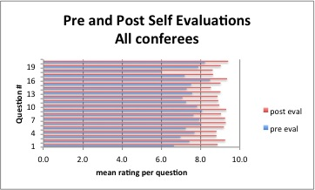

Statistical difference between pre and post evaluation per question for all conferees

(all answers Q1… pre camp vs all answers Q1… post camp

Question 1
P value and statistical significance:
The two-tailed P value is less than 0.0001
By conventional criteria, this difference is considered to be extremely statistically significant.
Confidence interval:
The mean of 2012 camp 2 Pre Q 1 minus 2012 camp 2 Post Q 2 equals -2.184
95% confidence interval of this difference: From -2.446 to -1.922
Intermediate values used in calculations:
t = 16.5039
df = 113
standard error of difference = 0.13
Question 2
P value and statistical significance:
The two-tailed P value is less than 0.0001
By conventional criteria, this difference is considered to be extremely statistically significant.
Confidence interval:
The mean of 2012 Camp 2 Pre Q 2 minus 2012 Camp 2 Post Q 2 equals -1.763
95% confidence interval of this difference: From -2.038 to -1.488
Intermediate values used in calculations:
t = 12.6919
df = 113
standard error of difference = 0.139

Question 3
P value and statistical significance:
The two-tailed P value is less than 0.0001
By conventional criteria, this difference is considered to be extremely statistically significant.
Confidence interval:
The mean of 2012 Camp 2 Pre Q 3 minus 2012 Camp 2 Post Q 3 equals -1.715
95% confidence interval of this difference: From -2.050 to -1.380
Intermediate values used in calculations:
t = 10.1328
df = 113
standard error of difference = 0.169

Question 4
P value and statistical significance:
The two-tailed P value is less than 0.0001
By conventional criteria, this difference is considered to be extremely statistically significant.
Confidence interval:
The mean of 2012 Camp 2 Pre Q 4 minus 2012 Camp 2 Post Q 4 equals -1.000
95% confidence interval of this difference: From -1.328 to -0.672
Intermediate values used in calculations:
t = 6.0452
df = 113
standard error of difference = 0.165

Question 5
P value and statistical significance:
The two-tailed P value is less than 0.0001
By conventional criteria, this difference is considered to be extremely statistically significant.
Confidence interval:
The mean of 2012 Camp 2 Pre Q 5 minus 2012 Camp 2 Post Q 5 equals -1.882
95% confidence interval of this difference: From -2.247 to -1.516
Intermediate values used in calculations:
t = 10.1908
df = 113
standard error of difference = 0.185

Question 6
P value and statistical significance:
The two-tailed P value is less than 0.0001
By conventional criteria, this difference is considered to be extremely statistically significant.
Confidence interval:
The mean of 2012 Camp 2 Pre Q 6 minus 2012 Camp 2 Post Q 6 equals -1.246
95% confidence interval of this difference: From -1.524 to -0.967
Intermediate values used in calculations:
t = 8.8512
df = 113
standard error of difference = 0.141

Question 7
P value and statistical significance:
The two-tailed P value is less than 0.0001
By conventional criteria, this difference is considered to be extremely statistically significant.
Confidence interval:
The mean of 2012 Camp 2 Pre Q 7 minus 2012 Camp 2 Post Q 7 equals -1.320
95% confidence interval of this difference: From -1.613 to -1.027
Intermediate values used in calculations:
t = 8.9297
df = 113
standard error of difference = 0.148

Question 8
P value and statistical significance:
The two-tailed P value is less than 0.0001
By conventional criteria, this difference is considered to be extremely statistically significant.
Confidence interval:
The mean of 2012 Camp 2 Pre Q 8 minus 2012 Camp 2 Post Q 8 equals -1.351
95% confidence interval of this difference: From -1.648 to -1.053
Intermediate values used in calculations:
t = 8.9962
df = 113
standard error of difference = 0.150

Question 9
P value and statistical significance:
The two-tailed P value is less than 0.0001
By conventional criteria, this difference is considered to be extremely statistically significant.
Confidence interval:
The mean of 2012 Camp 2 Pre Q 9 minus 2012 Camp 2 Post Q 9 equals -1.254
95% confidence interval of this difference: From -1.530 to -0.979
Intermediate values used in calculations:
t = 9.0112
df = 113
standard error of difference = 0.139

Question 10
P value and statistical significance:
The two-tailed P value is less than 0.0001
By conventional criteria, this difference is considered to be extremely statistically significant.
Confidence interval:
The mean of 2012 Camp 2 Pre Q 10 minus 2012 Camp 2 Post Q 10 equals -1.075
95% confidence interval of this difference: From -1.335 to -0.814
Intermediate values used in calculations:
t = 8.1742
df = 113
standard error of difference = 0.131

Question 11
P value and statistical significance:
The two-tailed P value is less than 0.0001
By conventional criteria, this difference is considered to be extremely statistically significant.
Confidence interval:
The mean of 2012 Camp 2 Pre Q 11 minus 2012 Camp 2 Post Q 11 equals -1.548
95% confidence interval of this difference: From -1.880 to -1.217
Intermediate values used in calculations:
t = 9.2488
df = 113
standard error of difference = 0.167

Question 12
P value and statistical significance:
The two-tailed P value is less than 0.0001
By conventional criteria, this difference is considered to be extremely statistically significant.
Confidence interval:
The mean of 2012 Camp 2 Pre Q 12 minus 2012 Camp 2 Post Q 12 equals -1.675
95% confidence interval of this difference: From -2.008 to -1.343
Intermediate values used in calculations:
t = 9.9878
df = 113
standard error of difference = 0.168

Question 13
P value and statistical significance:
The two-tailed P value is less than 0.0001
By conventional criteria, this difference is considered to be extremely statistically significant.
Confidence interval:
The mean of 2012 Camp 2 Pre Q 13 minus 2012 Camp 2 Post Q 13 equals -1.333
95% confidence interval of this difference: From -1.622 to -1.045
Intermediate values used in calculations:
t = 9.1534
df = 113
standard error of difference = 0.146

Question 14
P value and statistical significance:
The two-tailed P value is less than 0.0001
By conventional criteria, this difference is considered to be extremely statistically significant.
Confidence interval:
The mean of 2012 Camp 2 Pre Q 14 minus 2012 Camp 2 Post Q 14 equals -1.149
95% confidence interval of this difference: From -1.458 to -0.841
Intermediate values used in calculations:
t = 7.3783
df = 113
standard error of difference = 0.156

Question 15
P value and statistical significance:
The two-tailed P value is less than 0.0001
By conventional criteria, this difference is considered to be extremely statistically significant.
Confidence interval:
The mean of 2012 Camp 2 Pre Q 15 minus 2012 Camp 2 Post Q 15 equals -1.355
95% confidence interval of this difference: From -1.639 to -1.071
Intermediate values used in calculations:
t = 9.4516
df = 113
standard error of difference = 0.143

Question 16
P value and statistical significance:
The two-tailed P value is less than 0.0001
By conventional criteria, this difference is considered to be extremely statistically significant.
Confidence interval:
The mean of 2012 Camp 2 Pre Q 16 minus 2012 Camp 2 Post Q 16 equals -0.833
95% confidence interval of this difference: From -1.062 to -0.604
Intermediate values used in calculations:
t = 7.2049
df = 113
standard error of difference = 0.116

Question 17
P value and statistical significance:
The two-tailed P value is less than 0.0001
By conventional criteria, this difference is considered to be extremely statistically significant.
Confidence interval:
The mean of 2012 Camp 2 Pre Q 17 minus 2012 Camp 2 Post Q 17 equals -1.373
95% confidence interval of this difference: From -1.718 to -1.027
Intermediate values used in calculations:
t = 7.8706
df = 113
standard error of difference = 0.174

Question 18
P value and statistical significance:
The two-tailed P value is less than 0.0001
By conventional criteria, this difference is considered to be extremely statistically significant.
Confidence interval:
The mean of 2012 Camp 2 Pre Q 18 minus 2012 Camp 2 Post Q 18 equals -2.583
95% confidence interval of this difference: From -3.003 to -2.164
Intermediate values used in calculations:
t = 12.2067
df = 113
standard error of difference = 0.212

Question 19
P value and statistical significance:
The two-tailed P value is less than 0.0001
By conventional criteria, this difference is considered to be extremely statistically significant.
Confidence interval:
The mean of 2012 Camp 2 Pre Q 19 minus 2012 Camp 2 Post Q 19 equals -1.132
95% confidence interval of this difference: From -1.475 to -0.788
Intermediate values used in calculations:
t = 6.5242
df = 113
standard error of difference = 0.173

Question 20
P value and statistical significance:
The two-tailed P value is less than 0.0001
By conventional criteria, this difference is considered to be extremely statistically significant.
Confidence interval:
The mean of 2012 Camp 2 Pre Q 20 minus 2012 Camp 2 Post Q 20 equals -1.110
95% confidence interval of this difference: From -1.407 to -0.812
Intermediate values used in calculations:
t = 7.3972
df = 113
standard error of difference = 0.150

Team Stats all questions pre eval vs all questions post eval
TEAM A
P value and statistical significance:
The two-tailed P value equals 0.0001
By conventional criteria, this difference is considered to be extremely statistically significant.
Confidence interval:
The mean of Team A 2012 Camp 2 Pre Eval minus Team A 2012 Camp 2 Post eval equals -1.620
95% confidence interval of this difference: From -2.191 to -1.049
Intermediate values used in calculations:
t = 6.4170
df = 9
standard error of difference = 0.252
Review your data:

Group | Team A 2012 Camp 2 Pre Eval al | 2012 Camp 2 Post all Questions
Mean | 7.300 | 8.920
SD | 0.675 | 0.543
SEM | 0.213 | 0.172
N | 10 | 10
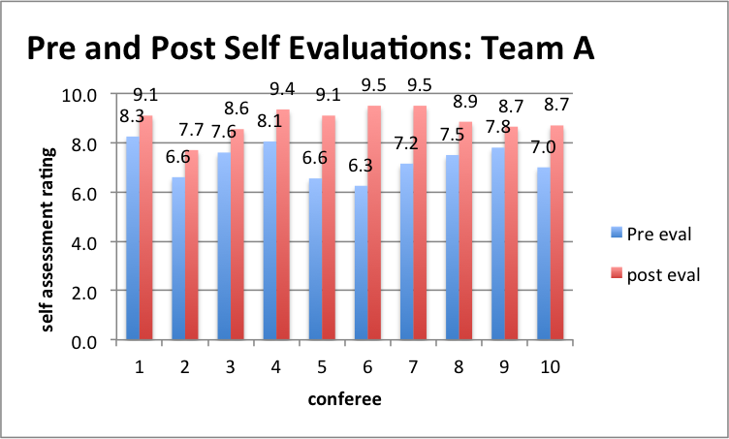

TEAM B
P value and statistical significance:
The two-tailed P value equals 0.0005
By conventional criteria, this difference is considered to be extremely statistically significant.
Confidence interval:
The mean of Team B 2012 Camp 2 Pre Eval minus Team B 2012 Camp 2 Post Eval equals -1.633
95% confidence interval of this difference: From -2.313 to -0.953
Intermediate values used in calculations:
t = 5.5393
df = 8
standard error of difference = 0.295

Review your data:

Group | Team B 2012 Camp 2 Pre Eval | Team B 2012 Camp 2 Pos Eval
Mean | 7.556 | 9.189
SD | 1.140 | 0.595
SEM | 0.380 | 0.198
N | 9 | 9
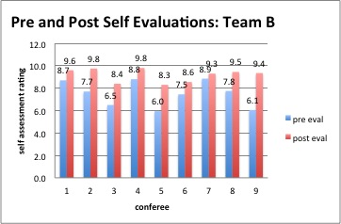

Team C
P value and statistical significance:
The two-tailed P value is less than 0.0001
By conventional criteria, this difference is considered to be extremely statistically significant.
Confidence interval:
The mean of Team C 2012 Camp 2 Pre Eval minus Team C 2012 Camp 2 Pos Eval equals -1.978
95% confidence interval of this difference: From -2.448 to -1.507
Intermediate values used in calculations:
t = 9.6963
df = 8
standard error of difference = 0.204
Review your data:

Group | Team C 2012 Camp 2 Pre Eval | Team C 2012 Camp 2 Pos Eval
Mean | 7.367 | 9.344
SD | 0.622 | 0.428
SEM | 0.207 | 0.143
N | 9 | 9
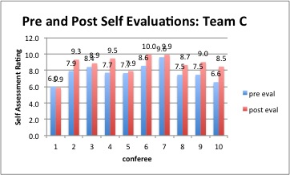

Team D
P value and statistical significance:
The two-tailed P value equals 0.0016
By conventional criteria, this difference is considered to be very statistically significant.
Confidence interval:
The mean of Team D 2012 Camp 2 Pre Eval minus Team D 2012 Camp 2 Pos Eval equals -1.010
95% confidence interval of this difference: From -1.524 to -0.496
Intermediate values used in calculations:
t = 4.4439
df = 9
standard error of difference = 0.227
Review your data:

Group | Team D 2012 Camp 2 Pre Eval | Team D 2012 Camp 2 Pos Eval
Mean | 7.750 | 8.760
SD | 1.006 | 1.190
SEM | 0.318 | 0.376
N | 10 | 10

Team E
P value and statistical significance:
The two-tailed P value equals 0.0023
By conventional criteria, this difference is considered to be very statistically significant.
Confidence interval:
The mean of Team E 2012 Camp 2 Pre Eval minus Team E 2012 Camp 2 Pos Eval equals -1.560
95% confidence interval of this difference: From -2.397 to -0.723
Intermediate values used in calculations:
t = 4.2157
df = 9
standard error of difference = 0.370
.
Review your data:

Group | Team E 2012 Camp 2 Pre Eval | Team E 2012 Camp 2 Pos Eval
Mean | 7.610 | 9.170
SD | 1.219 | 0.397
SEM | 0.385 | 0.126
N | 10 | 10

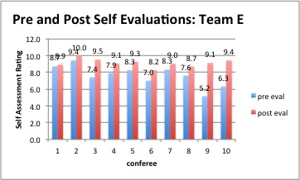

Team F
P value and statistical significance:
The two-tailed P value equals 0.0005
By conventional criteria, this difference is considered to be extremely statistically significant.
Confidence interval:
The mean of Team F 2012 Camp 2 Pre Eval minus Team F 2012 Camp 2 Pos Eval equals -1.364
95% confidence interval of this difference: From -1.957 to -0.770
Intermediate values used in calculations:
t = 5.1191
df = 10
standard error of difference = 0.266
Review your data:

Group | Team F 2012 Camp 2 Pre Eval | Team F 2012 Camp 2 Pos Eval
Mean | 7.264 | 8.627
SD | 0.804 | 0.773
SEM | 0.242 | 0.233
N | 11 | 11
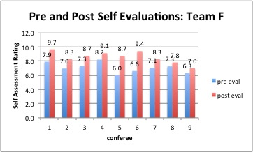

Team G
P value and statistical significance:
The two-tailed P value is less than 0.0001
By conventional criteria, this difference is considered to be extremely statistically significant.
Confidence interval:
The mean of Team G 2012 Camp 2 Pre Eval minus Team G 2012 Camp 2 Pos Eval equals -1.680
95% confidence interval of this difference: From -2.226 to -1.134
Intermediate values used in calculations:
t = 6.9652
df = 9
standard error of difference = 0.241
.
Review your data:

Group | Team G 2012 Camp 2 Pre Eval | Team G 2012 Camp 2 Pos Eval
Mean | 7.370 | 9.050
SD | 1.399 | 1.126
SEM | 0.442 | 0.356
N | 10 | 10
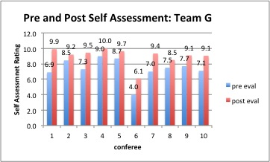

Team H
P value and statistical significance:
The two-tailed P value equals 0.0002
By conventional criteria, this difference is considered to be extremely statistically significant.
Confidence interval:
The mean of Team H 2012 Camp 2 Pre Eval minus Team H 2012 Camp 2 Pos Eval equals -1.160
95% confidence interval of this difference: From -1.584 to -0.736
Intermediate values used in calculations:
t = 6.1867
df = 9
standard error of difference = 0.187
Review your data:

Group | Team H 2012 Camp 2 Pre Eval | Team H 2012 Camp 2 Pos Eval
Mean | 7.710 | 8.870
SD | 0.615 | 0.751
SEM | 0.195 | 0.238
N | 10 | 10

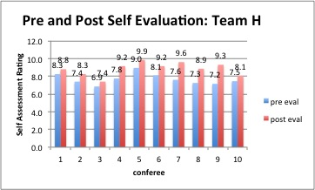

Team I
P value and statistical significance:
The two-tailed P value equals 0.0207
By conventional criteria, this difference is considered to be statistically significant.
Confidence interval:
The mean of Team I 2012 Camp 2 Pre Eval minus Team I 2012 Camp 2 Pos Eval equals -1.356
95% confidence interval of this difference: From -2.443 to -0.268
Intermediate values used in calculations:
t = 2.8736
df = 8
standard error of difference = 0.472
Review your data:

Group | Team I 2012 Camp 2 Pre Eval | Team I 2012 Camp 2 Pos Eval
Mean | 7.200 | 8.556
SD | 1.326 | 1.147
SEM | 0.442 | 0.382
N | 9 | 9

Team J
P value and statistical significance:
The two-tailed P value is less than 0.0001
By conventional criteria, this difference is considered to be extremely statistically significant.
Confidence interval:
The mean of Team J 2012 Camp 2 Pre Eval minus Team J 2012 Camp 2 Pos Eval equals -1.520
95% confidence interval of this difference: From -1.913 to -1.127
Intermediate values used in calculations:
t = 8.7498
df = 9
standard error of difference = 0.174
Review your data:

Group | Team J 2012 Camp 2 Pre Eval | Team J 2012 Camp 2 Pos Eval
Mean | 7.400 | 8.920
SD | 0.907 | 0.503
SEM | 0.287 | 0.159
N | 10 | 10

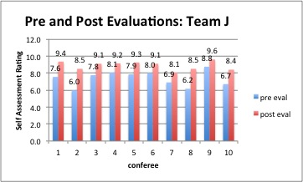

Team K
P value and statistical significance:
The two-tailed P value equals 0.0001
By conventional criteria, this difference is considered to be extremely statistically significant.
Confidence interval:
The mean of Team K 2012 Camp 2 Pre Eval minus Team K 2012 Camp 2 Pos Eval equals -1.300
95% confidence interval of this difference: From -1.760 to -0.840
Intermediate values used in calculations:
t = 6.3943
df = 9
standard error of difference = 0.203
.
Review your data:

Group | Team K 2012 Camp 2 Pre Eval | Team K 2012 Camp 2 Pos Eval
Mean | 7.990 | 9.290
SD | 0.610 | 0.526
SEM | 0.193 | 0.166
N | 10 | 10
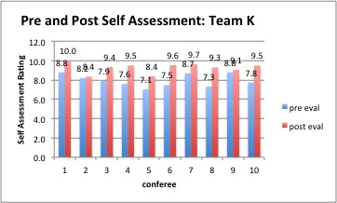

Team L
P value and statistical significance:
The two-tailed P value equals 0.0024
By conventional criteria, this difference is considered to be very statistically significant.
Confidence interval:
The mean of Team L 2012 Camp 2 Pre Eval minus Team L 2012 Camp 2 Pos Eval equals -1.133
95% confidence interval of this difference: From -1.646 to -0.621
Intermediate values used in calculations:
t = 5.6825
df = 5
standard error of difference = 0.199
Review your data:

Group | Team L 2012 Camp 2 Pre Eval | Team L 2012 Camp 2 Pos Eval
Mean | 8.067 | 9.200
SD | 0.367 | 0.477
SEM | 0.150 | 0.195
N | 6 | 6

PRE SELF EVALUATION

POST SELF EVALUATIONS

