G


The Power of One
One SONG can spark a moment
One FLOWER can wake the dream
One TREE can start a forest
One BIRD can herald spring
One SMILE begins a friendship
One HANDCLASP lifts a soul
One STAR can guide a ship at sea
One WORD can frame the goal
One VOTE can change a nation
One SUNBEAM lights a room
One CANDLE wipes out darkness
One LAUGH will conquer gloom
One STEP must start each journey
One WORD must start a prayer
One HOPE will raise our spirits
One TOUCH can show you care
One VOICE can speak with wisdom
One HEART can know what is true
One LIFE can make a difference
– You see, it’s up to you
-- Author Unknown --

July 28th- August 2rd 2013
Ponderosa Retreat and Conference Center; Larkspur, Colorado

Table of Contents
YRYLA 2013 STAFF & TEAMS! 2
YRYLA 2013 Biographies! 3
Counselors 3
Rotarians 8
Staff 12
Young RYLA Lingo 15
A Few Rotary Facts 16
Three Hoops Theme 17
A Brief History of RYLA 18
Young Rotary Youth Leadership Awards 19
YRYLA Bingo 20
Making a Difference – The Starfish Story 21
This is also …. The Power of One! 21
SUNDAY REFLECTION TIME 23
If 24
WHAT ARE YOUR TRUE COLORS? 25
True Colors Information 26
BRAINWISE NOTES 36
“My Life List” 39
Swept Away and Staying On top 44
MONDAY REFLECTION TIME 45
Ethics and The Four-Way Test 47
By Doug Young 47
BRAINWISE AND THE 4 WAY TEST 48
4 WAY TEST SCENARIOS 49
Core Values 53
SUCCESSFUL LEADERSHIP CHARACTER QUALITIES 55
Remember the Titans 57
TUESDAY REFLECTION TIME 58
WEDNESDAY REFLECTION TIME 60
Rotary Youth Programs 62
Starting an Interact Club 101 64
Looking for a project? 65
Passion to Action: 67
THURSDAY REFLECTION TIME 71
FRIDAY REFLECTION TIME 74
YRYLA Lyrics 75
YRYLA 2013 Evaluation 81

YRYLA 2013 STAFF & TEAMS!

Chair- Jim Hoops
Head JC- Alex “Cuad” Cuadrado
Head JC- Toria Vongphackdy
Staff- Sami Elliott
Staff- Julia Thompson
“Guru” Staff- Mikaila Way
Registrars- Dave Amen & Marc Solnet
Photographer- Tom Keyton

Teams
 | JC | SC
A | Maddy Searchinger | Larry Fitzsimmons
B | Brisco Arechederra | Junior Weed-Ziegler
C | Sarah Calhoun | Bill Rubin
D | David McManus | Peggy Halderman
E | Katie Lyons | Wally Van Sickle
F | Brian Winstanley | Joni Van Sickle
G | Connor Pierce | Norm Lyster
H | Elan Seideman | Melissa Adams
I | Caroline Vickstrom | Jan Keyton
J | DeVante Deschwanden | June Boon
K | Dana Kiel | Jim Halderman
L | Sami Elliott | Patti Stickler

YRYLA 2013 Biographies!

Counselors

Brian Winstanley

Hey, what’s poppin’ guys? I'm Brian. Apart from sleighing dragons this next year, I am going to be attending Denver East High School as a senior. I’ve lived in the city my entire life, and in my free time I enjoy playing sports, especially baseball, backpacking, traveling, and kicking it with friends. This past year, I spent most of my time studying the Bill of Rights at a graduate school level, so if you ever want to discuss your rights or role as a growing citizen in the American society, I’m your guy. I have family in Casper, Wyoming (yeah, I do listen to country music), so I already like you if you’re from or near there... Wyoming is a big place. You will recognize me as the burly, tall kid, and you may come to the conclusion that I eat people, but you would be mistaken. I’m a jolly giant who likes to talk to all kinds of people, and enjoys living life to the fullest. My advice to you this week is to become comfortable being uncomfortable... do this, and I guarantee you will find yourself living to the fullest. Let’s live it up this week!


Brisco Arechederra
Hey Everyone! My name is Brisco Arechederra, but my close friends call me Brillo. I’m the definition of a nerd! I love Star Wars, I take everything apart, and I almost put it all back together! I got to Longmont High School, and love to laugh. I love meeting new people and want to get to know as many of you as possible in this week of paradise known fondly as YRYLA! So come say hi to me and lets get to know each other.

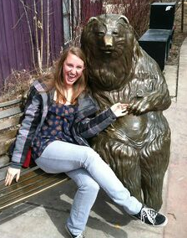
Caroline Vickstrom
What's up YRYLA?! I'm Caroline Vickstrom, and I'm from Evergreen Colorado. I love snowboarding, dancing, hiking, and pretty much anything that has to do with music. If you see a girl just roaming around singing to no one in particular, that's probably me. My favorite ice cream is cookie dough, my favorite pass time is tap dancing, and Harry Potter is the best thing ever. I hope you guys are as excited to be at YRYLA as I am! It's gonna be the best! I'm so happy to be hanging out with you guys this week, so come introduce yourself with a smile, a high five, or just burst out into your favorite song--chances are, I'll start singing along!

Connor Pierce

Connor Pierce is of Italian-Irish descent, with blue eyes and brown hair. In his spare time, he enjoys an array of artistic mediums, such as photography, drawing, painting, writing, dancing and metal-smithing. In addition, he likes to play soccer, video-games, read, take bubble baths and go for long walks on the beach. Connor enjoys taking part in RYLA so much last year that he had no choice but to apply for JC. He hopes he can be the most radical counselor that each camper has always wanted. RYLA was a life-changing experience for Connor and he's incredibly excited to be here and share the RYLA magic all over again. The growth everyone will experience this week is going to be a little surprising, so keep your minds open and do everything with enthusiasm. This can be one of the best weeks of your life!

Dana Kiel

Hey guys! The only thing you need to know about me is that I’m a complete nerd, but the cool kind! I love history, politics, geography, dates at the museum and reading on top of mountains. I spent a year in Germany during high school and I’m planning on spending a year in Japan soon. I’m from Golden, Colorado where I live in the summers with my parents, three siblings and two goofy basset hounds. I’m currently studying International Economics at the University of Denver and I want to write for a newspaper or work as an analyst for the CIA someday (not quite as cool as a spy). I love watermelon, black coffee, naps in the sunshine and music in languages I can’t understand (especially French rap). I’m also deathly afraid of lobsters.
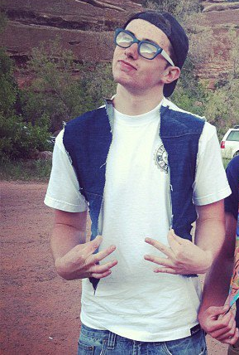
David McManus
My name is David, and I just wrapped up my sophomore year of college in Washington, D.C. at Georgetown University. I am majoring in Government and minoring in English so feel free to come talk to me about politics (probably unlikely) or your favorite book (more likely), I love both. When I'm not in class, I love reading, going on runs, listening to music, lifting, and hanging out with my friends. For whatever reason, some of the other JCs think that I really like cats which is NOT TRUE. I don't know where they get it from. Seriously its weird and I wish they'd stop. Also I love quoting movies and TV shows so if you surprise with a line from The Office, Scrubs, Anchorman, Wedding Crashers, or Workaholics, then we will be best friends. Get super excited for YRYLA and I hope you brought some tanks because, let be honest, tanks should be worn whenever possible. In conclusion I will leave you with these words: avuncular, haberdasher, esoteric, and obsequious.

DeVante Deschwanden

I am a dynamic figure, often seen crushing rocks and calculating implosion factors on circadian rhythms, I perform random acts of kindness without speculation. I constructed a solar panel powered frying pan just for my over easy eggs, I didn’t even patent it. I cook 30-minute brownies in 20 minutes. I drive with my feet, in my free time I conduct thermo magnetic experiments. I once proved the theory of general relativity wrong, but don't ask I forgot how! I watch movies ... in the dark. My hair grows in perfect 360's. I was born in Colorado and grew up on the road. I count clouds when nobody is looking, I love sushi. I bat 400, I've schooled LeBron in the sport of his endeavors. Children trust me. I once rewired the Antimatter machine at CERN so scientist could better understand the Big Bang. I learned a lot from RYLA, lets do this!!

Elan Seideman
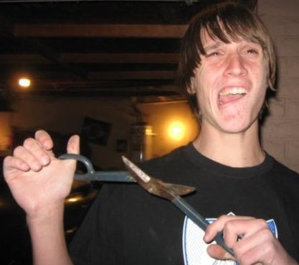
My full name is Elan Nashoba Yosef Seideman. A lot of people tend to be curious about it, you’re not the only one. Come ask me about it if you want to know more. I like romantic comedies, long walks on the...mountain side, singing to orphaned puppies, and as for food, if it’s not synthetic or moving I’ll eat it. I spend my free time playing football, eating, watching The Simpsons, playing music, eating, taking my dogs to the park, eating, and, as any typical guy does, juggling. I love playing RISK and strongly believe that anyone who tries to take Asia right away deserves to be kicked out of the game immediately. RYLA has become such a large part of my life over the years (starting at YRYLA) that I have wanted nothing more than to share my love for it with you all. Cut loose this week!

Katie Lyons

Greetings and salutations to my fantastic new YRYLA family!! I am super excited to get to meet as many as you as I can during this week (which will be the best week of your life.) I am from the lovely Greeley, Colorado (and no, I didn't bring any cows with me.) During this week, you'll discover a few things about me. First, running is one of my passions and I would love to be able to bond with anyone who chooses it as a morning activity! Second, I am a HUGE Lord of the Rings and Harry Potter nerd :) And finally, I love being outside and I would go camping anywhere at anytime (except for YRYLA week, of course.) Keep your mind wide open and get excited for the life changing adventure of YRYLA!

Maddy Searchinger
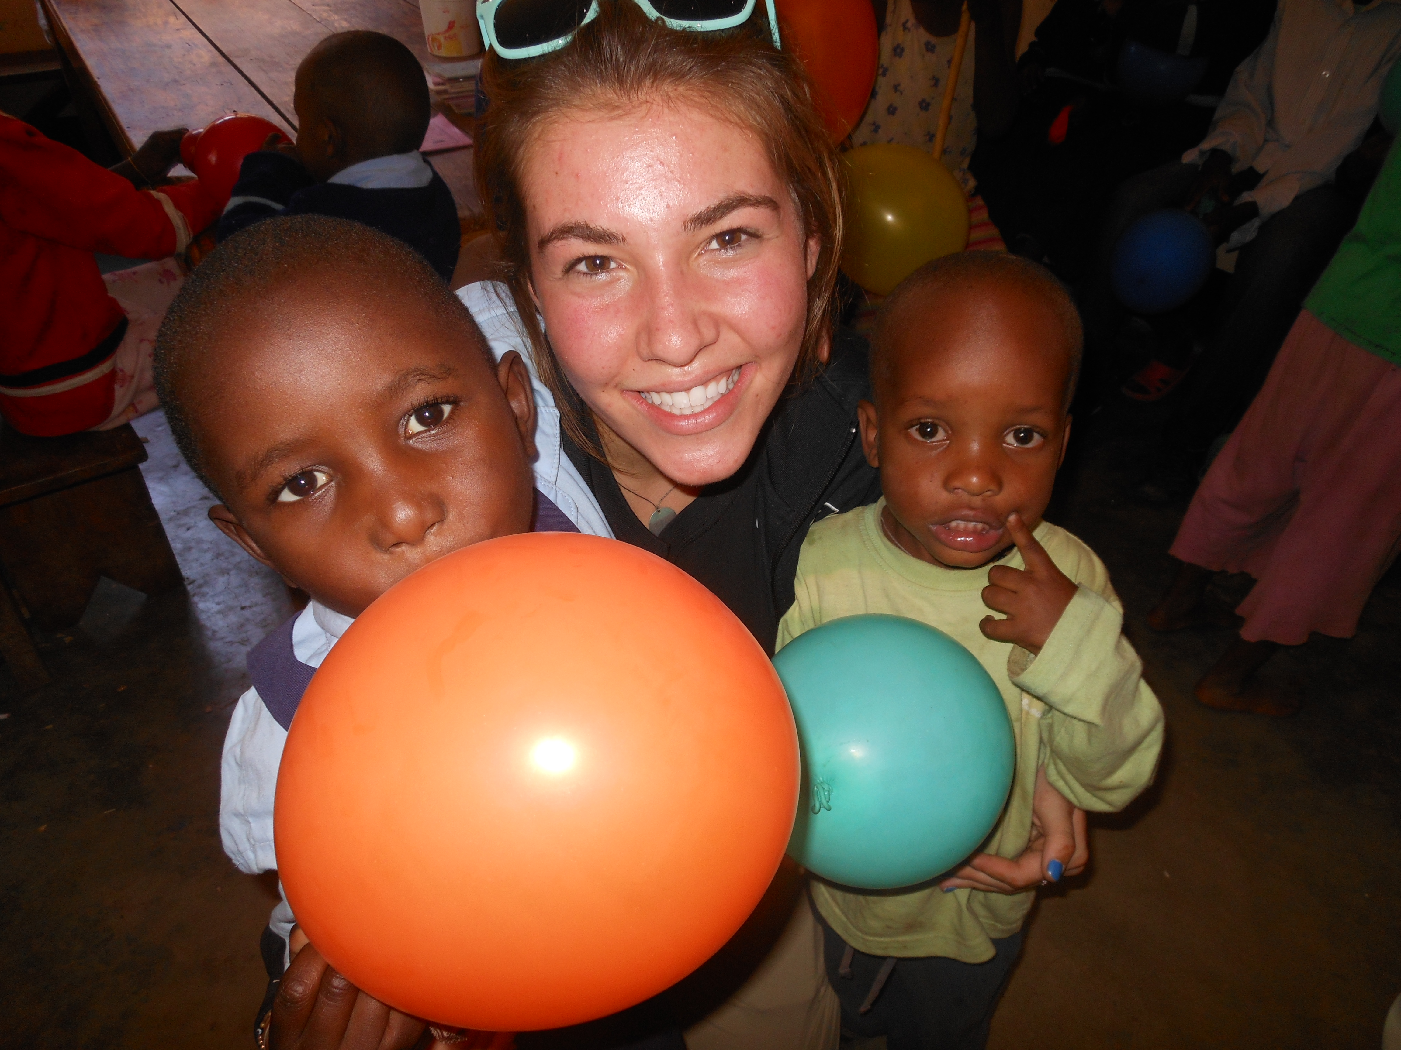
What's up YRYLA?! I'm crazy excited to be here with you all! I grew up in Boulder, playing soccer and basketball, swimming, hiking, skiing and pretty much living outside! When I was a Sophomore in high school I caught the travel bug and took off for Sardinia, Italy, for a year abroad as a Rotary Youth Exchange Student. When I came back, I hopped across the pond again (and then some!) to climb Mt. Kilimanjaro with an international science and research team (not that I know much about science, but I kept up somehow!). While in Tanzania I got to do some pretty cool things, like volunteering at orphanages and hanging out in the Serengeti! What a wonderful world we live in. My favorite kitchen utensil is the spatula, followed closely by the whisk. My favorite quote is by Lao Tzu: "When I let go of who I am, I become what I might be." I go to CU Boulder, and I plan to major in gender studies. I go nuts for dried mango, and I can't get enough chai. Come say hi to me and I'll tell you what you call a dog with no legs... spoiler alert: it's a joke.

Sami Elliott

I am Sam. Sam I am." (You can also call me Sami if that jiggles your jello) "I do not like green eggs and ham." Mostly because I'm an herbivore! But I do enjoy eating peanut butter on eggs, climbing trees, and watching British television. I'm a cat person and a drummer and would like to travel to India and South Africa! I believe in loving the environment and that music is the most powerful thing on earth. RYLA changed my life by changing how I think; live fully here and have no regrets! I wish you the best time of your life- so far. Come say hello, tell me a joke, or chat about music with me! SO MUCH YRYLA LOVE!! :)

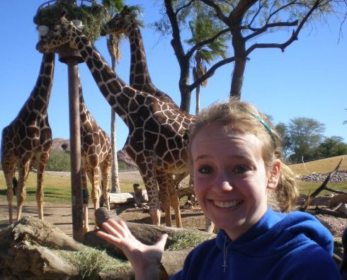
Sarah Calhoun
Hi my name is Sarah Calhoun! My home town is Longmont, CO (the same as Brisco! Woot) and I graduated from Longmont High School in 2012. Now I live in Iowa and go to school at Cornell College in Mt. Vernon Iowa. I'm studying Biochemistry and Biology and I might double major in English. When I grow up I want to research genetics. I really like giraffes. A lot. Like a lot a lot. They're tall and have a cool pattern, they're practically giants (and I'm really short, so that makes it even better), and they have horns for no reason. Can't beat that (: I do my smiley faces backwards, don't judge. My favorite commercials on TV are the AT&T commercials because the children are like me: four, adorable, and completely random. My favorite one is the one where the little boy says "But, what, what would the animals be made out of?" So adorable. I'm assuming candy. If you haven't seen it, YouTube it as soon as you get home. It's the best. This week is all about finding who you are and defining yourself as a leader. I hope you all enjoy YRYLA as much as I enjoy being with you guys. This is honestly the best week of your life, and you guys are all such amazing people, I can't wait to get to know all of you! Peace out girl scout.

Rotarians
Bill Rubin

Born in Chicago, Illinois, Bill moved to Colorado to attend the University of Colorado and loved the area so much, he made it his home. Bill made a living as a ceramic potter for 17 years. After a back injury, Bill shifted gears and became an accountant. He joined the CPA firm of Weatherwax & Associates in November, 1996 and works as a t ax manager for the firm. He is married to Karen Conduff, an artist and solar sales specialist, and has a 20 year old daughter Maddie who is currently traveling in Europe and singing opera. They live in Lefthand Canyon just north of Boulder. Bill’s hobbies include rafting, hiking and backpacking, volunteering, and spending time with his family.

Jim Halderman

Born in Ohio Jim Halderman left Ohio State University with education in Music and Philosophy. Then in Phoenix, AZ, had a short career in Music including seven years with the Phoenix Symphony before opening his Boat Dealership. After 19 successful years he sold the dealership and moved to Lakewood, CO where he soon discovered the power of Rotary. Filled with the passion for Rotary he served many positions in the club before moving to the District level where he soon became District Governor for District 5450. He currently enjoys many activities in Rotary along with his wife, Peggy, also a Rotarian. Currently, Jim teaches anger management in companies and for court ordered as well as presentation skills for public speaking.

Jan Keyton

I was born in northern California and grew up in Santa Barbara, California. I met my wife in 1970 at the Santa Barbara, California Outdoor Education School where we were both Naturalists.
I taught elementary school and college photography. I was a graphic artist; I bucked hay for a feedlot, drove a train for a sugar beet factory and owned a franchise business in California. I have three adult children and two grandchildren.
I’ve been an active Rotarian since 1991, on Rotary International trips to Guatemala, and Bangladesh and to India and Nigeria, working on Rotary’s polio eradication campaigns. I have found the trips difficult in terms of illness and comfort; but, paradoxically, that difficulty has made the trips even more fulfilling, We lived with Indian and Nigerian host Rotarians and experienced regular power outages, house guards with bows and arrows and children singing at our bedside. Experiencing Rotary families and their dedication to polio eradication changes one’s life.

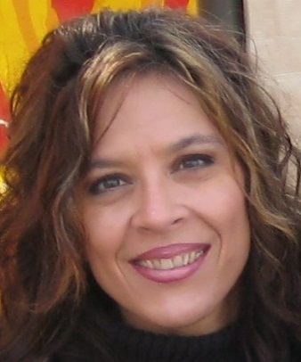
Joni Triantis Van Sickle
Joni is a “mad scientist” with a B.S. in Microbiology with a M.S. in Pathobiology and a PhD. in how to live with a crazy philanthropist. For the last 20 years she has been employed at Colorado State University as the Laboratory Coordinator for the Animal Population Health Institute. Joni wears a lot of hats at the lab (and shoes at home!). Joni is married to Wally Van Sickle, and she helped him to found IDEA WILD, a GREAT organization! Joni and Wally have three beautiful but hairy “children,” a cheeky cairn terrier named Sniffy, a naughty Westie named Toby and a two-and-a- half legged schnauzer named Chickadee.
June Boon
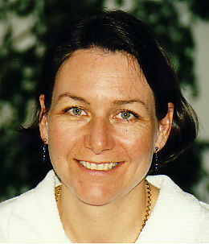
Born in a small town in northern Canada, I moved to southern Florida when I was 12 and have lived in the US ever since. I work at the Veterinary Teaching Hospital of Colorado State University. I am a technician that performs cardiac ultrasound exams in all species of animals from ferrets, dogs and cats, to bulls and llamas. The coolest animal I ever worked on was a jaguar. I have published the only book solely dedicated to cardiac ultrasound in animals. Raising two happy productive contributing daughters is my greatest accomplishment. I live in Fort Collins with my husband of 23+ years, Dave Boon.

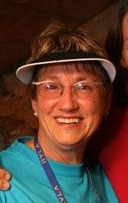
Junior Weed-Ziegler
Junior retired from teaching in the Denver Public Schools for 30 years and is dedicated to living life to the fullest and helping others to do the same. She began this with experiences with Colorado Outward Bound. In her retirement, she has had magnificent opportunities to travel the world including safaris in Africa, climbing Mt. Kilimanjaro, trips to Australia, New Zealand, Peru, Argentina, Chili, Mexico, Nicaragua, Israel, and this winter, to Antarctica where she fell in love with the 1000's of penguins she hiked with.She helped develop the curriculum for Young RYLA at its inception and is now a proud Rotarian with the Boulder Valley Rotary. She is working with JOY at filling her cup of life.

Larry “Iced Tea” Fitzsimmons
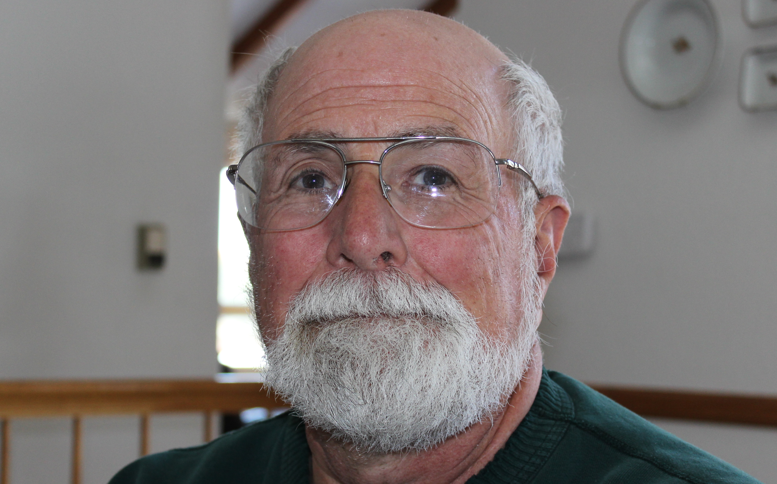
I have been in Rotary since 1997 and I'm currently a member of the Evergreen club. This is my fourth year as a SC ( 3 years at YRLYA and 1 year at RYLA). I'm enjoying the best job of my life being retired after 40 years in banking. I'm married to Linda and have one married son who lives in Thornton. Besides RYLA and Rotary I volunteer for the 1st Tee program and at History Colorado. I also enjoy playing golf and racquetball.

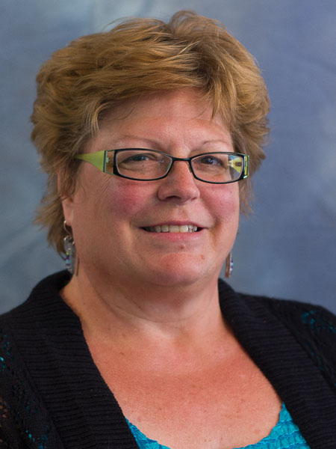
Melissa Adams
Melissa Adams has been a member of the Thompson Valley Rotary Club in Loveland for nine years. She has served as a member of the board for two previous term as and is currently on its board of directors. She was president in the 2005-2006 year and Rotarian of the Year in 2006-2007. She is a Paul Harris Fellow and has been active in her club through its many community support activities as a volunteer including a little book literacy project, the Hang a Heart program, Santa Party and more. She has been her club's coordinator of the RYLA and Young RYLA selections for her club for nine years. Melissa has a background in journalism and communications and worked at seven daily newspapers before moving into a communications role at the Thompson School District. She has been the Public Information Officer, assistant director of Communications, resource manager for the Thompson Education Foundation and is currently the grant coordinator. Her service through the years is nearly always focused on youth. She has served on the Partners of Larimer County board of directors of which she was also president. She served on the Loveland Chamber of Commerce Corn Roast Committee for many years.She has a son, Matthew, who graduated from Loveland High School and attended both Young RYLA and RYLA and wants to study piano performance in college.
Norm Lyster
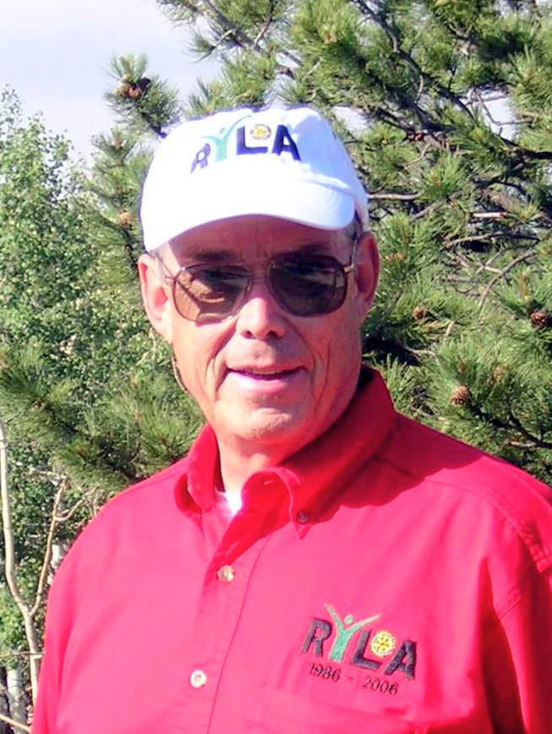
Norm was born in Greeley and worked on the family farm until attending college. He was employed by Frontier Airlines and Katzke Paper Company. He enlisted in the U.S. Army and after schooling at Ft. Devens, MA, was stationed in Germany when the Wall went up. Upon returning to Colorado he completed a Masters degree and teacher certification. Teaching in JeffCo for 5 years, he completed his Doctorate at UMass. His teaching continued at Hartwick College in Oneonta, NY. He completed a second Masters degree in Computer Science at Indiana. He took early retirement and returned to the farms in Greeley where he continues to manage them.

Patti Stickler
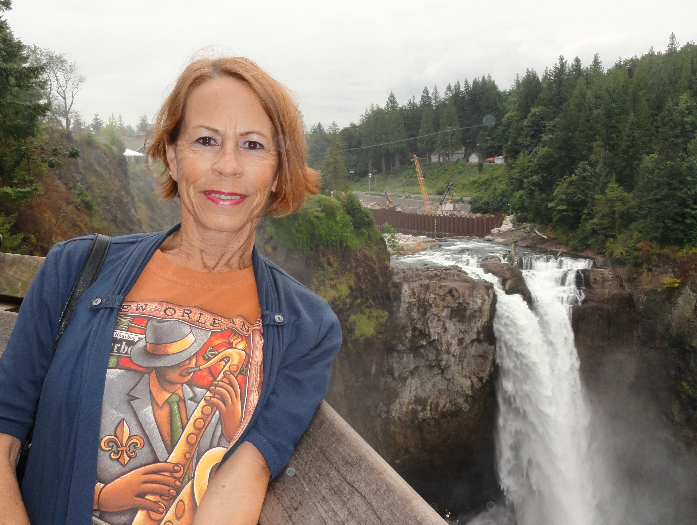
I have been in Rotary since 1992. I was one of the first women in the Loveland Club. That in itself was a challenge. After about 9 years I spent some time in Florida and was not very active with Rotary at that time. Did some visits but the club was just not a match for me. When I returned to Loveland about 10 years ago I joined Thompson Valley Club and am currently the president of our fun group. Our major fund raisers are a Valentine Hearts painting project and a huge Island style party in the summer. Plus the Governors Art Show which has been in existence for almost 25 years. I am the grammy of 3 (almost 4) wonderful granddaughters and live with my silky yorkie puppy.

Peggy Halderman

“Service Above Self” is a personal mantra for Peggy. A Rotarian for almost 7 years, Peggy has dedicated her retirement to working full time to help others. In 2008 Peggy created the Golden Backpack Program (GBP), a program that delivers weekend food to school children in need. The GBP now serves over 520 children in the Golden community every week. Currently Peggy is focused on expanding the GBP year-round, including creating and implementing a mobile food pantry that will serve weekday lunches to children during the summer break. Peggy serves as the President of the Rotary Club of Golden and a Director of the Golden Rotary Foundation. She is married to Past District Governor Jim Halderman. Together they have raised 9 kids and two football teams worth of grandkids.

Wally Van Sickle III
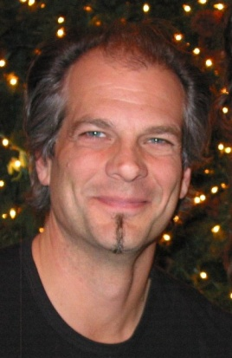
In 1986, after earning a B.S. in Zoology, Wally volunteered to assist a conservation biologist in Kenya and contracted the “travel and adventure bug.” He returned to the States to earn an M.S. in Zoology and develop methods of estimating mountain lion populations in Utah. Then, Wally got an idea, a Wild Idea, to found IDEA WILD, a conservation organization to assist conservation biologists by providing them with some of the funds and tools that they need. In between travels, and following a strict 1 to 1 play to work ratio, chasing his dogs and wife around the house with his rubber band gun, his work through IDEA WILD has empowered over 9,000 conservation biologists worldwide to make a difference.

Staff

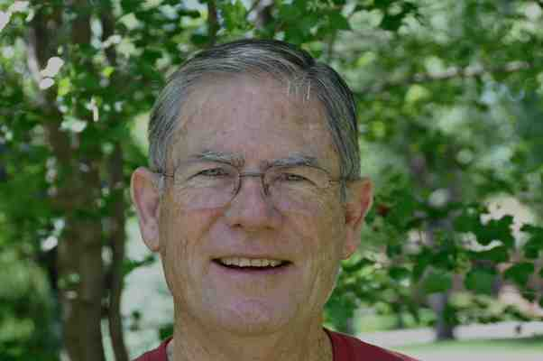
Jim Hoops - Chair
I am a partially retired high school and middle schoolteacher of 37 years, an experiential facilitator, photography teacher, past president of the Denver Cherry Creek Rotary Club and football coach (3 state championships along the way). I am president of the Board of Directors for Rocky Mountain RYLA and was part of a team of Rotarians who developed the Young RYLA curriculum. I am married (48 years) and have 2 sons and 4 grandchildren. I love to hike, bike and read. Rotary has been a big part of my life since joining. Trust the process of YRYLA.
Anne Li Meisel – Staff JC

Hey you! Yes, you! My name is Anne Li, and the first thing you should know about me is that I am a class A goofball. The very biggest. My dad is German and my mother Chinese, but I was born and raised in Germany until age 4. I grew up a little bit in California and a little bit in Colorado, but Colorado will always be my home (or the most important one at least). I say stupid things sometimes that make no sense just because I can, I never shut up, I have identity issues (my name is Anne Li and pronounced "Annalee", not "Annie Lee" or any variation of the sort, but no worries I'll forgive you if you don't get it right the first time!:), and I am all over the place, all the time. I love skiing, playing piano, music, good books, good food, good friends, and most of all, RYLA! I hope you will too! Also, I talk a lot, so please, come talk to me! Don’t be shy! I can’t wait to show and share with you all the RYLA Magic!

Julia Thompson – Staff JC

Yo wassup RYLArians! The name is Julia. I love all things fun and adventuresome! I enjoy skiing, snowboarding, snowmobiling, hiking, and living in the one and only Summit County! My passions are rugby, music (I love singing, playing guitar, uke, and piano), rugby, dancing, rugby, cinematography, and rugby. I also enjoy running track (hurdles!), sailing, cliff jumping, camping, traveling, board games, go-karting, playing at parks, blowing bubbles, rollerblading, being weird and basically anything else enjoyable. In my free time you can find me reading, baking, writing, going to a movie, watching Netflix (Arrested Development, Dr. Who, the good ones), or possibly even hanging out at my work (I work at a movie theatre) because...well, just because. I quote things. Like, constantly. I love art. I play video games. I love YouTube. I have 4 brothers. Also, I like nicknames. Get to know me! That's all. Stay classy!

Alex “Cuad” Cuadrado – Head JC

Believe it or not, I have a real name! It’s not just “Cuad” like what everyone says. Officially my name Alejandro, but people wouldn’t stop calling my name (I said “DON’T CALL MY NAME!), so I go by Alex or Cuad instead. I just finished my freshman year at Princeton University where I am studying Italian Literature and History. I hail from beautiful Summit County, Colorado, where I enjoy skiing and hiking, and the occasional guitar-playing on my porch. Travel, a good fish taco, and service are also some of my passions. But most of all, I love doing anything and everything related to Rotary Youth programs. During my junior year of high school, I lived in Vicenza, Italy as a Rotary Youth Exchange student and throughout my high school career I was highly involved with Interact. But most of all, I love RYLA (Young RYLA especially). This is my third year at Young RYLA, but combined, this is the seventh RYLA I’ve participated in! I hope to someday become an SC and continue the legacy! P.S. I’m an awful dancer. And I really, really like fish tacos.

Toria Vongphackdy – Head JC


Hi YRYLArians--My name is Toria and I am so excited for to be one of your Head JCs! I just finished my second year at Regis University where I am currently studying Peace and Justice with an emphasis on Politics, Ethics and Society on the Pre-Medicine track. I am a first generation baby, so if you know where Laos is, I'll tell Cuad to give you a Piggy-Back ride for the rest of the conference. (Only when pigs fly though.) I am the middle neglected peacemaker child. (High Five to all you middle children, I feel for ya!) My best friend is my violin, my second best friend is chai, my favorite food is ice cream, and my passion is learning. I currently am an El Pomar Scholar, which means I love to work with non-profits. I am super ambitious. Which means when I'm not planning RYLA or studying, I'm trying to accomplish my bucket list of reading all of Jodi Picoult’s books, mastering a back flip, learning sign language and trying to travel around Europe all before I finish college. If you breathe ambition, let me know so we can compare bucket lists! I leave you with a challenge and that is: where ever you go, go with all of your heart. Warm smiles!! :)

Mikaila Way – Guru
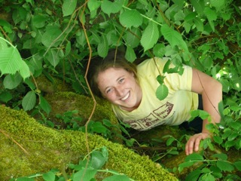
The Rocky Mountain RYLA bug snatched Mikaila as a junior at Conifer High School, since then she has enjoyed staying involved with Young RYLA as a junior counselor and head counselor. After growing up in the mountains of CO, you’re more likely to find Mikaila outside rather than inside! Fresh off the skillet from graduation at Pacific University (Forest Grove, OR), she studied environmental science, peace and social justice. Beyond the classroom, Mik has enjoyed learning by leading trips with the outdoor programs, working on the school’s permaculture farm, exploring places and people, and running around on the lacrosse field. Mik hopes you can be fully present at Young RYLA for our generations are in need of creative and compassionate leaders like you!

Tom Keyton – Photographer
Tom Keyton is a Rotarian in the Highlands Ranch Rotary Club. He is married to Jan (the SC for Team I!) and has been involved with RYLA for a few years. He will be the photographer at Yound RYLA ... and since he’s always behind a camera, there are no pictures of him!

Young RYLA Lingo
(What happens at YRYLA every day?)

Wake Up
Everyone is expected to be out of their rooms to participate in the morning activities that are led by the Counselors and Rotarians.
Word of Focus
This is a story presented by a Counselor to give a little bit of inspiration from their personal perspective, usually before a scheduled speaker, activity, or session.
Goofy Olympics
A collection of “Goofy Games” which tests a team’s ability to work together to accomplish mental, physical or team strengthening activities. These games are facilitated by the Counselors and are guaranteed to be goofy!
Reflection Time
This is an allotted amount of personal time for you to reflect on the day’s activities or to fill in your reflection worksheets (in your binder). This will prepare you for the discussions you will have in your team’s Twilight Time.
Galaxy Galley
Evening snacks during your team’s evening Twilight Time.
Twilight Time
Is held every night after the final session to discuss the day’s events, speakers, discussions, and give important information on the next day’s activities. It is also a great time for team bonding!
Warm-Fuzzies
Caring notes of cheer, respect, and admiration which you will receive in a warm-fuzzie bag of your own design, and that you will write to others and place in their warm-fuzzie bags, ideally each day.
Lights Out
Twilight Time will end at 10:15pm, which will give you a chance to wind down from the day before falling into bed at 10:30pm. Remember, you need your sleep!
Expected Conduct
Respect for property, privacy, the needs and personality of others, the Counselors, Rotarians and Speakers. On-time attendance at each activity is mandatory.
Random Acts of Kindness Cards
Whenever someone sees you perform a RAOK, they could give you a card. You should then send them to someone else you see doing a RAOK!

A Few Rotary Facts

The Mottoes of Rotary
Service Above Self
They profit most who serve the best

Rotary International is a worldwide secular organization open to all persons regardless of race, color, creed or political preference. 1.2 million members belonging to 32,000 clubs provide humanitarian service, encourage high ethical standards in all vocations, and help build goodwill and peace in the world.

The Rotary Foundation
Polio Plus: In 2009, contributions to the global effort to eradicate polio approached $750,000,000 which includes a grant of $355,000,000 from the Bill and Melinda Gates Foundation. Since 1985 a huge army of Rotary volunteers have provided support at clinics and helped to mobilize communities to immunize children around the world.

Programs: Youth Exchange, Group Study Exchange, Ambassadorial Scholarships, World Peace and Conflict Resolution Scholarships, Grants to university teachers willing to serve in developing countries.

The Four Way Test of the things we think, say, or do
Is it the TRUTH?
Is it FAIR to all concerned?
Will it build GOOD WILL and BETTER FRIENDSHIPS?
Will it be BENEFICIAL to all concerned?

The Object of Rotary
To encourage and foster the ideal of service as a basis of worthy enterprise and in particular, to encourage and foster:
- The development of acquaintance as an opportunity for service;
- High ethical standards in business and professions, the recognition of the worthiness of all useful occupations; and the dignifying by each Rotarian of his or her occupation as an opportunity to serve society
- The application of the ideal of service by every Rotarian to his to his or her personal, business, and community life;
- The advancement of international understanding, goodwill, and peace through a world fellowship of business and professional people united in the ideal of service.

Three Hoops Theme
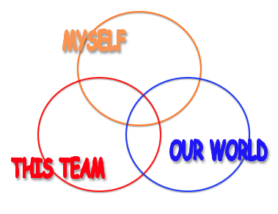

Throughout your week at Young RYLA you will be learning skills that are relevant to each portion of the continuum above. In order to be a leader you need to have a good understanding of each part and of your role in each circle. As you learn throughout the week add phrases, skills and activities that fit each specific circle and the ones that overlap as well.

Every day you are given infinite opportunities to be leader. In order to be the best leader that you can be, it is important to discover the answers to these three questions:

- What kind of leader are you?
-What are your strengths/weaknesses?

- How do you lead when you are part of a team?
-Are you vocal or passive? Are you a planner or an implementer?

- How can you use your leadership abilities to influence the world?
-What do you want to change in the world? What special talents do you have that you can use to help change the world?

A Brief History of RYLA
By Trustee Irving J. "Sonny" Brown
This article was originally published in the December 1999 issue of The Rotarian.

In 1959, the state government of Queensland, Australia, invited local Rotarians to help plan a festival celebrating Queensland's upcoming centenary. Learning that Queen Elizabeth II was sending her cousin Princess Alexandra, who was in her early 20s, to the celebration, Rotarians planned activities specifically for the princess' age group.

The gundoo, an aboriginal word meaning "festival" or "fun together," was a rousing success. More than 300 men and women between the ages of 17 and 23 attended. Encouraged by the event's popularity with the young attendees, Rotarians saw potential to create a similar annual youth program. With little hesitation, Governor Art Brand of then-District 260 approved the project, and on 2 May 1960, RYLA was born.

Australian districts 258 and 260 shared in establishing a committee that developed the official framework of RYLA: to train youth (ages 14-30) in character, leadership, personal development, and good citizenship. These guidelines helped RYLA expand to all Rotary districts in Australia and led to RYLA's approval as an international program by the Rotary International Board at the 1971 RI Convention in Sydney, Australia.

After District 5520's first RYLA camp 20 years ago, a conferee summed up his RYLA experience in one word, "Camelot." He wrote the RYLA chairman, "If you know the story of King Arthur, you may recall that as King Arthur was dying in a young man's arms, he turned to the youth and said, 'If you learn of anyone that has not heard of Camelot, tell them loudly and clearly that there really was that one wisp of glory called Camelot.'"

"Gundoo" or "Camelot?" RYLA is both and aren't we fortunate? Dedication, passion and love describe the heart of RYLA, a most remarkable investment that assures Rotary's future.

~~~~

The first RYLA in districts 5440 and 5450 for students going into the 11th or 12th grade took place July 26-31, 1987. This year the districts comprise 117 Rotary clubs in Central and Northern Colorado, Western Nebraska, and Wyoming.

In 2002, a team of Rotarians from these districts established the first Young RYLA in the United States. Eighty-eight middle school students from the two districts participated in building a foundation for their “personal leadership” – making good decisions, withstanding peer pressure and developing empathy for others, among many other topics. Young RYLA has grown to 240 students annually, split into two weeks with 120 YRYLArians at each.

Young Rotary Youth Leadership Awards
Established in 2002 for students entering 8th grade

Objectives:
- to be an active participant in a team setting
- to understand what it means to be a person of integrity and responsibility
- to be motivated to take action
- to be willing to push the limits of their comfort zone
- to have confidence in themselves and others
- to show empathy and demonstrate respect towards others
- to gain a realistic appreciation of their own strengths and weaknesses

Rules and Regulations

You have been honored as a recipient of a Rotary Youth Leadership Award, and, in turn you must honor and obey ALL applicable rules.

EXPECTED behavior includes:

- Respect the property of others, both public and private.
- Respect the privacy, needs and personality of others.
- Respect for Staff, Speakers, Counselors and Rotarians. Their decisions regarding rule infractions and discipline shall be final.
- ATTEND and BE ON TIME for all sessions and scheduled activities.
- Most importantly, HAVE FUN!

If you exhibit any unacceptable behavior which violates the rules, you will be sent home. UNACCEPTABLE behavior includes:

- Use of alcohol, tobacco or drugs
- Stealing, gambling or lying
- Possession of guns or knives
- Leaving the camp without permission of your Counselor
- Use of ANY cell phones or pagers
- Use of ANY iPod or similar device
- Intentionally harming yourself or others
Stay away from anyone who demonstrates unacceptable behavior and report him or her to a Counselor immediately.

YRYLA Bingo

Play YRYLA Bingo – Blackout! In order to cross off a box, you must write down the names of the people who completed the activity with you. Beware – some boxes require more than one person!
B | I | N | G | O
Create a handshake with 5 people | Teach one person your favorite song | Learn how to sing the alphabet backwards with 5 people | Give 15 compliments | Tell someone 5 things you would like to do in life
Meet someone who is wearing the same color shirt as you are | Introduce yourself to 2 JCs and 2 SCs | Introduce yourself, then introduce yourself in an accent | Give Cuad or Toria a high-five | Do 50 jumping jacks with 10 people
Meet 4 people who are not from your hometown | Teach 3 people your signature dance move | FREE SPACE: GO TO YRYLA CUAD & TORIA ARE THRILLED TO HAVE YOU HERE! <3 YOUR HEAD JCs | Find someone who has the same name as you | Play two rounds of rock-paper-scissors with 3 JCs
Read two quotes on the floor and write your favorite quote with chalk. Get your quote approved by a JC | Meet 10 people and remember their names | Find someone who has been to a different country | Count how many times you find RYLA/YRYLA | Skip to meet someone new and tell them what you expect YRYLA to be all about!

Making a Difference – The Starfish Story

A man was jogging down a beach early one morning. The sun had been up for approximately two hours and it was starting to get hot. The tide was receding and all along the beach were thousands and thousands of starfish. Stranded at high tide the starfish were all going to die on the beach, as the sun rose higher by the minute. The seagulls had spotted the opportunity for an easy morning breakfast and were starting to swoop down on the helpless starfish.

As the man ran down the beach he noticed a young boy in the distance walking back and forth between the high tide mark and the water. As he got closer to the boy he observed that the boy was picking up starfish and throwing them back into the water. The man slowed his jog to a walk and approached the young boy.

The man stopped and asked the young boy what he was doing. The boy replied, “The tide is going out and these starfish are going to die, so I am helping by putting them back in the water.” The man commented to the boy, “There are thousands maybe even a million starfish on this beach. Your efforts cannot make a difference.” The young boy picked up another starfish from the beach, walked to the water’s edge tossed it into the ocean and turned to the man and said, “It made a difference to that one.”

This is also …. The Power of One!

SUNDAY REFLECTION TIME
This is an opportunity for personal review of experiences and learning from the events of today. The reflections are just for you, but if you would like to share anything with your team, you are welcome to do so.

If
If you can keep your head when all about you
Are losing theirs and blaming it on you;
If you can trust yourself when all men doubt you,
But make allowance for their doubting too:
If you can wait and not be tired by waiting,
Or, being lied about, don't deal in lies,
Or being hated don't give way to hating,
And yet don't look too good, nor talk too wise;
If you can dream---and not make dreams your master;
If you can think---and not make thoughts your aim,
If you can meet with Triumph and Disaster
And treat those two impostors just the same:.
If you can bear to hear the truth you've spoken
Twisted by knaves to make a trap for fools,
Or watch the things you gave your life to, broken,
And stoop and build'em up with worn-out tools;
If you can make one heap of all your winnings
And risk it on one turn of pitch-and-toss,
And lose, and start again at your beginnings,
And never breathe a word about your loss:
If you can force your heart and nerve and sinew
To serve your turn long after they are gone,
And so hold on when there is nothing in you
Except the Will which says to them: "Hold on!"
If you can talk with crowds and keep your virtue,
Or walk with Kings---nor lose the common touch,
If neither foes nor loving friends can hurt you,
If all men count with you, but none too much:
If you can fill the unforgiving minute
With sixty seconds' worth of distance run,
Yours is the Earth and everything that's in it,
And---which is more---you'll be a Man, my son!
Rudyard Kipling

WHAT ARE YOUR TRUE COLORS?

Rank each grouping across each row from left to right as to the highest priority in your life or most like you. Give a 4 for the highest down to the 1 as lowest. Don’t use a number twice in each row.
Add the numbers in each column to determine the amount of each color in your personality.
Calculate the percentage of each color in your personality (total at bottom of column X 2)

RANK NUMBERS 1 TO 4 IN THIS DIRECTION

Active Organized Nice Learning
Variety Plan Helpful Science
Sports_____ Neat_____ Friends_____ Privacy_____

Fun Clean Caring Curious
Action On-Time People Ideas
Contests_____ Honest_____ Feeling_____ Questions____

Playful Helpful Kind Independent
Quick Trustworthy Understanding Exploring
Adventuresome____Dependable_____ Giving_____ Doing Well____

Busy Follow Rules Sharing Thinking
Free Useful Getting along Solving Problems
Winning_____ Save money_____ Animals_____ Challenge____

Exciting Pride Nature Books
Lively Tradition Easy Going Math
Hands-on_____ Do things right_____Happy Endings_____ Making sense_____

Amount Orange Amount Gold Amount Blue Amount Green

/ % / % / % / %

True Colors Information

WE HAVE ALL FOUR OF THE TRUE COLORS IN SOME VARIATION.
WE USE TRUE COLORS AS A TOOL TO EXPLAIN BEHAVIOR,
NOT EXCUSE IT.
WE ARE NOT TRYING TO STEREOTYPE OTHERS OR LIMIT OURSELVES.
EVERY COLOR HAS STRENGTHS & CHALLENGES.
Copyright of True Colors
Adapted by Emily Prascher
WHEN I AM GREEN…

I seek knowledge & understanding.
Analytical – Global – Conceptual

I live life by my own standard.
Cool – Calm – Collected

I need explanations & answers.
Inventive – Logical – Perfectionistic

I value intelligence, insight, fairness and justice.
Abstract – Hypothetical – Investigative

I am a natural non-conformist, a visionary and a problem solver.

Green May Perceive Self As:
- Confident - Good at Analysis/Objective
- Mentally Tough - Having Ability to Reprimand
- Logical, Rational - Having High Expectations
- Visionary, Inventive - Respecting Knowledge
- Self-Controlled - A Deep Thinker
- Enjoying One’s Own Company

Others May Perceive Green As:
- Arrogant, Know It All - Critical, Fault-Finding
- Cold, Hard - Lacking Compassion
- Insensitive - Unappreciative of Others
- Head in the Clouds - Intellectually Demanding
- Cool, Aloof, Unfeeling - Argumentative
- Afraid to Open Up - Absent Minded

Greens Are Stressed Out By:
- Not Being In Charge - Small Talk
- Lack of Independence - Routine
- Subjective Judgment - Social Functions
- Elaborate Use of Adjectives - Lack of recognition of their abilities
-Emotional Displays - Incompetence

True Colors – Green Character Traits

Values: Intellectual (achievements), Logic, Knowledge, Competency
Joys: High achievement, Recognition of ideas, Personal achievement,
Meeting challenges, Investigation

Strengths: Confidence, Analysis/Analytical, Logic, Problem-solving
Needs: Challenge, Need to understand, Autonomy, Truth and Facts, Accuracy

Stresses/Frustration: Rules, Unfairness, Incompetence, Confusion, Nonsense

Life Philosophy: Knowledge is power”

Nicknames: Visionary/Architect

Leadership Strengths: Excellent analytical skills, Enjoys complicated theories and models, Comfortable with rapid change
Keys to Leadership Success: Clarity, Competence, Intelligence, Logic, Ideas,
Keys to Personal Success: Using precise language, Exploring ideas, Abstract thinking, Striving for competence

Team Contributions: Can see the “big picture”, Can see potential barriers, Not afraid to challenge the process

How it helps to understand green friends: Be aware of their curiosity about life. Respect their need for independence and know that they are caring even though they may not show their feelings easily. Reinforce their new ideas and concepts.

How it helps to understand green teachers: Be curious, observing, and ask lots of questions. Be open to their ideas and praise their competence and knowledge. Be original in your assignments. They like to say it once, so pay attention the first time.

How it helps to understand green parents/adults: Respect their preoccupation with wisdom, knowledge, ideas and logic. Help them with the day-to-day details and praise their ingenuity and intelligence. Think ahead because they are future-oriented.
WHEN I AM BLUE…

I need to feel unique and authentic.
Enthusiastic – Sympathetic – Personal

I look for meaning and significance in life.
Warm – Communicative – Compassionate

I need to contribute, to encourage and to care.
Idealistic – Spiritual – Sincere

I value integrity and unity in relationships.
Peaceful – Flexible – Imaginative

I am a natural romantic, a poet and a nurturer.
Blue May Perceive Self As:
- Having Feelings - Seeing the Best in Others
- Compassionate - Nurturing
- Romantic - Liking to Please People
- Idealistic - Wanting Harmony
- Empathetic - Great Communicator
- Caring - Valuing Feelings
Others May Perceive Blue As:
- Very Emotional - Too Trusting
- Overly Sensitive - Smothering
- Mushy - Too Soft, Too Giving
- Too Tender-Hearted - Weak
- Easily Persuaded - Talking Too Much
- Too Nice - Illogical

Blues Are Stressed Out By:
- Broken Promises - Lying
- Too Much Negative - Rejection
- Not Being Involved - Insincerity
- Lack of Social Contact - Completing Paperwork
- Clock Watching - Placing System Before People
- Being Compared to Others - Conflict
True Colors – Blue Character Traits

Values: Honesty, Friendship, Sensitivity, Harmony, Compassion
Joys: Romance, Family, Friendships, Music, Affection
Strengths: Communication, Creativity, Nurturing, Sincerity, Listening
Needs: Harmony, People, Understanding, Love, Affection
Stresses/Frustration: Disharmony, Uncaring, Time limits, Insincerity,
Lack of romance
Life Philosophy: “To thine own self be true”

Nicknames: Catalyst/Energizer

Leadership Strengths: Creates enthusiasm and energy, Finds potential in
others, Natural democratic leader

Keys to Leadership Success: Authenticity, Harmony, Uniqueness,
Self-actualization, Cooperation, Personal relationships

Keys to Personal Success: Devotion to relationships, Making a difference in the world, Seeking harmony, Self-searching

Team Contributions: Ensures group participation, Brings inspiration and enthusiasm, Values open and honest communication

How it helps to understand blue friends: Spend quality time, one-on-one with tem. Be aware that they wear their hearts on their sleeves. Listen to them as they listen to you and be supportive. Share your thoughts and feelings and praise their imagination and creativity.

How it helps to understand blue teachers: Respect their concern for the feelings of students. Get along with other students in the class. Offer your ideas and feelings and give the teacher positive feed-back. Appreciate their warmth and caring attitude. Be dramatic and expressive.

How it helps to understand blue parents/adults: Respect their need to know about you. Be truthful, sincere, helpful, open and communicative. Take a creative approach to problem solving and cooperate with other family members. Show that you value them through thoughtfulness.
WHEN I AM GOLD…

I follow the rules and respect authority.
Loyal – Dependable – Prepared

I have a strong sense of what is right and wrong in life.
Thorough – Sensible – Punctual

I need to be useful and to belong.
Faithful – Stable – Organized

I value home, family and tradition.
Caring – Concerned – Concrete

I am a natural preserver, a good citizen and helpful.

Gold May Perceive Self As:
- Consistent - Realistic
- Providing Structure - Decisive, Seeking Closure
- Goal-Oriented - Dependable
- Very Traditional - Concerned About Security
- Knowing Right From Wrong - Follower of a Routine
- Loyal to Organization - Having Leadership Ability
Others May Perceive Gold As:
- Rigid, Inflexible - Lacking Imagination
- Controlling, Bossy - Judgmental
- Too Serious - Boring
- Resistant to Change - Uptight
- Opinionated - Predictable
- System-Bound - Autocratic
Golds Are Stressed Out By:
- Incomplete Tasks - Non-Conformity
- Disorganization - Lack of Structure
- Irresponsibility - Haphazard Attitude
- Changing Details - Too Many Things Going On
- Lack of Direction - No follow through
- Waste - Ambiguous Tasks
True Colors – Gold Character Traits

Values: Loyalty, Dependability, Honestly, Responsibility, Perfection
Joys: Time for family, Home, Job satisfaction, Order, Sense of family

Strengths: Organization, Commitment, Consistency, Responsibility,

Needs: Stability, Time, Consistency, Organization, Appreciation

Stresses/Frustration: Lack of control, Change, Disloyalty, Money

Life Philosophy: “Be prepared”

Nicknames: Stabilizer/Traditionalist

Leadership Strengths: Establishes and follows policies, procedures and rules,
Meticulous attention to detail

Keys to Leadership Success: Tradition, Dependability, Loyalty, Discipline,
Trustworthy, Decisiveness

Keys to Personal Success: Work ethic, Predictability, Sense of history,
Team Contributions: Stabilizing force, Gets the job done

How it helps to understand gold friends: Try to be organized, efficient, dependable and loyal. Remember to be on time. They are generous and like things to be returned. Respect their need for security and do what you say you will do.

How it helps to understand gold teachers: Pay attention to details and be neat and orderly. Respect their need for rules and regulations. They value their position as a teacher, so follow directions carefully. Make an extra effort to be on time for class.

How it helps to understand gold parents/adults: Respect their need for tradition and stability. Be loyal, dependable and truthful. Be up front with them and understand their desire for structure and security. Be clean and neat in appearance.
WHEN I AM ORANGE…

I act on a moment’s notice.
Witty – Charming – Spontaneous

I consider life as a game, here and now.
Impulsive – Generous – Impactful

I need fun, variety, stimulation, and excitement.
Optimistic – Eager – Bold

I value skill, resourcefulness, and courage.
Physical – Immediate – Fraternal

I am a natural trouble-shooter, a performer, and a competitor.

Orange May Perceive Self As:
- Flexible, Easy-Going - Able to Do Many Things
- Having a Playful Attitude - Adventurous
- Exploring New Possibilities - Valuing Freedom
- Clever, Good Negotiator - Bold, Assertive
- Open to Change - Fun-Loving, Enjoying Life
- Having Many Interests - Independent

Others May Perceive Orange As:
- Irresponsible - Taking Unnecessary Risks
- Goofing Off Too Much - Resisting Closure or Decisions
- Manipulative - Obnoxious
- Unable to Stay On Task - Immature
- Scattered - Self-Centered

Oranges Are Stressed Out By:
- Repetition - Too Much Responsibility
- Following Detailed Directions - Rules and Regulations
- Routine - Being Stuck at a Desk
- Deadlines - Abstract Concepts
- Inactivity - Reading Manuals
- Lack of Fun - Imposed Structure
- Lack of Variety - Personal Criticism
True Colors – Orange Character Traits

Values: Freedom, Adventure, Fun/Play, Variety, Spontaneity
Joys: People, fun, Adventure, Excitement, Performing

Strengths: Independence, Flexibility, Energy, Taking action, Optimism

Needs: Freedom, Variety, Money, Recognition, Expression

Stresses/Frustration: Being on time, Waiting, Lack of money, Unnecessary routine,

Life Philosophy: “Forget the torpedoes, full speed ahead!”

Nicknames: Troubleshooter, Negotiator

Leadership Strengths: Welcomes change and taking risks, Excels in crisis situations

Keys to Leadership Success: Action, Variety, Performance, Fun, Freedom

Keys to Personal Success: The impulse to really live, Testing limits, Variety

Team Contributions: Quickly diagnoses problems, works well under pressure, Sees
opportunities

How it helps to understand orange friends: Be active with them and do not slow down. Be energetic and ready to go. Be adventurous, optimistic, spontaneous, and fun. Compete in fun when appropriate. Do not play heavy.

How it helps to understand orange teachers: Because they like students to solve problems and to move quickly, be open and ready to wing it. Be willing to work on your hands-on activities. Respect their changes of directions and fast pace. Get actively involved in class.

How it helps to understand orange parents/adults: Compliment their generosity and sense of humor. Use a direct, right-to-the-point approach. Get involved in physical activities with them. Respect their lack of structure and need for space
Lizard and Wizard Brain Behaviors

GREEN
“Lizard Brain” Behaviors “Wizard Brain” Behaviors
-Behaves indecisively -Questions and explores ideas
-Refuses to comply or cooperate -Considers others ideas
-Extreme aloofness and withdrawal -Works independently
-“Snobbish” put-downs and sarcastic remarks -Pleasant but not very social
-Refuses to communicate, the silent treatment -Thrives on own work and ingenuity
-Perfection ties to performance anxiety -Strives for improvement
-Highly critical towards self and others -Has high expectations

BLUE
“Lizard Brain” Behaviors “Wizard Brain” Behaviors
-Attention-getting behavior -Appreciates everything, everyone
-Lying to “save face” -Behaves with honesty & integrity
-Withdraws -Likes teamwork
-Fantasizes, day-dreams excessively -Creates things to make life better
-Overly expresses emotions -Strives for peace & harmony
-Behaves in passive, resistant ways -Contagiously enthusiastic
-Cries often & appears depressed -Cooperative & encouraging
GOLD
“Lizard Brain” Behaviors “Wizard Brain” Behaviors
-Complains & behaves with self pity -Task & structure focused
-Exhibits anxiety & worry -Serious attitude
-Is depressed & acts fatigued -Likes to do things to help
-Expresses psychosomatic problems -Cares for own body & health
-Malicious in judgment of self & others -Direct but cautious
-Exhibits “blind herd” mentality -Respects authority
-Exhibits phobic reactions -Is dependable & reliable

ORANGE
“Lizard Brain” Behaviors “Wizard Brain” Behaviors
-Acts rude & with defiance -Acts boldly & is direct
-Breaks the rules on purpose -Risk-taking behavior
-Runs away, drops out -Acts impulsively & spontaneously
-Involved with alcohol, drugs -Seeks reasonably “safe” adventures
-Acts out boisterously -Has high expectations
-Lying & cheating behavior -Wants “hands-on” activities
-Violent behavior -Is assertive & to the

BRAINWISE NOTES
Synopsis Created By Dr. Lloyd Thomas

Underlined Wise Ways are the ones we are focusing on during YRYLA Camp II

WISE WAY #1: Use your Wizard Brain (frontal cortex) rather than your Lizard Brain (hypothalamic system). The former is the seat of thinking, judgment, logic and rational decision-making. The latter is emotional reactivity, survival reflexes and non-rational choices/decisions.

WISE WAY #2: Build a strong support system of resources: non-toxic people; programs; books; classes; networks etc. Toxic people (jerks) are always focused on the negative and you feel worse/drained after interacting with them. Supportive people focus on the positive and making suggestions on how you can attain your desired outcomes. They accept you and are “there for you.”

WISE WAY #3: Become aware of “red flags.” Red flags are those intuitive (small voices) senses that something is not right about the situation/behavior/choices/decisions... yours and others’. Becoming sensitive to, and recognizing red flags clues you in to use your Wizard Brain rather than simply reacting from your Lizard Brain.

WISE WAY #4: Learn how to manage your strong emotions. Managing your emotional life usually means to practice lowering the intensity of your fear, anger, sadness, joy, etc. High-intensity of emotions are always stressful. Practice using your strong emotions to motivate you to act in ways that are beneficial (and calming) to you and those around you. Emotional-management tools might include: modifying your self-talk; breath control; distracting yourself; declaring/taking “time out”; and relaxation skills. Always maintain your emotions at a lower level than the other person(s) with whom you are interacting.

WISE WAY #5: Practice distinguishing between “facts” and “opinions.” Former Senator, Patrick Moynihan, once said, “You have the right to your opinions, but you do not have the right to the facts.” Much of our emotional reactivity is based on opinions we hold that differ from the opinions of others. If you seek out and focus on facts (the truth) rather than react to opinions, you will make better/rational decisions and choices.

WISE WAY #6: Learn to ask questions (make inquiries) rather than trying to come up with all the “right” answers. Become curious about circumstances/situations that raise “red flags.” Ask questions that begin with the words, “Who, What, Where, When, How and Why. Ask questions (make inquiries) that require more than single-word responses and that trigger thoughtfulness in others. Ask yourself similar questions.

WISE WAY #7: Realize that no matter what happens, you always have multiple choices about how you respond in any given situation. No one can take away your ability to choose how you respond, how you choose to think or how you choose to interpret reality. Remember that not making a choice is also a choice.

WISE WAY #8: Realize that there are ALWAYS consequences to your thoughts, choices, decisions, every action, all your behavior. The trick is to learn what consequences are connected to what behavior. If you want good, positive consequences to happen, learn what choices will most likely lead to those results. If you are not aware of possible consequences of your actions, it is like shooting an arrow without knowing where the target is. If you choose not to act at all out of fear of the consequences, you become a victim of circumstance and lose control of your own life.

WISE WAY #9: Take control of your life by envisioning the outcomes you really want (dreams); setting realistic goals for yourself; prepare plans (strategies) for goal attainment; commit yourself to attaining your desired outcomes; and take actions that increase the probability you will reach your goals and fulfill your desires.

WISE WAY #10: Learn effective communication skills. Probably the most important communication skill is LISTENING. Listen out of curiosity and genuine interest. Avoid rehearsing your replies while others are speaking. There is rarely ever a time when you need to reply/respond immediately. Think before you speak. Make “I-statements.” Practice the phrases: “I want (or need) .... Will you ....” All other phrases are either indirect or not asking.

~ A Splash of Inspiration ~

Giving When it Counts.
Many years ago, when I worked as a volunteer at a hospital, I got to know a little girl named Liz who was suffering from a rare and serious disease. Her only chance of recovery appeared to be a blood transfusion from her 5-year old brother, who had miraculously survived the same disease and had developed the antibodies needed to combat the illness. The doctor explained he situation to her little brother and asked the little boy if he would be willing to give his blood to his sister. I saw him hesitate for only a moment before taking a deep breath and saying, "Yes, I'll do it if it will save her." As the transfusion progressed, he lay in bed next to his sister and smiled, as we all did, seeing the color returning to her cheek. Then his face grew pale and his smile faded. He looked up at the doctor and asked with a trembling voice, "Will I start to die right away?" Being young, the little boy had misunderstood the doctor; he thought he was going to have to give his sister all of his blood in order to save her. Yet he was willing.
Unselfishly Serving Others

Pickup in the rain one night, at 11.30 p.m., an older African American woman was standing on the side of an Alabama highway trying to endure a lashing rainstorm. Her car had broken down and she desperately needed a ride. Soaking wet, she decided to flag down the next car. A young white man stopped to help her, generally unheard of in those conflict-filled 1960s. The man took her to safety, helped her get assistance and put her into a taxicab. She seemed to be in a big hurry, but wrote down his address and thanked him. Seven days went by and a knock came on the man's door. To his surprise, a giant console color TV was delivered to his home. A special note was attached. It read:
”Thank you so much for assisting me on the highway the other night. The rain drenched not only my clothes, but also my spirits. Then you came along. Because of you, I was able to make it to my dying husband's bedside just before he passed away. God bless you for helping me and unselfishly serving others."
Sincerely, Mrs. Nat King Cole

“My Life List”

When John Goddard was 15 years old, he overheard his parents friends say, “I wish I were John’s age again, I would do things differently.” Something about that remark seemed to have touched a nerve inside the boy. He took out a yellow legal pad and wrote the words, “My Life List” across the top. He began writing down goals. The list grew to 127 items. Today, John has accomplished all but 13 of those original goals. The ones not accomplished by June 2006 are designated with an (*).

Explore: Study/Learn:

1. Nile River 37. Carry out careers in medicine and exploration
2. Amazon River *38. Visit every country in the world (30 to go)
3. Congo River 39. Study Navaho and Hopi Indians
4. Colorado River 40. Learn to fly a plane
5. Yangtze River, China 41. Ride horse in a Rose Bowl Parade
*6. Niger River
*7. Orinoco River, Venezuela Photograph:
8. Rio Coco, Nicaragua
42. Iguaçu Falls, Brazil
Study Native Cultures In: 43. Victoria Falls, Rhodesia
44. Sutherland Falls, New Zealand
9. Congo 45. Yosemite Falls
10. New Guinea 46. Niagara Falls
11. Brazil
12. Borneo 47. Retrace the travels of Marco Polo and
13. Sudan Alexander the Great
14. Australia
15. Kenya Explore Underwater:
16. Philippines
17. Tanganyika (now Tanzania) 48. Coral Reefs of Florida
18. Ethiopia 49. Great Barrier Reef, Australia
19. Nigeria 50. Red Sea
20. Alaska 51. Fiji Islands
52. The Bahamas
Climb: 53. Explore Okefenokee and Everglades

*21. Mount Everest Visit:
*22. Mount Aconcagua, Argentina
*23. Mount McKinley *54. North and South Poles
24. Mount Huascaran, Peru 55. Great Wall of China
25. Mount Kilimanjaro, Africa 56. Panama and Suez Canals
26. Mount Ararat, Turkey 57. Easter Island
27. Mount Kenya 58. The Galapagos Islands
*28. Mount Cook, New Zealand 59. Vatican City
29. Mount Popocatepetl, Mexico 60. The Taj Mahal
30. The Matterhorn 61. The Eiffel Tower
31. Mount Rainer 62. The Blue Grotto
32. Mount Fuji 63. The Tower of London
33. Mount Vesuvius 64. The Leaning Tower of Pisa
34. Mount Bromo, Java 65. Sacred Well of Chichen-Itza
35. Grant Tetons 66. Climb Ayers Rock, Australia
36. Mount Baldy, California 67. Follow River Jordon from Sea of
Galilee to the Dead Sea
Swim In:

68. Lake Victoria 101. Run a mile in 5 minutes
69. Lake Superior 102. Weigh 175 (still does)
70. Lake Tanganyika 103. Perform 200 sit-ups and 20 push ups
71. Lake Titicaca, Peru 104. Learn French, Spanish, and Arabic
72. Lake Nicaragua 105. Study dragon lizards of Komono Island
106. Visit birthplace of grandfather Sorrenson
Accomplish: 107. Visit birthplace of grandfather Goddard
108. Ship aboard a freighter as a seaman
73. Become an Eagle Scout *109. Read the entire Encyclopedia Britannica
74. Dive in a submarine 110. Read the Bible cover to cover
75. Land on and take off from an aircraft carrier 111. Read the works of Shakespeare, Plato,
76. Fly in a blimp, hot air balloon, glider Aristotle, Thoreau, Poe, Rousseau, Bacon,
77. Ride and elephant, camel, ostrich and bronco Hemingway, dickens, Twain, Burroughs,
78. Skin dive to 40 feet, hold breath Conrad, Talmage, Tostoi, Longfellow, Keats,
2.5 minutes underwater Whittier and Emerson
79. Catch a 10 lb lobster and ten-inch abalone 112. Become familiar with the compositions of
80. Play a flute and violin Bach, Beethoven, Debussy, Ibert,
81. Type 50 words a minute Mendelssohn, Lalo, Rimski-Korsakov,
82. Take a parachute jump Respighi, Liszt, Rachmaninoff, Stravinshy,
83. Learn water and snow skiing Toch, Tshcikovsky, and Verdi
84. Go on a church mission 113. Become proficient in the use of a plane,
85. Follow the John Muir Trail motorcycle, tractor, surfboard, rifle, pistol,
86. Study native medicines, bring back useful ones canoe, microscope, football, basketball, bow
87. Bag camera trophies of elephant, lion, rhino, and arrow, lariat and boomerang
cheetah, cape buffalo and whale 114. Compose music
88. Learn to fence 115. Play Clair de Lune on the piano
89. Learn jujitsu 116. Watch fire-walking ceremony in Bali
90. Teach a college course 117. Milk a poisonous snake
91. Watch a cremation ceremony in Bali 118. Light a match with a 22 rifle
92. Explore the depths of the sea 119. Visit a movie studio
*93. Appear in a Tarzan movie 120. Climb Cheops’ Pyramid
*94. Own a horse, chimp, cheetah, ocelot and 121. Become a member of the Explorers’ Club
coyote (Chimp and cheetah to go) and the Adventures’ Club
*95. Become a ham radio operator 122. Learn to play Polo
96. Build own telescope 123. Travel the Grand Canyon (by foot and boat)
97. Write a book 124. Circumnavigate the globe (4 times)
98. Publish article in National Geographic *125. Visit the moon
99. High jump 5 feet 126. Marry and have children (has 5 kids)
100. Broad jump 15 feet 127. Live to see the 21st Century

Your Life List – So, what’s on your life list? Have you ever sat down and created your own life list? If so, how long ago was that and have you continued to add to the list? A My Life List, exercise is a great way to set a plan into action for creating an exciting and successful future.

Here is the path:
1) Creating your life list, 2) make sure you have the “vision” of what you want clearly in your mind , 3) take action through personal initiative, 4) attract and find people (mentors) to help you achieve these goals, and 5) persevere by never, never, never giving up. Have a “great future of success!” As John would say, “This conversation it to be continued.”

John Goddard recently published a book titled, The Survivor: 24 Spine-Chilling Adventures on the Edge of Death (Health Communications, Inc.) which further describes his Life List, many additional goals beyond the original 127 and how he achieve them. Check it out – it’s a good read!

My Life List
At Least What I Can Think of Today

Name Date___________

My Life List:

Goal : _____________________________________________________________________________________

Time Frame (deadline): ______________________________________________________________

Things to Do in Order To Achieve that Goal:
People/Mentors that can Help Me: (constellation of support)
Talk To: ___________________________________________________________________
By Which Date: __________________________________________________
Learn About: _____________________________________________________
_____________________________________________________
_____________________________________________________
Talk To: ___________________________________________________________________
By Which Date: __________________________________________________
Learn About: _____________________________________________________
_____________________________________________________
_____________________________________________________
Talk To: ___________________________________________________________________
By Which Date: __________________________________________________
Learn About: _____________________________________________________
_____________________________________________________
_____________________________________________________

Knowledge/Information Required:
Item #1: __________________________________________________________________
How do I gain that knowledge: _________________________________
_____________________________________________________________
_____________________________________________________________
Date I will have that information: ______________________________

Item #2: __________________________________________________________________
How do I gain that knowledge: _________________________________
_____________________________________________________________
_____________________________________________________________
Date I will have that information: ______________________________

Item #3: __________________________________________________________________
How do I gain that knowledge: _________________________________
_____________________________________________________________
_____________________________________________________________
Date I will have that information: ______________________________

What do I Need (supplies, money,etc):
What do you need: ______________________________________________________
How much does it cost: _________________________________________________
How can you raise this money: _________________________________________
_____________________________________________________________________
_____________________________________________________________________
Who can help you with this: ____________________________________________
When will you contact this person: ___________________________

What do you need: ______________________________________________________
How much does it cost: _________________________________________________
How can you raise this money: _________________________________________
_____________________________________________________________________
_____________________________________________________________________
Who can help you with this: ____________________________________________
When will you contact this person: ___________________________

What do you need: ______________________________________________________
How much does it cost: _________________________________________________
How can you raise this money: _________________________________________
_____________________________________________________________________
_____________________________________________________________________
Who can help you with this: ____________________________________________
When will you contact this person: ____________________________

Swept Away and Staying On top

On January 6, 2007 Dave Boon, his wife June and a friend of the family, 13-year-old Gary Martinez who attended the 2006 YRYLA, were driving up Berthoud Pass on Highway 40 for two days of skiing at the Winter Park – Mary Jane ski area. As we started the steep climb after the turn toward the summit of Berthoud Pass the song, Affirmation by Savage Garden started to play on the CD player. Stanley Mountain rising to a height of 12,524 feet was on our left as we saw the first “Avalanche Area – No Stopping” signs.

I was marveling at the gorgeous deep blue ski when something caught my eye about twenty yards ahead of our car and to the left a small cloud of power came down onto the road. Both of my hands were on the steering wheel and this little white puff of powder was the only warning we got. Less than a second later our car was literally blown out of control and slammed into the guard rail by a blast of air and snow. It was a total white out and I could not see past my windshield and I could hear snow and ice hitting our car as if being blown by a 120mph wind. One moment I was going 45 mph looking at royal blue sky and now something very wrong was going on – my mind knew I had not hit a car, I wasn’t in an accident, I just thought, “What is going on.”

The next instant we were hit by an incredible force – one I can only describe as being hit by a freight train. The impact caused the car to flip into the air – then I knew what it was. We had been swept away by an avalanche – a massive avalanche. Everything went dark and we flew into the air. Over and over we went in total darkness. We must have flipped several times in the air before we hit the ground and started to roll. We had driven this road hundreds if not a thousand times and I thought about the steepness of the slope the avalanche was going down – with us in it. The slope must be 30-40º so we were going for quite a wild and long ride. We rolled over and over. Everything was black, we couldn’t see anything. We just kept rolling. Then we hit something and the car starting spinning upside down. We started slowing down and as we did, June shouted, “Make an air space. Make an air space.” Then the car came to a stop.

Everything was dark – we were upside down and we were buried alive.

- What are the things in life that knock you off your Highway 40 (the highway to accomplishing your dreams and goals)? List all the things you can think of that slow you down or keep you from staying on a positive path in life. Post these negative influences on “post-its” and place them on the wall.

Staying On Top - If you are ever in an avalanche get rid of everything that can bring you down – get rid of your pack, ski poles, skies or snow shoes, -- then try and swim with the mass of moving snow trying your best to keep your head up and staying on top. If you do get below the surface and as the snow slows down try and pack the biggest air-space you can in front of your mouth – it may be the only air you have.

- Now list all the things you can do to “stay on top” and not get buried or swept away or away by bad influences. Again, put them on “post-its” and place them on the wall.

- As a group discuss what sweeps you off your highway of life and what you can do to “stay on
top.” Have any of these things happened to you or your friends? Could you have used some of the techniques or ideas for staying on top? Will you be better prepared next time to stay on top and not get swept away?

MONDAY REFLECTION TIME
This is an opportunity for personal review of experiences and learning from the events of today. The reflections are just for you, but if you would like to share anything with your team, you are welcome to do so.

~ A Splash of Inspiration ~

“Go confidently in the direction of your dreams. Live the life you imagined.”
–Thoreau

“Three grand essentials to happiness in this life are something to do, something to live, and something to hope for.” – Joseph Addison

“The only people who never fail are those who never try.” –Iika Chase

“To the world you may be just one person, but to one person, you may be the world.” – Josephine Billings

“Only those who risk going too far will ever know how far they can truly go.”
-Unknown

Lesson #1:The Cleaning Lady

During my second month of college, our professor gave us a pop quiz. I was a conscientious student who had breezed through the questions, until I read the last one, “What is the first name of the woman who cleans the school?”

Surely this was some kind of joke. I had seen the cleaning woman several times. She was tall, dark-haired and in her 50’s, but how would I know her name? I handed in my paper, leaving the last question blank. Just before class ended, one student asked if the last question would count toward our quiz grade. “Absolutely,” said the professor. “In your careers, you will meet many people. All are significant. They deserve your attention and care, even if all you do is smile and say hello.”

I’ve never forgotten that lesson. I also learned her name was Dorothy.

~Unknown

Ethics and The Four-Way Test

By Doug Young
District 5450 Ethics Committee Chairman

Of the things we think, say or do
Is it the Truth?
Is it Fair to all concerned?
Will it build Good Will and Better Friendships?
Will it be Beneficial to all concerned?

From the earliest days of the organization, Rotarians have been concerned with promoting high ethical standards in their professional lives. This has never been more important.

Ethics is not merely a trendy buzzword. In today’s scandal-plagued world, ethics have become an everyday concern for each one of us. A strong ethical framework provides strength to our families, our friendships, our business relationships, and the daily encounters we have with people in our community. Character, respect, and trust have never been more important, and they are highly predictive of individual success in every aspect of life.

Written by Herbert Taylor in 1932, the Rotary Four-Way Test has stood the test of time. It was adopted by Rotary International in 1943, has been translated into more than 100 languages, and Herbert Taylor became President of Rotary International in 1954-55.

The Four-Way Test is a simple but remarkable tool. Its purpose is to help us make better choices and decisions in our interactions with others. It does not automatically give us the answer to an ethical dilemma, but it causes us to think more deeply about what is right! Using The Four-Way Test as a guide will positively impact the quality of your life and the quality of your personal performance!

BRAINWISE AND THE 4 WAY TEST

Is it the Truth?
- Separate fact from fiction (wise way #5)
- Ask qustions (wise way #6)

Is it Fair to All Concerned?
- Consider the consequences affecting others (wise way # 8)
- Consider consequences now and later (wise way #8)

Will it Build Goodwill and Better Friendships?
- Communicate effectively by taking other people’s points of view and recognizing other people’s differences. (wise way # 10)

Will it be Beneficial to all Concerned?
- Identify choices. (wise way # 7)
- Consider the consequences affecting others (wise way #8)
- Set goals and plans for action. (wise way # 9)

4 WAY TEST SCENARIOS
School Scenario
Julia was in 6th grade and had been at her school since kindergarten. Her two best friends were Wendy and Erin. Erin was the most popular girl in the class and all the girls saw her as the leader. One morning Julia arrived at school and Erin was acting weird. When Julia said hi to her, she didn’t respond. She just looked away and smiled at a group of girls in the corner of the classroom.
It didn’t take long for Julia to figure out that Erin had turned most of the girls against her. But, she didn’t know why! She went to Wendy and asked her why Erin was mad at her. Wendy acted nervous and said that all she knew was that Erin told her that if she hung out with Julia, none of the rest of the girls would talk to her anymore.
The rest of that day lasted forever. Whenever the teacher was looking everyone was nice to Julia. But, when her back was to the class, Erin or another girl would throw pieces of paper toward Julia or whisper to each other and look in her direction. Julia thought Wendy would help her but Wendy just pretended nothing was happening.
That night Julia talked to her parents and they told her to wait and see if tomorrow was better. If not, they said, perhaps they could help Julia talk to Erin and work through the problem. Julia felt like that would make her look stupid if everyone found out that her mom and dad had to get involved. She knew that sometimes the class would pick on someone, but she never thought her friends would turn against her and do the same thing to her. She felt like she didn’t have any friends and nobody liked her.
The next day was even worse. No one wanted to hang out with her at recess and she had to sit by herself at lunch. At the end of lunch she went into the girls’ bathroom. While she was there, a girl from her class came in and said that Erin had sent her in and that Julia had to take off her shoes and send them back to Erin or no one would talk to her tomorrow. Julia just wanted to go home. She didn’t want to cry but she was confused and hurt and scared. She gave the girl her shoes.
Now she was late for class and was in the bathroom with no shoes. She headed to class and walked in quietly with her head down. Before she could get to her chair, the teacher asked her why she was late and where her shoes were.
Here was her dilemma. What should she do now? Everyone was watching her. If she told the teacher about Erin and the girls ganging up on her she would look like a snitch, and who knows what the kids would do to her after that. But, if she didn’t say anything or lied to the teacher, she would get into trouble.
What should Julia do?

Family Scenario
Chris was just about to finish his sophomore year and felt like his whole world was crashing in around him. His mom was a recovering alcoholic and had been sober for three years . . . until now.
When Chris was in middle school his mom went through rehab. When she finally came home, Chris’s dad said he would leave her if she ever drank again. Everything seemed okay until his dad took a new job this year and had to travel a lot.
During that last few months, every time Chris’s dad left town his mom would drink. It was on the sly but Chris knew the signs. He saw the thermoses in the bathroom, the “water” bottles in her bedroom. It was like middle school all over again. It was like living in a nightmare.
The hardest part was trying to figure out what he was supposed to do. If he called her out on her drinking, his dad would probably leave all of them. If he didn’t do anything, something bad could happen to his mom. He was mad and hurt and lonely. He had friends he could talk to but what could they do? He felt like there wasn’t a single good choice to make.
What should Chris do?

Community Scenario
Ben said good-bye to his friends and started heading for home. He was in a great mood. He had two weeks off from school for winter break, he had just passed the test for his driver’s license, and with no homework he could hang out with his friends whenever he wanted to. Things couldn’t be better. He turned his iPod up and smiled. As he passed the last row of stores before the hill leading to his house something caught his eye at the bank. Something was sticking out of the ATM machine. As he got closer, he saw it was cash.
Ben looked around. There was nobody. No cars, nobody walking nearby. Someone must have just used the machine and then forgotten to take the money. Whoever it was, was gone now. He walked over to the machine and took the money out. Sixty dollars. There was also a receipt sticking out.
Ben looked around again. Still no one. He could turn the money in at the bank tomorrow—it was after hours now. But, really, it was sixty bucks! Probably not much to the customer, but it would make a difference as to how many Christmas gifts he could get for his family.. or new music for his iPod.
Does it really count if you only do something like this once? Ben thought this over. It’s not like he’s a thief or anything. Someone messed up by leaving the cash there in the first place. He felt pretty good about taking it. It’s a one-time deal. And no one ever needs to know. He put the money in his pocket, crumpled up the receipt, and walked away.
As the next song started playing, Ben remembered something his grandfather always said, “Every time you lie, you get closer to being a liar.” But this wasn’t the same thing. Was it? He turned up the volume and headed up the hill to home.
What should Ben do?

Community Scenario
A friend stole a good used bike from a store in your community and told his parents that a buddy gave it to him because he didn’t need it anymore. He uses the bike to ride to school as well as to deliver papers on his new paper route. His family is struggling financially and he gives a significant part of his earnings to his family. You just learned that he actually stole the bike which is worth about $250. You know the theft is wrong, and you’ve talked to your friend. He refuses to turn himself in. You also know the bike store owner who is a supporter of youth activities in your community even though his business is way town because of the poor economy.
What would you do?

Core Values
My Inner Compass

SUCCESSFUL LEADERSHIP CHARACTER QUALITIES
By Lloyd J. Thomas, Ph.D.
Very few of us aspire to be followers in everything we do. It might be useful therefore, to identify some personal character qualities of competent, ethical and successful leaders.
Self-discipline. Any person who leads others needs to do so by example. If you expect those who follow you to be self-disciplined, you must be so yourself. Self-discipline is a
willingness to do what needs to be done, even when you don’t want to do it. Practice self-control to accomplish your objectives...step by step.
Fairness. Without a highly developed sense of justice, no leader will ever be respected by those she or he wishes to lead. If you treat everyone, including yourself, with fairness and respect, you will be emulated and receive the same in return from those who follow you.
Courage. You must have the courage to confront personal fears and take reasonable risks. When we confront common fears like rejection, others opinions, public speaking etc., they usually diminish. Most of our fears are around non-dangerous, anticipated events. Courage to take reasonable risks is like stealing second base in a baseball game. You can’t expect to succeed at it unless you risk taking your foot off first base. No intelligent follower will follow a wimp. Leaders who lack self-confidence rarely risk anything.
High moral values. A study by Harvard Business School a few years ago indicated that the primary characteristic needed most by top-level executives was integrity. The next one was a desire to serve the common good. Whatever happened to those character qualities? Dishonesty, undependability, lack of caring for those less fortunate, greed and an unwillingness to sacrifice self in the service of others may characterize some people, but certainly not long-term successful leaders.
Awareness and understanding of other points of view. A competent leader must listen much more than talk. Only through observing and listening with the intention to understand does any one become aware of another’s perceptual world.
Willing to assume full responsibility. The genuine leader assumes responsibility for the mistakes and shortcomings of his/her followers. Blaming or trying to shift responsibility always undercuts one’s personal power and ability to take action to correct mistakes.
Attentiveness to people, the organization and to details. Leaders must have a mastery of detail. Efficient action requires detailed organization, strategic plans, and persistence.
Doing more than required. Finally, doing more than the minimum required. Leaders pursue their goal-attainment with focus and a willingness to do ”whatever it takes” within their moral and ethical standards, to reach their envisioned goals. Minimum effort attains only minimum results.
If you ever find a company in which the leadership has most of the above personal characteristics, you have found a leading company. If you develop those personal character qualities yourself, you will be, by definition, a leader of character.

Remember the Titans

Please pay particular attention to when and how these wise ways show up in the movie …with which character and in what situation. Do you see certain personality colors.

What problems are portrayed in the movie?
- What are the dominant colors of the main characters?
- What characters called in a constellation of support, who were they, were they a positive or negative support?
- What internal or external red flags did the director use to portray a coming problem?
- What were the emotions portrayed?
- What was opinion and what was fact?
- Who asked questions? What was the right question?
- What were the choices made? What were the consequences of their choices…at the time, later, and to others?
- Notice the non-verbal communications, the “I” vs. “You” messages, and the double messages.
- Notice when the characters use aggressive, passive, passive-aggressive and assertive communication styles.

_______________________________________________________________________________________________________________________________________________________________________________________________________________________________________________________________________________________________________________________________________________________________________________________________________________________________________________________________________________________________________________________________________________________________________________________________________________________________________________________________________________________________________________________________________________________________________________________________________________________________________________________________________________________
_______________________________________________________________________________________________________________________________________________________________________________________________________________________________________________________________________________________________________________________________________________________________________________________________________________________________________________________________________________________________________________________________________________________________________________________________________________________________________________________________________________________________________________________________________________________________________________________________________________________________________________________________________________________
________________________________________________________________________________________________________________________________________________________________________________________________________________________________________________________________________________________________________________________________________________________________________________________________________________________________________________________________________

TUESDAY REFLECTION TIME
This is an opportunity for personal review of experiences and learning from the events of today. The reflections are just for you, but if you would like to share anything with your team, you are welcome to do so.

~ A Splash of Inspiration ~
“No act of kindness, no matter how small, is ever wasted.” –Aesop

“Far better is it to dare mighty things, to win glorious triumphs, even though checkered by failure, than to take rank with those poor souls who neither enjoy much more suffer much, because they live in the gray twilight that knows neither victory nor defeat.” –Theodore Roosevelt

“A ship in a safe harbor is safe, but that is not what a ship is built for.”
–William Shed

“In order to succeed, you must know what you are doing, like what you are doing and believe what you are doing.” –Will Rogers

“There are many things in life that will catch your eye, but only a few will catch your heart; pursue these.” –Michael Nolan

Lesson #2: Ice Cream Sundae

In the days when an ice cream sundae cost much less, a 10-year-old boy entered a hotel coffee shop and sat at a table. A waitress put a glass of water in front of him. “How much is an ice cream sundae?” he asked. “Fifty cents,” replied the waitress. The little boy pulled his hand out of his pocket and studied the coins in it. “Well, how much is a plain dish of ice cream?” he inquired. By now more people were waiting for a table and the waitress was growing impatient. “Thirty-five cents,” she brusquely replied. The little boy again counted his coins. “I’ll have the plain ice cream,” he said. The waitress brought the ice cream, put the bill on the table and walked away. The boy finished the ice cream, paid the cashier and left. When the waitress came back, she began to cry as she wiped down the table. There, placed neatly beside the empty dish, were two nickels and five pennies. You see, the little boy couldn’t get the sundae because he had to have enough money left to leave her a tip.
~Unknown

WEDNESDAY REFLECTION TIME
This is an opportunity for personal review of experiences and learning from the events of today. The reflections are just for you, but if you would like to share anything with your team, you are welcome to do so.

~ A Splash of Inspiration ~
“The future belongs to those who believe in the beauty of their dreams.”
–Eleanor Roosevelt

“Take a lesson from the grass. No matter how many times it's cut or trampled on, it rises again and continues. So get back up my friend, get back up and rise again.”
-Unknown

“Opportunity dances with those already on the dance floor.” –Jackson Brown, Jr.

“The greatest leaders don’t rule—they inspire.” –Robert Mondavi

“Every day is filled with opportunities to live.” -Unknown

“What the caterpillar thinks as the end of the world…The butterfly knows only as the beginning.” –Unknown

Lesson #3:To Take Risks

To laugh is to risk appearing the fool.
To weep is to risk appearing sentimental.
To reach out for another is to risk involvement.
To expose feelings is to risk exposing your true self.
To love is to risk not being loved in return.
To live is to risk dying.
To hope is to risk despair.
To try is to risk failure.

But risks must be taken, because the greatest hazard in life is to risk nothing. The person who risks nothing does nothing, has nothing, is nothing. He may avoid suffering and sorrow, but he simply cannot learn, feel, change, grow, love…live. Chained by his certitude, he is a slave; he had forfeited freedom. Only a person who risks is truly free.
~Unknown

Rotary Youth Programs

Young-Rotary Youth Leadership Awards (Y-RYLA)
A leadership training program sponsored by Rotary International that promotes, encourages and rewards outstanding young people. An all-expenses paid five-day camp that brings together a special group of boys and girls from Northern Colorado, Wyoming and Western Nebraska to share ideas about becoming better leaders. An action-packed program of activities that help build confidence and leadership skills (like problem solving games, challenge course, zip line, skits, group discussions and teambuilding activities). An adventure that might change your life! This is what you are at!

Rotary Youth Leadership Awards (RYLA) is a life-changing leadership training program for young men and women where leadership skills and principles are learned, developed and enhanced in an atmosphere of trust and respect. The purpose of RYLA is to encourage and assist current and potential youth leaders in methods of responsible and effective leadership. Many past RYLArians have said, "It was the best week of my life!" Any high school sophomore or junior may apply.

Interact – Interact is Rotary International’s service club for young people ages 14 to 18. Interact clubs are sponsored by individual Rotary clubs, which provide support and guidance, but they are self-governing and self-supporting. Club membership varies greatly. Clubs can be single gender or mixed, large or small. They can draw from the student body of a single school or from two or more schools in the same community. Each year, Interact clubs complete at least two community service projects, one of which furthers international understanding and goodwill. Through these efforts, Interactors develop a network of friendships with local and overseas clubs and learn the importance of: developing leadership skills and personal integrity, demonstrating helpfulness and respect for others, understanding the value of individual responsibility and hard work, and advancing international understanding and goodwill. As one of the most significant and fastest-growing programs of Rotary service, with more than 10,700 clubs in 109 countries and geographical areas, Interact has become a worldwide phenomenon. Almost 200,000 young people are involved in Interact.

Rotaract – Rotaract is a Rotary-sponsored service club for young men and women ages 18 to 30. Rotaract clubs are either community or university based, and they’re sponsored by a local Rotary club. This makes them true "partners in service" and key members of the family of Rotary. As one of Rotary’s most significant and fastest-growing service programs, with more than 7,000 clubs in about 163 countries and geographical areas, Rotaract has become a worldwide phenomenon. All Rotaract efforts begin at the local, grassroots level, with members addressing their communities’ physical and social needs while promoting international understanding and peace through a framework of friendship and service. Rotaractors may also: assist in organizing Interact clubs or mentor Interactors, participate in Rotary Youth Leadership Awards, become Rotary Foundation Ambassadorial Scholars or Group Study Exchange team members, and seek membership in their local Rotary club.

Rotary Youth Exchange Programs – Whether you participate in Rotary’s long-term or short-term Youth Exchange programs, you’ll learn a new way of living, a great deal about yourself, and maybe even a new language. You’ll also be an ambassador, teaching people you meet about your country, culture, and ideas. You can help bring the world closer – and make some good friends in the process. More than 8,000 young people each year have experiences like these through Rotary Youth Exchange. All students ages 15-19 are eligible. Find out what countries participate by contacting Rotarians or the Youth Exchange chair in your area.

- Youth Year Long Exchange - As a Rotary Youth Exchange student, you’ll spend up to a year living with a few host families and attending school in a different country. To gain a greater understanding of your host country’s culture, you will live with at least two, preferably three, host families during your stay. The host Rotary club will conscientiously screen and select your host families. You will make friends and get to know the area where you’re living.

- Youth Summer Exchange - Short-term exchanges are available to qualified students and vary in length from several days to several weeks. Although participants in short-term exchanges generally don’t attend school in their host country, they may be able to tailor their exchange to match their interests or to include tours of specific places or regions.

Starting an Interact Club 101

The most exciting and sometimes most challenging part about coming to Young RYLA is going back to school and spreading the leadership skills and passion that you learned here. An amazing way to do it is by starting an Interact club at your school!
What is Interact? A club for 12-18 year olds that focuses: developing leadership skills and personal integrity, demonstrating helpfulness and respect for others, understanding the value of individual responsibility and hard work and advancing international understanding and good will.

Here are 5 steps to starting an Interact at your school.

- First, you need to find a Rotary Sponsor- write down 1-3 Rotarians that you know and would be able to help you. They can be from your club or even your SC here at RYLA who can help you to get in touch with a Rotarian in your club.
- Find a school sponsor- write down the names of 3 teachers who might want to help you.
- Think of 5 friends who might want to be in your club- from there you can grow your club through friends of friends and advertising around school.
- Next, you need to fundraise, write down 3 fundraising ideas that you could use to make money for your club.
- Finally, think of some projects your club could do. Write down three service projects that your club could take on!

Now you are set to go home and start a club that will make a difference in your town and eventually in the world, the last step in our three step theme here at Young RYLA. If you have questions work together with your teammate and know your counselors are always here to help you! Good luck!

Looking for a project?
Some ideas to get you started!

- Contact your local Rotary club. Tell them you want to help!
- Volunteer at a local nursing home
- Local hospitals usually have great programs set up for kids
- Like animals? Try Humane Societies!
- Join the Girls Scouts or Boy Scouts of America
- Call up your old elementary school and ask if they need volunteers to read aloud to the younger kids.
- Volunteer at the library!
- Call soup kitchens in the Denver area
- Donate to or work at local Food Banks …….what ideas do you have?

Some Helpful Hints

- Be CREATIVE!
You don’t have to do a service project that everyone else is doing
Just because there isn’t an organization doing a project doesn’t mean it’s impossible. Start the organization yourself!

- Find something that you are PASSIONATE about!
- If you love to swim, volunteer as a swim teacher’s aid. If you love dogs, work with the local humane society or Dumb Friends League
- If you enjoy doing a service, you’re going to do it more often and you’re going to get a lot more out of it.
- Find some HELP
  - You don’t have to do everything yourself. Having an adult (parent, sibling, neighbor, teacher, counselor, etc.) who supports you is a big help!
  - It’s hard to get started! Having people who are passionate right along with you makes your projects easier and more fun!
- STICK to it!
  - If it’s important to you, chances are it’s important to someone else…go for it!
  - Don’t give up on the first try, if for some reason a project doesn’t happen, just change your approach and try again!
- AGE DOESN’T MATTER!
  - You can do anything, no matter what your age, no matter what your budget as long as you want to help someone else.

Mentors Can Help
You Reach Your Goals Sooner

“All who acquired enduring riches have ascended the ladder

with two outstretched hands.

One extended upward to receive help and

the other extended downward to aid those still climbing.”

Napoleon Hill

Passion to Action:

Goal : _____________________________________________________________________________________

Time Frame (deadline): ______________________________________________________________

Things to Do in Order To Achieve that Goal:
People/Mentors that can Help Me: (constellation of support)
Talk To: ___________________________________________________________________
By Which Date: __________________________________________________
Learn About: _____________________________________________________
_____________________________________________________
_____________________________________________________
Talk To: ___________________________________________________________________
By Which Date: __________________________________________________
Learn About: _____________________________________________________
_____________________________________________________
_____________________________________________________
Talk To: ___________________________________________________________________
By Which Date: __________________________________________________
Learn About: _____________________________________________________
_____________________________________________________
_____________________________________________________

Knowledge/Information Required:
Item #1: __________________________________________________________________
How do I gain that knowledge: _________________________________
_____________________________________________________________
_____________________________________________________________
Date I will have that information: ______________________________

Item #2: __________________________________________________________________
How do I gain that knowledge: _________________________________
_____________________________________________________________
_____________________________________________________________
Date I will have that information: ______________________________

Item #3: __________________________________________________________________
How do I gain that knowledge: _________________________________
_____________________________________________________________
_____________________________________________________________
Date I will have that information: ______________________________

What do I Need (supplies, money,etc):
What do you need: ______________________________________________________
How much does it cost: _________________________________________________
How can you raise this money: _________________________________________
_____________________________________________________________________
_____________________________________________________________________
Who can help you with this: ____________________________________________
When will you contact this person: ___________________________

What do you need: ______________________________________________________
How much does it cost: _________________________________________________
How can you raise this money: _________________________________________
_____________________________________________________________________
_____________________________________________________________________
Who can help you with this: ____________________________________________
When will you contact this person: ___________________________

What do you need: ______________________________________________________
How much does it cost: _________________________________________________
How can you raise this money: _________________________________________
_____________________________________________________________________
_____________________________________________________________________
Who can help you with this: ____________________________________________
When will you contact this person: ____________________________

July 28st-August 2nd 2013

I Can Make a Difference – My Personal Commitment

Please write a letter to yourself about the commitments you are willing to make as a result of your experience at Y-RYLA. Your commitments can be to yourself, your family, your friends, your school, your church, your community, or whatever it is that you genuinely want to commit to doing. Use the back of the page if your need more room. When you have completed and signed your letter of commitment, fold it and put it in an envelope addressed to yourself. Give the envelope to your team Counselor. Your letter will be mailed to you around Christmastime.
_______________________________________________________________________________________________________________________________________________________________________________________________________________________________________________________________________________________________________________________________________________________________________________________________________________________________________________________________________________________________________________________________________________________________________________________________________________________________________________________________________________________________________
______________________________________________________________________________________________________________________________________________________________________________________________________________________________________________________________________________________________________________________________________________________________________________________________________________________________________________________________________________________________________________________________________________________________________________________________________
__________________________________________________________________________________________________________________________________________________________________________________________________________________________________________________________________________________________________________________________________________________________________________________________________________________________________________________________________________________________________________________________________________________________________________________________
__________________________________________________________________________________________________________________________________________________________________________________________________________________________________________________________________________________________________________________________________________________________________________________________________________________________________________________________________________________________________________________________________________________________________________________________
______________________________________________________________________________________________________________________________________________________________________________________________________________________________________________________________________________________________________________________________________________________________________________________________________________________________________________________________________________________________________________________________________________________________________________________________________________________________________________________________________________________________________________________________________________________________________________________________________________________________________________________________________________________________________________________________________________________________________________________________________________________________________________________________________________________________________________________________________________________________________________________________________________________________________________________________________________________________________________________________________________________________________________________________________________________________________________________________________________________________________________________________________________________________________________________________________________________________________________________________________________________________________________________________________________________________________________________________________________________________________________________________________________________________________________________________________________________________________________________________________________________________________________________________________________________________________________________________________________________________________________________________________________________________________________________________________________________________________________________________________________________________________________________________________________________________________________________________________________________________________________________________________________________________________________________________________________________________________________________________________________________________________________________________________________________________________________________________________________________________________________________________________________________________________________________________________________________________________________________________________________________________________________________________________________________________________________________________________________________________________________________________________
__________________________________________________________________________________________________________________________________________________________________________________________________________________________________________________________________________________________________________________________________________________________________________________________________________________________________________________________________________________________________________________________________________________________________________________________________________________________________________________________________________________________________________________________________________________________________________________________________________________________________________________________________________________________________________________________________________________________________________________________________________________________________________________________________________________________________________________________________________________________________________________________________________________________________________________________________________________________________________________________________________________________________________________________________________________________________________________________________________________________________________________________________________________________________________________________________________________________________________________________________________________________________________________________________________________________________________________________________________________________________________________________________________________________________________________________________________________________________________________________________________________

THURSDAY REFLECTION TIME
This is an opportunity for personal review of experiences and learning from the events of today. The reflections are just for you, but if you would like to share anything with your team, you are welcome to do so.

~ A Splash of Inspiration ~
“Never doubt that a small group of thoughtful, committed citizens can change the world. Indeed, it’s the only thing that ever has.” –Margaret Mead

“Do not go through life, grow through it.” –Erin Butterworth

“We define ourselves by the best that is in us, not the worst that has been done to us.” -Edward Lewis

“When you build bridges you can keep crossing them.” –Rick Pitino

“One tragic thing I know about human nature is that all of us tend to put off living. We are all dreaming of some magical rose garden over the horizon instead of enjoying the roses that are blooming outside our windows today.” –Dale Carnegie

“To accomplish great things, we must not only act, but dream; not only plan, but also believe.” –Anatole France

“Do not go where the path may lead, go instead where there is no path and leave a trail.” –Ralph Waldo Emerson

Lesson #4:The Obstacle
In ancient times, a King had a boulder placed on a roadway. Then he hid himself and watched to see if anyone would remove the huge rock. Some of the king’s wealthiest merchants and courtiers came by and simply walked around it. Many loudly blamed the King for not keeping the roads clear, but none did anything about getting the stone out of the way. Then a peasant came along carrying a load of vegetables. Upon approaching the boulder, the peasant laid down his burden and tried to move the stone to the side of the road. After much pushing and straining, he finally succeeded. After the peasant picked up his load of vegetables, he noticed a purse lying in the road where the boulder had been. The purse contained many gold coins and a note from the King indicating that the gold was for the person who removed the boulder from the roadway. The peasant learned what many of us never understand. Every obstacle presents an opportunity to improve our condition. Unknown

“Always be a first rate version of yourself, instead of a second rate version of someone else.” –Judy Garland

“The greatest oak was once a little nut who held its ground…” –Unknown
”The first step towards getting somewhere is to decide that you are not going to stay where you are.” –John Pierpont Morgan

“Learn as if you were going to live forever. Live as if you were going to die tomorrow.” –Gandhi

“Whatever you can do, or dream you can, begin it. Boldness has genius, Power, and magic in it.” –Goethe

Lesson #5: State of Mind

If you think you are beaten, you are.
If you think you dare not, you don’t.
If you think you’d like to win, but you can’t
It’s almost a cinch you won’t.
If you think you’ll lose, you’ve lost.
For out in the world you’ll find
Success begins with a person’s will—
It’s all in the state of mind.

Full many a race is lost
Ere even a race is run,
And many a coward fails
Ere even their work’s begun.
THINK BIG and your deeds WILL GROW
Think small and you fall behind.
Think that you can and you will,
It’s all in that state of mind.
~Unknown

FRIDAY REFLECTION TIME

This is an opportunity for personal review of experiences and learning from the events of today. The reflections are just for you, but if you would like to share anything with your team, you are welcome to do so.

YRYLA Lyrics

My Wish
– Rascal Flatts

I hope that the days come easy and the moments pass slow,
And each road leads you where you want to go,
And if you're faced with a choice, and you have to choose,
I hope you choose the one that means the most to you.
And if one door opens to another door closed,
I hope you keep on walkin' till you find the window,
If it's cold outside, show the world the warmth of your smile,
But more than anything, more than anything,
(Chorus:)
My wish, for you, is that this life becomes all that you want it to,
Your dreams stay big, and your worries stay small,
You never need to carry more than you can hold,
And while you're out there getting where you're getting to,
I hope you know somebody loves you, and wants the same things too,
Yeah, this, is my wish.

I hope you never look back, but ya never forget,
All the ones who love you, in the place you left,
I hope you always forgive, and you never regret,
And you help somebody every chance you get,
Oh, you find God's grace, in every mistake,
And you always give more than you take.
But more than anything, yeah, and more than anything,
(Chorus 2x)
This is my wish
I hope you know somebody loves you
May all your dreams stay big
All For You
– Sister Hazel

(Chorus:)
Finally I figured out,
But it took a long long time
Now there's a turnabout,
Maybe cause I'm tryin'
There's been times, I'm so confused
Down my road, will it lead to you?
Just can't turn and walk away
It's hard to say what it is I see in you
Wonder if I'll always be with you
Words can't say it, I can't do
Enough to prove, it's all for you
And I'd thought I seen it all,
Cause it's been a long long time
Oh bothered that we'll trip and fall,
Wonderin' if I'm alive
There's been times, I'm so confused
Down my road, will it lead to you?
I just can't turn, and walk away
Its hard to say what it is I see in you
Wonder if I'll always be with you
Words can't say, and I can't do
Enough to prove it's all for you
Rain comes pourin' down,
Fallin' from blue skies
Words give out a sound,
comin' from your eyes
(Chorus)
Well it's hard to say what it is I see in you
Wonder if I'll always be with you
Words can't say, I can't do
Enough to prove, it's all for you
Hard to say
Hard to say, it's all for you

ONE TRIBE – BLACK EYED PEAS

Whoa-oh-oh-oh-oh!
Whoa-oh-oh-oh-oh-oh!
Woah-oh-oh-oh-ooooh!
Oh-woah-oh!
One Tri...
One Tri...
One Tribe, one time, one planet, one race
Its all one blood, don't care about your face
The color of your eye or the tone of your skin
Don't care where ya are
Don't care where ya been
Cause where we gonna go
Is where we wanna be
The place where the little language is unity
And the continent is called Pangaea
And the main ideas are connected like a spear
No propaganda, They tried to upper hand us
Cause man I'm loving this peace
Man, man, I'm loving this peace
Man, man, I'm loving this peace
I don't need no leader
That's gonna force feed a
Concept that make me think I need to
Fear my brother and fear my sister
And shoot my neighbor or my big missile
If I had an enemy to [enemy]
If I had an enemy to [enemy]
If I had an enemy, then my enemy is gonna try to come and kill me
Cause I'm his enemy
There's one tribe ya'll
One tribe ya'll
One tribe ya'll
One tribe ya'll
We are one people
Let's cast amnesia, forget about all that evil
Forget about all that evil, that evil that they feed ya
Let's cast amnesia, forget about all that evil
That evil that they feed ya
Remember that we're one people
We are one people
One people, one people [One People]
One people, one people [One People]
One people, one people [One People]
One tribe, one tribe
One tribe, one time, one planet, one [race]
Race, one love, one people, one [and]
Too many things that's causing one [to]
To forget about the main cause
Connecting, uniting
But the evil is seen and alive in us
So our hopes are colliding
And our peace is sinking like Poseidon
But, we know that the one [one]
The evil one is threatened by the sum [sum]
So he'll come and try and separate the sum
But he dumb, he didn't know we had a way to overcome
Rejuvenated by the beating of the drum
Come together by the cycle of the hum
Freedom when all become one [one]
Forever
One tribe ya'll
One tribe ya'll
One tribe ya'll
We are one people
Let's cast amnesia
Forget about all that evil [evil]
Forget about all that evil [evil]
That evil that they feed ya
Let's cast amnesia
Forget about all that evil [evil]
That evil, that they feed ya [feed ya]
Remember that we're one people
We are one people
One people, one people [One People]
One people, one people [One People]
One people, one people [One People]
One love, one blood, one people
One heart, one beat, we equal
Connected like the internet
United that's how we do
Lets break walls, so we see through
Let love and peace lead you
We could overcome the complication cause we need to
Help each other, make these changes
Brother, sister, rearrange this
The way I'm thinking that we can change this bad condition
Wait, use you mind and not your greed
Let's connect and then proceed
This is something I believe
We are one, we're all just people
One tribe ya'll
One tribe ya'll
One tribe ya'll
We are one people
Let's cast amnesia
Forget about all that evil
Forget about all that evil, that evil that they feed ya
Let's cast amnesia
Let's cast amnesia, forget about all that evil
That evil, that they feed ya
We're one tribe ya'll
We people, we people
One tribe ya'll
One people, one people [One People]
One people, one people [One People]
One people, one people [One People]
One people, one people [One People]
One people, one people [One People]
One people, one people [One People]
Lets, lets cast amnesia
Lord help me out
Trying to figure out what its all about [what its all about]
Cause we're one in the same [one in the same]
Same joy, same pain
And I hope that you're there when I need ya
Cause maybe we need amnesia
And I don't wanna sound like a preacher
But we need to be one
One world, one love, one passion
One tribe, one understanding
Cause you and me can become one.

YRYLA 2013 Evaluation

Rating Scale: 5) Amazing 4) Good 3) Alright 2) Didn’t Like it 1) Never Again

Speakers and Presentations
Sunday: Welcome – District Governors 5 4 3 2 1
Brain Wise 5 4 3 2 1
WoF ___________________ 5 4 3 2 1
Circle of Support 5 4 3 2 1

Monday: True Colors 5 4 3 2 1
Life List - Dave Boon 5 4 3 2 1
WoF ___________________ 5 4 3 2 1
WoF ___________________ 5 4 3 2 1
WoF ___________________ 5 4 3 2 1
Team Building Activities 5 4 3 2 1
Counselor Skit with props 5 4 3 2 1
Towers 5 4 3 2 1
Swept Away 5 4 3 2 1
Skit Prep 5 4 3 2 1

Tuesday: Remember the Titans 5 4 3 2 1
WoF ___________________ 5 4 3 2 1
WoF ___________________ 5 4 3 2 1
WoF ___________________ 5 4 3 2 1

Matrix 4 Way Test 5 4 3 2 1
Core Values 5 4 3 2 1
Choices 5 4 3 2 1
Spiderweb 5 4 3 2 1
Car Car & Trust Walk 5 4 3 2 1
Ebola 5 4 3 2 1
Revolving Bookcase 5 4 3 2 1
All Aboard & Maui Kauai 5 4 3 2 1
Zip line 5 4 3 2 1
Challenge Course (low ropes) 5 4 3 2 1
Finding My Voice- Briana Exum 5 4 3 2 1
Service Project 5 4 3 2 1

Wednesday: Interact Presentation – Sarah Olson and Sarah Solnet 5 4 3 2 1
Youth Exchange and ShelterBox 5 4 3 2 1
WoF ___________________ 5 4 3 2 1
WoF ___________________ 5 4 3 2 1
WoF ___________________ 5 4 3 2 1
WoF ___________________ 5 4 3 2 1
Hike 5 4 3 2 1
Walk of Possibilities 5 4 3 2 1
Take a Look Around 5 4 3 2 1

Thursday: Passion to Action-Wally Van Sickle
5 4 3 2 1
WoF ___________________ 5 4 3 2 1
WoF ___________________ 5 4 3 2 1
WoF ___________________ 5 4 3 2 1
WoF ___________________ 5 4 3 2 1
Sunrise Hike 5 4 3 2 1
RYLA Ball 5 4 3 2 1
Comedy Club Skits 5 4 3 2 1
Goofy Olympics 5 4 3 2 1
Passion to Action Part 2 5 4 3 2 1

Friday Dance and Ice Cream Social 5 4 3 2 1
WoF ___________________ 5 4 3 2 1
River Crossing 5 4 3 2 1
Circle of Friends 5 4 3 2 1
All week: Morning Activities 5 4 3 2 1
Words of Focus – JCs 5 4 3 2 1
All evenings: Reflection Time 5 4 3 2 1
Twilight Time 5 4 3 2 1

Your suggestions, comments, and ideas are welcome!
__________________________________________________________________________________________________________________________________________________________________________________________________________________________________________________________________________________________________________________________________________________________________________________________________________________________________________________
Thank you

