RYLA 2013 ~ If it is to be it is up to me!

Counselor Manual
*The blue and gray pages are only in the counselor manual!
Table of Contents
Counselor Manual 1
Mission Statement 3
Welcome Counselors! 3
Counselors as Facilitators 5
Counselor Tips: 6
The Top Ten RYLA Counselor Do’s and Don’ts 7
Pre-RYLA To Do List 8
Packing List 9
Guidelines for Speaker Introductions and Thank Yous 10
Hints For Guiding Groups 11
Icebreakers!! 12
Group Debrief: Good Questions 13
A Formula for Effective Debriefing 14
Conferee Manual 17
Mission Statement 18
Welcome to RYLA! 18
A Brief History of the Incredible Group that is Rotary 20
A Brief History of RYLA 20
Counselors & Teams for 2013 21
Sunday, July 14th 23
Icebreaker Activity 25
Wrap Session Checklist 27
My Proudest Achievements 29
Make A Difference Topics 31
Evaluation for Sunday 33
Hike Sign Up 35
Monday, July 15th 37
True Colors Worksheets 43
True Colors Skit 49
True Colors-Word Cluster 55
Wrap Session Checklist 57
Evaluation for Monday 59
Tuesday July 16th 61
RYLA Ball Schedule 63
Eggspress Instructions 65
Wrap Session Checklist 67
Evaluation for Tuesday 69

Wednesday July 17th 71
RYLA Rumble Instructions 73
Comedy Club Skit Judging Sheet 75
Wrap Session Checklist 76
Talent Show Sign Up 77
Evaluation for Wednesday 79
Thursday July 18th 81
Parade of Flags Judging Sheet 81
Olympics Schedule 83
RYLA Rumble #2 Instructions 84
Wrap Session Checklist 85
Letter to Me 87
Evaluation for Thursday 89
Friday July 19th 91
Final Wrap Session 93
Evaluation for Friday 95
What’s Your Word? 97
Problems I Observed and Potential Changes For Next Year’s RYLA Conference 99
Conferee Evaluation 101
Extra Resources 103
Interact 103
Rotary Youth Exchange 104
Rotaract 105
Becoming a Junior Counselor 105
Young RYLA 105
Junior Counselor Bios 106
Senior Counselor Bios 113
Staff Bios 119

 July 14 – July 19, 2013

Mission Statement

RYLA believes that leadership is a skill that can be learned, practiced, and must be applied to have worth. RYLA strives to improve judgment, personal responsibility, builds awareness of key leadership traits, group needs, and the needs of the world. RYLA values leaders who exhibit integrity, accountability, and humility. Through personal interaction and firm teaching, we accomplish our mission of bettering the young leaders of our region.

Welcome Counselors!

Congratulations! You have been selected as a Counselor for RYLA 2013!!! Prepare to embark on a great experience with a team of extremely special young men and women. The teams of young people with whom you will be working have been carefully selected by many Rotarians, and are the best Colorado, Wyoming, and western Nebraska has to offer. RYLA Counsellorship is a wonderful opportunity to enjoy the lives of these special young people and help to direct them toward a positive future. Many have asked for this opportunity, but you were selected because you have the skills and abilities to become an outstanding RYLA Counselor.

The primary responsibility of RYLA Counselors is to help the conferees receive the greatest benefit from the RYLA program in a safe and healthy environment. Also, of equal importance, whatever counselors do will be perceived as acceptable behavior by other counselors and students. It is nothing less than being a role model 24 hours a day. The theme of the conference may help: If it is to be it is up to me! Our Rocky Mountain RYLA definition of leadership is “Leaders are those who compel others to positive action by the power of their own positive actions.”

This week is for the Conferees! Everything you do is for their benefit!

There are two orientation sessions for the Junior and Senior Counselors. The first is June 14th-16th and is a Dress Rehearsal of the week. The second is on the Saturday and Sunday morning July 13th and 14th before RYLA registration begins.

The counselors will be given a binder containing information about their conferees. Each team will be a mix of males and females entering their junior or senior year of high school. The counselor binder will include: the conferees in the team, their room assignment, and their sponsoring clubs. Also you will receive a list of all the conferees attending the conference, their home addresses, phone numbers, emergency phone numbers, and medical information and restrictions (if applicable). Counselors will also be furnished with copies of the program and other relevant information such as conference rules, policies, and emergency procedures. Information on the conference is also available at www.rmryla.org.

An important function of the counselors is to pass information on to their teams. The teams need to be kept informed and on track. Students need to be frequently reminded that they are expected to wear their nametags and be on time to all activities. They represent their communities, their schools, and sponsoring Rotary Clubs.

Start gearing up for an incredible week of RYLA Magic!!!

Counselors as Facilitators

Counselor Roles: Counselors are to be friends and resources for the conferees. JCs and SCs operate as a team, with the JC taking the lead. The main role of the JCs is to facilitate team discussions, help develop a team identity, and foster creativity and leadership during designated activities. SCs will aid them in these goals, providing JCs with support and acting as the main enforcer of the rules when necessary. Counselors MUST NOT dominate the discussions!

Group Dynamic: Don’t stress out over how your group is doing. Every group evolves at its own rate. No need to worry, each team always finds their special bond. Relax!

Rules and Behavior: If a problem arises, the Chair or Assistant Chair will be available to help. Counselors have a responsibility to observe, remind, and encourage the conferees to abide by the rules and fully participate in activities of the conference. Counselors must be especially vigilant during times like “Rise and Shine” and “Lights Out” as well-rested conferees will benefit more from the week. RYLA insists that conferees attend all sessions, and conduct themselves with dignity. The counselors are expected to know where their conferees are and see that they are in attendance at the various scheduled activities. This includes sitting with the team during sessions at Willome Hall and requires unobtrusive head counts.

Emergencies: The conferees have been instructed to contact the nearest counselor if anyone is hurt or injured. Please go to the person that is injured to determine the extent of the problem. Have someone contact Curt Harris (cell phone 303-589-4723) or Rolo Cuadrado (cell phone 970-389-9801). Stay with the injured party. If the injury is minor, there is dispensary available between 8:00 AM and 4:30 PM just east of the Ponderosa Dining Hall. A doctor is on call 24 hours a day. RYLA has prearranged with the hospital in Estes Park for any major problems, and an ambulance can be summoned. RYLA has the signed parental release forms for all conferees.

Phone Call Emergencies: Should parents of conferees need to contact their child, they will call the phone number for the camp that is in their application brochure. They will leave a message with the Conference Center Office. The office will bring us the message and we will get the information to the person quickly.

Counselor Tips:

Communication
- Get to know your team, by name and personality, as quickly as possible.
- Make them ALL an active part of the team.
- Make them respectful friends, so there is a level of respect between everyone.
- Never give the answer, be patient, they will get it if you let them.
- Remind them of the Conference’s theme: If it is to be it is up to me!

Information
- Stress the importance of the schedule and that you expect them to be personally responsible for knowing and following it.

Enjoy
- Make this week fun for yourself and your team.
- Laugh with them, cheer them on, be a part of the experience, and love them!

More Practical Tips
- Read the manual. Re-read the manual. Take Notes while reading the manual.
- Give your team members lots of permission to brag about themselves and their accomplishments.
“If you can do it [or have done it], it ain’t braggin’”
- Baseball Hall of Famer, Dizzy Dean.
- Begin the week by being very clear about your expectations of the conferees’ behavior (e.g., they will follow the rules and principles of RYLA).
- “We will always treat you as adults unless or until you give us reason not to.”
- Encourage drinking water from hour #1. The high altitude can be tough!
- Listen. Listen. Listen not only to words, but also to the feelings being expressed and listen to what is not being said.
- Keep in mind that your actions speak louder than your words, soooo “walk your talk.”
- When you think of it, initiate…don’t procrastinate.
- Take the initiative, but emotionally let go of the outcome.
- The best way to make new friends is to let them help you.
- SCs: email or call your JCs and ask: “What are your expectations for RYLA?”
- JCs: email or call your SCs and ask: “What are your expectations for RYLA?”

The Top Ten RYLA Counselor Do’s and Don’ts

10. DO learn your team members’ names. Actively include all of your team members in all team discussions and activities. Look at the profiles and know their interests.

9. DON'T worry if your team isn't immediately bonding and forming the "dream team"... Have patience and allow your team to develop naturally into something truly special…No two teams are ever the same! DON’T be disappointed if you feel like your team is forming in a way that leaves you on the outside looking in. You are there to support and foster your team, not to relive the conferee experience.

8. DO talk and communicate with the other counselors, especially your Head JC or SC.

7. DO privately ask one of the leaders in the group to help draw in those who are not actively participating.

6. DON’T be afraid to ask for help if you need it. This is the best support group you’ll ever find!

5. DO bring small candies and snacks to Willome to pass out to the group if they are starting to get less focused or tired. Just do it subtly, preferably no loud wrappers.

4. DO end wrap sessions at 10:00 PM sharp and lights out at 10:30 PM - YMCA Conference Center Rules. Get logistics done at the beginning of the wrap session and then enjoy the fun!

3. DO stress RESPECT for each other and the speakers, and require and confirm that all team members are in attendance at all sessions and activities as well as on time!!! (The team is a team only when all team members are present).

2. DO make sure you get as much SLEEP as possible.

1. DO make the week fun and enjoyable, this is an incredible opportunity to learn, grow, and laugh until your stomach hurts!

Pre-RYLA To Do List

- Read the manual…Read the manual…Really, read the manual!
- Meet with or talk on the phone to your other counselor AT LEAST TWICE!
- Prepare for your Word of Focus
- Plan for Make a Difference Group
- Do research on statistics and background of your topic; go in prepared
- Make sure you have written your brief on your issue, and bring a copy for your MAD SC
- Contact each of your conferees by phone (until you hear from each of them)
- Figure out your costume for the dance!
- Get sleep before RYLA (lots of it)
- Call/Facebook/E-mail Evert or Ashley with any questions!
- Evert: evert_justice_finger@brown.edu (970) 576-9325
-Ashley: ashley.n.packard@gmail.com (970) 313-6203
- Finally, GET EXCITED!

Packing List
(This is the conferee list)

- combination of shorts and pants for 5 days
- shirts for 5 days (don’t forget RYLA shirts!)
- socks and shoes to hike in and play basketball in
- underwear
- comfortable footwear to wear around rooms and between buildings
- rain gear, especially jacket
- light jacket
- sweatshirt for night (don’t forget RYLA sweats!)
- all bathroom things needed
- toothbrush and toothpaste
- shampoo
- brush or comb
- deodorant
- anything else necessary, contacts, glasses, lotion, etc
- sunscreen and sunglasses/hat
- backpack or string bag to carry manual and other materials
- paper and pen
- alarm
- sleeping bag (only if you are not okay sharing a double bed!)
- watch
- camera
- sleepwear
- swimsuit and towel (only if you want to go swimming as an activity in the mornings)
*note you can only swim laps
- small musical instruments ex: guitar (if wanted)

Guidelines for Speaker Introductions and Thank Yous

Introduction
The speakers are our invited guest. They are taking their valuable time and making considerable effort to be with us and share their knowledge and experiences with us. It is up to us to be courteous hosts and attentive listeners!

Two objectives should be uppermost in telling the audience about the speakers:
- Sell the speakers and subjects to the audience
- Create interest and/or suspense

In selling the speakers, be sincere, not gratuitous. Emphasize what they have done, the important positions held, significant experiences and accomplishments.

Intro Sequence: The subject, the speaker’s background and the SPEAKER’S NAME.
Telling the audience about the speaker suggests the strong qualifications of the speaker regarding the subject. Giving the speaker’s name at the end of the introduction completes the process. An example would be: “Please join me in a warm RYLA welcome to (name).” At this time begin the applause, welcome the speaker to the lectern or stage with a warm handshake and hand him or her the microphone. Time is important so do all of these in two to three minutes and enjoy!

Thank You
The objective is to express to the speaker our appreciation for him or her spending significant time and effort to make our day more special. Do the “Thank You” at the end of the Q & A period. Have the speaker gift with you. Look directly at the speaker, state a brief, sincere expression of appreciation, give the gift to the speaker and lead the applause again. Lastly, escort the speaker from the stage.

Thank You Letter
Both the teams conducting the Introduction and Conclusion will need to write a brief card thanking the speaker for his/her time. Have the whole team sign it!

Hints For Guiding Groups

Some Principles to Consider as Facilitator for Your Group
- Be patient.
- The discussion and debriefing are more important than finishing an activity.
- Guide the Group (OUR JOB IS TO STEER THE BOAT, NOT ROW IT).
- Allow the group to make mistakes (so they can learn from them).
- Ask other members of the group (privately) to bring the shy individuals in.
- Listen to what is being said, as well as what is not.
- Don’t evaluate or judge what is said!
- Watch for body signals to see who is ready to speak next, bring in those who continually are overridden.

Some Ways to Handle Difficult Situations
If the group is challenging you as the facilitator for why something is being done at RYLA…
- Explain your understanding, but avoid defending the way it is done.
- Ask the group what it thinks needs to be done to make it better.
- Ask the group to explain in more detail what is not working.
- Make sure no more than one person is speaking at a time.

If one or two people in the group are consistently being disruptive…
- Talk to those individuals in private.
- Ask them to explain how they see the situation.
- Tell them that your perception is that they are disruptive to the group process in a way that is not helpful.
- See if they will agree to tone it down so the group can have a better meeting process.

If they are consistently violating any ground rules…
- Ask them to please follow the ground rules everyone agreed to.
- If that is still not working, talk to the Head JCs and Chair to come up with other solutions.

Icebreakers!!

Get It Together: Have members line up according to directions given (i.e. shoe size, birth date). Increase difficulty by restricting speech, sight, mobility.

Circle Sway: Have the group stand in a tight circle around one member. The person in the middle should cross his/her arms across his/her chest, then allow him/her self to fall forward keeping the feet in the same place and the body rigid. The members of the circle will support the person while slowly moving him/her around the circle.

Wild Wind Blows: Group sits in a circle with one person in the center. The person in the middle says something like, “The wild wind blows for all those wearing blue.” Then all the people wearing blue must get up and change seats. They cannot move to the seat on either side of them. The person in the middle tries to get to an open seat, thereby taking someone’s place and leaving a new person in the middle.

Ha: In this game, members of the group lie on the floor on their backs. Each member must have his/her head resting on the stomach of another group member, so the group forms a zigzag line. The object is to pass around the word “ha” without laughing. The first person begins by saying “ha”, then the next member repeats it and adds on another “ha”. This continues on to the last person, unless the group starts laughing first.

In addition to these games, there are many others that do not necessarily need explanation. They include:

“Smile if you love me honey”
Ninja
Human knots
Group lap tag
Chinese sit-ups
A variety of name games
Pterodactyl

Group Debrief: Good Questions

Keep these questions in mind (or handy) while you observe your group working and then come back to them during debrief and or during Rap Sessions. Teams often learn more from a good debrief than from the activity itself.

Ask the team to respond to these questions:

How did our team perform? What factors led to it performing well? What would have made our team perform better?

Who became a leader during this exercise? How were they beneficial to completing the task?
What was the main message of the speaker? What is one (or a few) thing you will take away from the speaker?

Who can share something that was helpful during the activity?

Was there respect shown in the team? Were team members able to “disagree agreeably?”

What did people do or say that demonstrated leadership?

What examples of team support did you see?

How did decisions get made? By the leader? By the expert? By consensus?

Did people feel free to contribute? Why or why not?

Were you a good follower in this activity? What are some of the characteristics of a good follower?

What would you do differently if done again?

Did the group communicate well? If not, how could the communication be improved?

A Formula for Effective Debriefing

Remember that the debriefing process has a sequence. It works best when you begin with simple ideas and then work the group into more difficult and abstract debriefing topics. Try thinking of the debriefing process as a three-step process – or just three (3) leading question headings:

What? ……………. So What? ………… Now What?

What?
What actually happened?
What was observed?
Who said/didn’t say what?
What did you see?
What did you think?

So What?
So what was learned?
So what skills or talents were demonstrated and by whom?
So what feelings arose? When did they arise? What thoughts promoted them?
So why did the group’s plan work or not work?
So what would have made it work more effectively?
So how would you rate you current level of teamwork?
So what resentments, apologies, requests or acknowledgments would you like to make before moving on?

Now What?
Now what plans, techniques or strategies do we want to keep?
Now what plans, techniques or strategies do we want to avoid?
What new skills do we want to develop or practice before going on?
How does anything we have learned so far apply to our daily lives?
What skills and talents have you used effectively today that you would like to use more often in your daily lives?
Pages Color Coding

White – regular pages of the manual

Yellow – pages to be turned in by conferees to JC,
then by JC’s to Evert and Ashley

Blue and Gray – counselor resources

RYLA 2013 ~ If it is to be it is up to me!

Conferee Manual
Table of Contents
Conferee Manual 17
Mission Statement 18
Welcome to RYLA! 18
A Brief History of the Incredible Group that is Rotary 20
A Brief History of RYLA 20
Counselors & Teams for 2013 21
Sunday, July 14th 23
Icebreaker Activity 25
Make A Difference Topics 31
Evaluation for Sunday 33
Monday, July 15th 37
True Colors Worksheets 43
True Colors-Word Cluster 55
Evaluation for Monday 59
Tuesday July 16th 61
Eggspress Instructions 65
Evaluation for Tuesday 69
Wednesday July 17th 71
Evaluation for Wednesday 79
Thursday July 18th 81
Parade of Flags Judging Sheet 81
Letter to Me 87
Evaluation for Thursday 89
Friday July 19th 91
Evaluation for Friday 95
What’s Your Word? 97
Extra Resources 103
Interact 103
Rotary Youth Exchange 104
Rotaract 105
Becoming a Junior Counselor 105
Young RYLA 105
Junior Counselor Bios 106
Senior Counselor Bios 113
Staff Bios 119

July 14 – July 19, 2013

Mission Statement

RYLA believes that leadership is a skill that can be learned, practiced, and must be applied to have worth. RYLA strives to improve judgment, personal responsibility, and builds awareness of key leadership traits, group needs, and the needs of the world. RYLA values leaders who exhibit integrity, accountability, and humility. Through personal interaction and firm teaching, we accomplish our mission of bettering the young leaders of our region.

Welcome to RYLA!

Congratulations on being selected out of hundreds of applicants to attend this very special Rotary Youth Leadership Award conference. This next week will be busy, but also a once-in-a-lifetime opportunity! RYLA has the potential to change your life dramatically and for the better, all it takes is an open mind!

This notebook is a crucial piece of getting through the next week. Inside these pages are all the basic facts you need to know about every activity, as well as forms, quotes, and stories to help you along the way. Don’t leave it behind!

For the next week, you will be with a team of ten to twelve other students who are probably completely different from you. Many relationships made during RYLA will stay with you for years, maybe even the rest of your life. The groups will each be led by a Junior Counselor, who has been to RYLA at least once before, and a Senior Counselor, who is a Rotarian. Both of the counselors have a unique role in guiding the group and are essential parts of the whole experience. There are also two Head JCs, Ashley Packard and Evert Justice Finger, who are there to make sure everything runs smoothly. Rolo Cuadrado is an excellent person to know, as he is the conference chair and head honcho running RYLA!

The theme of this year’s conference is If it is to be it is up to me! This theme will be very important throughout the week, along with the daily themes. Each activity goes along with these themes as well as our three objectives:

Personal Leadership through overcoming personal challenges and becoming the best leader possible.

Compassionate Leadership by encouraging heartfelt leading of peers by peers.

Real World Leadership by providing young leaders with foundational leadership skills for use in the real world.

In addition, there are daily themes to help focus our thinking and behavior around Rotary’s
4-Way Test. The conference will include speakers, activities, and brainstorming about leadership and what leaders say, do, and think. A big part of the week is looking at ways each of us can Make a Difference in our lives and the lives of others.

One more thing: RYLA is a time to get involved and try new things. We ask that you try everything with your full heart devoted to it. However, if you still feel uneasy after you have tested the waters feel free to sit out of the activity. Keep in mind that RYLA is designed to push the limits of your comfort level and that will be easiest with an open mind!

It is time to start thinking and living leadership. The RYLA definition: “A Leader is One Who Compels Others to Positive Action by the Power of Their Own Positive Action.” The way to get the most out of RYLA is to be open-minded, open-hearted, and most importantly by being yourself. Have a fantastic week!

A Brief History of the Incredible Group that is Rotary
* From the Rotary International Website www.rotary.org

The world's first service club, the Rotary Club of Chicago, Illinois, USA, was formed in 1905 by Paul P. Harris, an attorney who wished to recapture in a professional club the same friendly spirit he had felt in the small towns of his youth. The name "Rotary" derived from the early practice of rotating meetings among members' offices. By 1921, Rotary clubs had been formed on six continents, and the organization adopted the name Rotary International a year later.

As Rotary grew, its mission expanded beyond serving the professional and social interests of club members. The organization's dedication to helping communities in need is best expressed in its principal motto: Service Above Self. Rotary also later embraced a code of ethics, called The 4-Way Test. Today, 1.2 million Rotarians belong to some 33,000 Rotary clubs in over 200 countries.

In 1985, Rotary made a historic commitment to immunize all of the world's children against polio with its PolioPlus program. Rotarians have mobilized hundreds of thousands of PolioPlus volunteers and have immunized more than one billion children worldwide.

A Brief History of RYLA

RYLA began in Queensland, Australia in May of 1960 by Rotary districts 260 and 258. The committee created a program to train youth (14-30) in character, leadership, personal development, and good citizenship. RYLA was approved by the RI board in 1971 as an official program.

After hearing about the success of RYLA from a Texan District Governor in 1983, DG Stan Black asked Virgil Holtgrewe from Lakewood to attend the Dos Rios, NM camp with a few boys (girls were not allowed) the following summer. In 1985, Virgil asked Murph Widdowfield from Lakewood and Warren Holmes from Greeley to take another 11 boys to experience the camp. As a result of the pilot project’s success, the three Rotarians spent 1986 planning for the first District 545 RYLA Camp took that place July 26-31, 1987. There were 102 attendees and 15 Rotarians involved from Colorado, Wyoming, and Northern Nebraska. By 1988 the program grew to include 120 participants. In the early 1990’s Districts 5450 and 5440 were separated, though the District Governors elected to still hold RYLA together. Finally, in 2002, RYLA grew to its current capacity of 240 participants, 20 junior counselors, 20 senior counselors, and 5 staff.

Counselors & Teams for 2013

 | Chair | Rolo Cuadrado
 | Head JCs | Evert Justice Finger  Ashley Packard
 | Sidekick  Assistant Chair | Annie Casey  Curt Harris

Teams JC SC
1 Macee Jo Mueller Dan Davis
2 Crystal Nichols Bill Grady
3 Nicolas Chavez Stacy Kiehl
4 Maddie Azari Marc Solnet
5 Josh Mellin Donna Martemucci
6 Mackenzie Tilton Barb Scripps
7 Danny Cuadrado Rawnda Pierce
8 Ashley Klingbiel Len Brass
9 Adam Wolford Maria Camp Galter
10 Abbey Solnet Ron Clark
11 Shannon Galligan Vicky Opipari
12 Joree Sandin Mike Hitchcock
13 Colin Kerr Maud Huey Kenyon
14 Ellie Scripps Susan Perkins
15 Jordan Carr Kathy Davis
16 Lyndsey Dent Norm Lyster
17 Ashleigh Feather Mel Grusing
18 Derek Maiolo Greg Hoskinson
19 Madi Kerndt Skye Coleman-Weisz
20 Katlyn Alapati Brent Morris

Sunday, July 14th

Icebreaker Instructions
“The opportunity for brotherhood presents itself every time you meet a human being.”
- Jane Wyman
On a following page is a list of interesting facts with a blank line next to them. Try to find a person to sign every line on the sheet!

Pledge of Allegiance
“America is more than a place, it is a feeling.” – Tumbleweed Smith
Throughout the week we will say the Pledge of Allegiance at the beginning of every day in recognition of the amazing place we live.
I pledge allegiance to the Flag
of the United States of America,
and to the Republic for which it stands,
one Nation under God, indivisible,
with Liberty and Justice for all.

Welcome to RYLA!
“Look all around you, welcome to this day” – Melissa Etheridge
Meet your JC and SC team!

Word of Focus
“What lies behind us and what lies before us are small matters compared to what lies within us.” – Ralph Waldo Emerson
This is a very special time for the JCs to take ten minutes to share with the entire conference something that matters to them. The focuses of these talks range all over from personal experiences to world-wide topics. Often this is everyone’s favorite time of the week, because the conferees learn about each of the wonderful counselors, and the JCs address topics close to their hearts.

Corey Ciocchetti
“Authentic Success” http://www.coreyspeaks.com/
Professor Corey Ciocchetti is passionate about "authentic success" – in other words, a life filled with genuine contentment, strong personal relationships and a solid character. Corey’s message is about achieving authentic success as a prerequisite to achieving true happiness in life. Corey is currently a professor at the University Of Denver; Daniels College Of Business.

Icebreaker Activity
Find someone who…
was born in another state ____________________________________________________
skis or snowboards _________________________________________________________
goes to a private school _____________________________________________________
has a dog ________________________________________________________________
loves to play cards _________________________________________________________
has red hair ______________________________________________________________
lives in Nebraska __________________________________________________________
plays football or basketball ___________________________________________________
has a brother _____________________________________________________________
loves English ______________________________________________________________
has never been to Estes Park _________________________________________________
has been mountain biking _____________________________________________________
is over 6 feet tall __________________________________________________________
was born in another country __________________________________________________
drinks Diet Coke ___________________________________________________________
lives in a big city ___________________________________________________________
has a sister ______________________________________________________________
loves math _______________________________________________________________
has ridden on a motorcycle ___________________________________________________
speaks another language _____________________________________________________
has a job ________________________________________________________________
goes hiking _______________________________________________________________
rides the bus to school ______________________________________________________
has been in a play __________________________________________________________
plays a musical instrument ____________________________________________________
loves the color green _______________________________________________________
has grey eyes _____________________________________________________________
loves science _____________________________________________________________
has initials that spell a word __________________________________________________
loves chocolate ____________________________________________________________
plays baseball or soccer _____________________________________________________
lives in Wyoming ___________________________________________________________
is excited for RYLA!! ________________________________________________________
Page intentionally left blank

Wrap Session Checklist
- Look over the schedule, go through the manual pointing out descriptions, checklists, evaluations
- Call attention to the way the manual can help guide throughout the week
- Ask if anyone has any questions or concerns

Rules - These are all non-negotiable
- No leaving the YMCA
- No drugs, alcohol, tobacco, driving, and pagers
- Cell phones only during approved times
- No hats worn in Willome Hall
- Lights out means that! 10:30 sharp, it’s the YMCA’s rule
- Unlock doors at night! Bed checks will be done and are for your safety
- Behavior - punctuality, respect, attend all events
- Speakers-Respect! Applause and standing ovations
- No spending time with people from other organizations at the YMCA, even if you know them from home

Expectations
- Participation in all activities
- Follow directions of JCs and SCs or other conference personnel
- Wear name tags at all times
- Wear white T-shirt for picture Thursday
- Morning Activities - not optional!!!
  - There is a whole list to choose from, try multiple things
- Demonstrate respect for speakers, other teams, other groups not RYLA, your own team (basically everyone)
- Warm Fuzzies
  - No cold pricklies or hot and steamies!
  - No purple!
- If there is not enough time to deliver them, the JCs will do it; just make sure to put the name and room number on it
- Make Warm and Fuzzy bags during wrap session
Team Responsibilities
- Clean up Willome Hall (assigned time)
- Introduce & Thank Speakers

Group Decisions (discuss these with the group, and make sure everyone is involved)
- Ground rules for interacting as a team: be respectful, no negative comments
- Suggest eating all meals together
- Talent Show on Thursday – would anyone like to be a part of it?
  - Need to know everyone who wants to do it by Tuesday night after Wrap Session.
  - Write down name, talent, and time length, and give it to your JC
- Go through the next day’s schedule (briefly, don’t have to read it all)
- Sign up for Make a Difference Topic (next page)
- Sign up for Hikes
  - Hikers must have appropriate footwear!
- Collect all the sign up sheets and turn them into the Head JCs
- Fill out daily evaluations, nightly so the events of the day are still fresh
  - Emphasize the importance of these- we actually read them all!!
- Make warm fuzzy bags
- My Proudest Achievements

After Wrap Session Instructions: (for counselors)
- Each JC/SC team will meet together after Wrap Session for 5 to 10 minutes:
  - Meet with your partner and discuss the day and how your team is doing
  - Keep an eye on the conferees, making sure lights are out and they are in bed
  - Ashley, Evert, and Rolo will all be in the lobby ready for any personal questions
- The JC large group meetings will start promptly at 10:30 in the fireside room
  - If you are not there, either Ashley or Evert needs to know why
- First-year SCs will meet briefly at 10:30 in the lobby, all other SCs are invited.
  - These meetings will end no later than 11:00, then it’s time for Warm and Fuzzies and SLEEP!
- SCs will be in charge of the controlling Lights Out at 10:30 – Each SC is asked to volunteer for one night and all SCs will be on hall duty on Thursday night
- The SC large group meetings will start promptly at 7:00am during morning activities and will end before breakfast

My Proudest Achievements

This exercise is done as part of the introduction of each of us to the group. It is an integral part of fully participating in the RYLA experience and will help you learn more about your team.

All are asked to close their eyes and reflect on their lives to this point for a period of one minute. Choose three of your proudest achievements, it does not matter how big or little an achievement is; only that you are very proud of it. Each counselor and RYLArian will share their three proudest accomplishments.

While a person is speaking, everyone else will write down one-word characteristics that the achievements indicate; e.g., loving, sharing, strong, persistent, achiever, sensitive, sense of community, leader, religious, open, family-oriented, giver, etc. Everyone can be as creative as he or she wants.

After each person has introduced himself/herself, the others will go, in turn, and share their descriptions with that RYLArian. The time is less than 1 minute per person. It is important that one or two word descriptions are used; not stories. Then the next person is given the same feedback until all have heard feedback from each member of the team, including the SC and JC. The teams Proudest Achievements starts with the JC, then the conferees go, and end with the SC. After the JC gives his/her achievements the SC is the first to put a sticker on their paper and set an example for what the conferees are supposed to do.
Page intentionally left blank

Make A Difference Topics

NAME: SCHOOL:

JUNIOR COUNSELOR:

Please list your top three choices for the topics you are most interested in learning about and discussing. This is to ensure that people get in the group they want to discuss most, so please be honest. 1 being your first choice, 2 your second, and 3 your last.

1.

2.

3. _____________________________________________________________

Topics:
- Teen suicide
- Abusive relationships/ Sexual harassment
- Sexual orientation/ identity
- Substance/ drinking and driving
- Depression
- Parent/ family relationships (divorce)
- Eating disorders
- Overcoming stereotypes on teens
- Responsible social media
- Peer pressure/bullying/violence
- Terminal diseases
- Abstinence
- Discrimination (race, gender etc.)

If there are not at least six people who want to meet to talk about a certain topic, you may be placed into a group to talk about your #2 or #3 topic. We will do everything we can to make sure you get your number one choice, but we appreciate your flexibility when needed.
Page intentionally left blank

Evaluation for Sunday

Registration:

Tough | 1 | 2 | 3 | 4 | 5 | Easy

Icebreakers:

Waste of Time | 1 | 2 | 3 | 4 | 5 | Fun

Keynote Speaker: Corey Ciocchetti:

Disappointing | 1 | 2 | 3 | 4 | 5 | Excellent

Should he be invited back? Yes No

First Wrap Session:

Disappointing | 1 | 2 | 3 | 4 | 5 | Excellent

Other Recommendations and Thoughts:

Page intentionally left blank

Hike Sign Up

*Turn in to Evert and Ashley at JC meeting

Team Number ___________

Total Number of Conferees ____________

Number of Conferees for Bible Point ____________

Number of Conferees for Eagle Cliff ____________

Number of Conferees for Long Five-Mile Walk ____________

Any conferees unable to participate? Why?

Monday, July 15th
Morning Activities
“All that we need to make us really happy is something to be enthusiastic about.”
– Charles Kingsley
Get up every morning and get the blood moving. Every conferee is required to do one of the activities listed below for half an hour each morning. Pick whatever activity you like, you can even switch every day if you want!
Swimming - meet outside at 6:30!! - Only M and W
Dancing – meet outside
Yoga – meet outside
Basketball - meet outside
Running - meet outside
Volleyball - meet outside
Frisbee – meet outside
Walking – meet outside
Kickball – meet outside

SC Word of Focus
“Think like a wise man but communicate in the language of the people.”
– William Butler Yeats
It’s the Senior Counselors time to share some wisdom! The SCs take this time to let you get to know them a little better and more importantly tell you about one part of the Rotary 4-Way Test; the very foundation of Rotary.

The 4-Way Test states that, in anything we think, say, or do:
Is it the TRUTH?
Is it FAIR to all concerned?
Will it build GOODWILL and BETTER FRIENDSHIPS?
Will it be BENEFICIAL to all concerned?

Dave Boon
“Your Success Toolkit” dave@daveboon.com
Dave, his wife and a 13 year old family friend survived a horrific event on January 6, 2007 when a Class IV 18’ tall avalanche hit them at 85 mph and blasted their car off Highway 40 on Berthoud Pass. They flew over the guard rail and rolled over and over down a 40% slope until they snapped a tree in half and came to a stop buried alive upside down over 300 feet from where the avalanche first hit them. This amazing miracle survival story is described in his recently released self-help book My Wish: Don’t Get Swept Away As A Teen. He has a true passion for motivating and inspiring others. He has been a coach and mentor for over 30 years, is a pilot, tennis professional, scuba diver, author, and has also been a teacher at various levels. Dave delivers motivational presentations to over 4,000 people per year, and his goal is to get students and adults to set and achieve goals and to create a life of passion and life-long learning. Fasten your seatbelt while the “energizer bunny” motivates, educates, and empowers you to higher levels of “uncommon success” in your academic and personal lives.

Team Time Activities
"Don't walk in front of me, I may not follow. Don't walk behind me, I may not lead. Walk beside me and be my friend." - Albert Camus (also attributed to Maimonidies)
The team time activities are your chance to get to know your teammates better and work with them to solve a variety of physical and mental challenges. Teamwork, communication, patience, and leadership are key ingredients to these activities. You will get frustrated, you won’t always succeed, but you will learn a lot! Take time to think about your leadership during these activities and most importantly have fun!

Sec. | Teams 1-5 | Teams 6-10 | Teams 11-15 | Teams 16-20
I | Spiderweb | Flip that Mat | Blind Square  Traffic Jam | Ebola
II | Ebola | Spiderweb | Flip that Mat | Blind Square  Traffic Jam
III | Blind Square  Traffic Jam | Ebola | Spiderweb | Flip that Mat
IV | Flip that Mat | Blind Square  Traffic Jam | Ebola | Spiderweb

Make a Difference Breakout 1
“Change your thoughts and you change the world.” – Harold R. Maclindon
This first session is aimed at discussing the issue at hand. What are the various aspects of this issue? Why is it a problem? Why did each of you choose this topic? Nothing personal that is said will go beyond the group if that is a concern for anyone; this is an open environment in which to discuss issues that you would like to do something about. During this session you will also prepare for your presentation at the second MAD group meeting. The second half of the session should discuss what you can do to make a difference on this issue in your world. These can be small steps (tell someone you love them, etc) or large initiatives (start a club, try to pass a law at the state legislature, etc). The point is to get a solid plan of what you can do.

Shannon Galpin
Shannon Galpin founded Mountain2Mountain in November 2006. A rape survivor and mother, she realized she couldn’t just stand on the sidelines, watching women and girls routinely raped, oppressed and denied basic human rights. Believing that connecting communities on both sides of the equation was key to combating the apathy that prevents action and that changing perceptions was just as important as tangible projects, she developed events that involved communities and provoked discussion through art, music, and sport.
After four years working in various parts of Afghanistan working with women it was in the Kandahar prison, where Shannon was confronted with the power of voice. Frustrated by the lack of tangible help she would be able to provide, she was overwhelmed by the outpouring of stories from the women. They were desperate to be heard, to know that their injustice, their struggle, their heartbreak would survive outside of those walls.
An avid mountain biker continually focused on breaking gender barriers, in 2009, she became the first woman to mountain bike in Afghanistan, a country where the culture does not allow women to ride bikes. In 2010 she became the first person to ride across Afghanistan’s Panjshir Valley.
Shannon writes regularly for Huffington Post and Matador Network, and is currently writing her first book. She has been featured on Dateline NBC, Today Show, Huffington Post and in Outside Magazine. Her first TEDx Talk was in 2012 on the Power of Voice which best illustrates the thread that links all of her work together. She is the subject of the award winning documentary film Moveshake, screening at film festivals throughout 2012 and 2013 and is working as the producer for the upcoming documentary with Let Media about the Afghan National Women's Cycling Team.
Shannon was recognized for her work by National Geographic in November 2012 as one as their 2013 Adventurers of the Year.
sgalpin@me.com

Scene It!
“Life’s like a play; it’s not the length but the excellence of the acting that matters.” - Seneca
Each team will be given two movies to choose a scene from to reenact via pictures. In a minimum of 15 pictures and maximum of 20, you must act the scene out in a play-by-play of pictures. This will essentially be like a flip book of pictures depicting the scene you chose. You must incorporate every member of your team (bonus for sneakily integrating your JC or SC!) and accurately act out the scene of your choice. Your JC will have the two choices of movies you can pick from.

Tower Building
“The loftier the building, the deeper must the foundation be laid.” – Thomas Kempis
Each team will divide themselves in half. Both groups will first build a tower at least three inches high that can support a textbook. Next both groups will see who can build the tallest free standing tower ***set time limit. When this activity is over, wait for directions from Ashley and Evert.

True Colors
“I see your true colors shining through.” – Phil Collins
What’s your color? Find out how you work and how you interact with others using the “True Colors” personality test. Everyone has a color or combination of colors, so figure out what shade you are! A skit will be performed by the JC players so you can fully see each color in action!

Team Time Activity Instructions

Flip That Mat
Objective: The team has 15 minutes to turn the mat upside down without anyone stepping off.
Rules:
- All the team members need to get on the mat (as many as possible).
- At no time can one step off the mat.
- If one steps/falls off the mat, then everyone must restart.

Ebola
Objective: A Koosh Ball containing the Ebola virus has been discovered here at RYLA. It is on top of a white bucket a few yards away from here. The team must move the virus into the controlled area and save the conference.
Rules:
- The Ebola Koosh Ball it can only travel on top of the bucket on which it rests. NO one may touch the ball!
- Your RYLA Hazmat team must transport the bucket and Koosh Ball to the small circle of cord, a safe zone, lying on the ground several yards away.
- A large circle of rope that will isolate the virus surrounds the small circle of cord.
- The bucket must rest only within the small circle in order to neutralize the virus.
- You may use only the apparatus that you see lying before you to transport the contaminated Koosh Ball and the only people that may touch the apparatus are the blindfolded implementers.
- No one may go into the circle of rope. No one may touch the bucket.
The completion of this task, be it success or failure, will determine the very existence of the people here at RYLA. You have 10 minutes to develop a plan for this task and a maximum of 30 minutes total for implementation; otherwise, the Koosh Ball will explode! The last 15 minutes must be used for debrief.

Spiderweb
Objective: Each member of the team must get to the opposite side of the spiderweb.
Rules:
- The web is made of Lava, so no one can touch the web
- An opening can only be used once
- If anyone touches the spiderweb or goes through an opening previously used, everyone will get 3rd degree lava burns…and restart.

Blind Square
Objective: While holding on to a rope, the team must work together to make the various shapes their JC asks for (Square, Triangle, Pentagon…etc).
Rules:
- The team is blindfolded and holds onto the outside of a rope.
- No team member can let go of the rope.
Traffic Jam
Objective: The entire team must switch places with the opposite side.
Rules:
- The team splits in half and is instructed to stand on file folders facing each other.
- Only one person can move at a time.
- Only one person can be on a square at a time.
- You can only move forwards (towards the center).

1
2
3
4
B
5
6
7
8

5
6
7
8
B
1
2
3
4

True Colors Worksheets
Copyright of True Colors
Adapted by Jim Davis

WHEN I AM GREEN…

I seek knowledge & understanding.
Analytical – Global – Conceptual

I live life by my own standard.
Cool – Calm – Collected

I need explanations & answers.
Inventive – Logical – Perfectionistic

I value intelligence, insight, fairness and justice.
Abstract – Hypothetical – Investigative

I am a natural non-conformist, a visionary and a problem solver.

Green May Perceive Self As:
- Confident - Good at Analysis/Objective - Self-Controlled
- Mentally Tough - Having Ability to Reprimand - A Deep Thinker
- Logical, Rational - Having High Expectations - Visionary, Inventive
- Respecting Knowledge - Enjoying One’s Own Company

Others May Perceive Green As:
- Arrogant, Know It All - Critical, Fault-Finding - Afraid to Open Up
- Cold, Hard - Lacking Compassion - Absent Minded
- Insensitive - Unappreciative of Others - Cool, Aloof, Unfeeling
- Head in the Clouds - Intellectually Demanding - Argumentative

Greens Are Stressed Out By:
- Not Being In Charge - Small Talk - Emotional Displays
- Lack of Independence - Routine - Incompetence
- Subjective Judgment - Social Functions
- Elaborate Use of Adjectives - Lack of recognition of their abilities
WHEN I AM BLUE…

I need to feel unique and authentic.
Enthusiastic – Sympathetic – Personal

I look for meaning and significance in life.
Warm – Communicative – Compassionate

I need to contribute, to encourage and to care.
Idealistic – Spiritual – Sincere

I value integrity and unity in relationships.
Peaceful – Flexible – Imaginative

I am a natural romantic, a poet and a nurturer.
Blue May Perceive Self As:
- Having Feelings - Seeing the Best in Others - Caring
- Compassionate - Nurturing - Empathetic
- Romantic - Liking to Please People - Valuing Feelings
- Idealistic - Wanting Harmony - Great Communicator

Others May Perceive Blue As:
- Very Emotional - Too Trusting - Too Nice
- Overly Sensitive - Smothering - Illogical
- Mushy - Too Soft, Too Giving - Easily Persuaded
- Too Tender-Hearted - Weak - Talking Too Much

Blues Are Stressed Out By:
- Broken Promises - Lying - Conflict
- Too Much Negative - Rejection - Completing Paperwork
- Not Being Involved -Placing the System Before People - Insincerity
- Lack of Social Contact - Clock Watching

WHEN I AM GOLD…

I follow the rules and respect authority.
Loyal – Dependable – Prepared

I have a strong sense of what is right and wrong in life.
Thorough – Sensible – Punctual

I need to be useful and to belong.
Faithful – Stable – Organized

I value home, family and tradition.
Caring – Concerned – Concrete

I am a natural preserver, a good citizen and helpful.

Gold May Perceive Self As:
- Consistent - Realistic - Loyal to Organization
- Providing Structure - Very Traditional - Dependable
- Knowing Right From Wrong - Follower of a Routine - Decisive Seeking Closure
- Concerned About Security - Having Leadership Ability - Goal-Oriented

Others May Perceive Gold As:
- Rigid, Inflexible - Lacking Imagination - Autocratic
- Controlling, Bossy - Judgmental - System-Bound
- Too Serious - Boring - Predictable
- Resistant to Change - Uptight - Opinionated

Golds Are Stressed Out By:
- Incomplete Tasks - Non-Conformity - Waste
- Disorganization - Lack of Structure - Ambiguous Tasks
- Irresponsibility - Haphazard Attitude - Lack of Direction
- Changing Details - Too Many Things At Once - No Follow Through

WHEN I AM ORANGE…

I act on a moment’s notice.
Witty – Charming – Spontaneous

I consider life as a game, here and now.
Impulsive – Generous – Impactful

I need fun, variety, stimulation, and excitement.
Optimistic – Eager – Bold

I value skill, resourcefulness, and courage.
Physical – Immediate – Fraternal

I am a natural trouble-shooter, a performer, and a competitor.

Orange May Perceive Self As:
- Flexible, Easy-Going - Able to Do Many Things - Independent
- Having a Playful Attitude - Adventurous, Courageous - Having Many Interests
- Exploring New Possibilities - Valuing Freedom - Open to Change
- Clever, Good Negotiator - Bold, Assertive - Fun-Loving, Enjoying Life

Others May Perceive Orange As:
- Irresponsible - Taking Unnecessary Risks - Scattered
- Goofing Off Too Much - Resisting Closure or Decisions - Self-Centered
- Manipulative - Obnoxious - Immature
- Unable to Stay On Task

Oranges Are Stressed Out By:
- Repetition - Too Much Responsibility - Lack of Variety
- Following Detailed Directions - Rules and Regulations - Lack of Fun
- Routine - Being Stuck at a Desk - Imposed Structure
- Deadlines - Abstract Concepts - Personal Criticism
- Inactivity - Reading Manuals

Stressed Out and Relaxed Behaviors
GREEN “Stressed Out” Behaviors Relaxed Behaviors
-Behaves indecisively -Questions and explores ideas
-Refuses to comply or cooperate -Considers others ideas
-Extreme aloofness and withdrawal -Works independently
-“Snobbish” put-downs and sarcastic remarks -Pleasant but not very social
-Refuses to communicate, the silent treatment -Thrives on own work and ingenuity
-Perfection ties to performance anxiety -Strives for improvement
-Highly critical towards self and others -Has high expectations

BLUE “Stressed Out” Behaviors Relaxed Behaviors
-Attention-getting behavior -Appreciates everything, everyone
-Lying to “save face” -Behaves with honesty & integrity
-Withdraws -Likes teamwork
-Fantasizes, day-dreams excessively -Creates things to make life better
-Cries often & appears depressed -Strives for peace & harmony
-Overly expresses emotions -Contagiously enthusiastic
-Behaves in passive, resistant ways -Cooperative & encouraging

GOLD “Stressed Out” Behaviors Relaxed Behaviors
-Complains & behaves with self pity -Task & structure focused
-Exhibits anxiety & worry -Serious attitude
-Is depressed & acts fatigued -Likes to do things to help
-Expressed psychomatic problems -Cares for own body & health
-Malicious in judgment of self & others -Direct but cautious
-Exhibits “blind herd” mentality -Respects authority
-Exhibits phobic reactions -Is dependable & reliable

ORANGE “Stressed Out” Behaviors Relaxed Behaviors
-Acts rude & with defiance -Acts boldly & is direct
-Breaks the rules on purpose -Risk-taking behavior
-Runs away, drops out -Acts impulsively & spontaneously
-Involved with alcohol, drugs -Seeks reasonably “safe” adventure
-Is assertive & to the point -Has high expectations
-Acts out boisterously -Wants “hands-on” activities
-Lying & cheating behavior
-Violent behavior
Page intentionally left blank

True Colors Skit
For the junior counselors to perform Monday night during the True Colors presentation

Scene One
(Whistle blows offstage. All characters enter. Gold is at the head of the line giving commands. Its complete chaos as everyone tries to put in their say.)

GOLD: Ten Hut! Left, Right, Left, Right, Left, Left, Left, Left…
(Green gets annoyed at the directions that don’t make sense. Orange is confused as to why they stopped, and Blue is gently trying to help Orange to understand).

GREEN: (to Gold) That was four lefts in a row! You know, performing the pattern of taking four steps in a row with the left foot is entirely impossible for the human race!

ORANGE: Yeah, the whole Left, Right thing went right over my head…

GOLD: That’s because you don’t follow orders!

GREEN: Well, perhaps if you explained the orders clearly, then we might not all be so confused.

BLUE: Hey guys, come on now. There is no need to get hostile…Can’t we all just get along?

GOLD: If everyone just followed the rules then there wouldn’t be any problems.

GREEN: (getting angry) I have a hard time following rules that don’t make any sense.

BLUE: What if the rules hurt someone’s feelings? I couldn’t live with that!

ORANGE: (in a mocking tone of Gold) What are these “rules” we’re supposed to follow anyway?

(With visible disgust, Gold exists).

ORANGE: (pinpoints someone in the audience and shouts to them…) How you doin’? Enjoyin’ this little shindig I hope…

GREEN: Don’t you ever THINK before you ACT? I could never imagine…

ORANGE: (in a mocking tone, interrupts) Don’t you ever ACT before you THINK? I could never imagine…(exits mimicking Green)

GREEN: Hmmm….I’ll have to think about it…(begins to exit).

BLUE: Do you want to talk about what just happened? It would hurt to try you know. You never open us and talk about your feelings!

GREEN: Why should I? You talk about your feeling enough for the both of us!

BLUE: Hey, that’s not fair! Can we talk about this? (exit)

Scene Two
(Blue Boy & Blue Girl enter from opposite sides in a romantic slow motion run, where they meet in the center. Do a dipping stage kiss. Boy pulls away reluctantly.)

BLUE BOY#1: I must leave you to attend a poetry reading at the café. I’ll call you soon, sweetheart. (exit)

BLUE GIRL#1: Oh, I’ve never been so happy!!

(Orange boy enters pretending to dribble a basketball to show off his “moves” and makes a shot right over Blue Girl’s head).

ORANGE BOY#1: Wassup? I just saw you with (insert Blue Boy’s name). What a loser. I can show you how to live on the edge, whaddya say?

BLUE GIRL#1: You mean you want to have an exclusive relationship with me, where you call me for at least an hour every night, plan beautiful picnics in the Rocky Mountains underneath the stars, and watch romantic movies together every Friday night?

ORANGE BOY#1: Hold on a minute! I just wanted to know if we could go on a date…not become soulmates! Geez.

BLUE GIRL#1: Well, I suppose that I could try it for a year or so…

ORANGE BOY#1: A year!!?! What, are we planning to get hitched? How about a week?

BLUE GIRL#1: Agh! You insensitive animal!!! (storms offstage in disgust).

(Gold Girl enters)

ORANGE BOY#1: What up, (insert Orange girl name). You wanna go out this weekend?

GOLD GIRL: Depends. Are you going to be a lawyer, banker or doctor? See, it’s in my 5 year plan to only date boys that are going to make something of themselves.

ORANGE BOY#1: You mean go to school for like 20 billion years just so I can work for exactly 8 hours a day cramped inside somewhere and driving a station wagon? No way! I’m gonna have my own band, the Puff Daddies! (dances around the stage with an air guitar)

(Orange girl enters)

ORANGE GIRL: (crosses to orange boy) Hey listen to this! My dad says that if I get my grades up, he’ll get me that stereo that I want!

GOLD GIRL: That’s great, (insert name of orange girl)! You’ve still got plenty of time to catch up before the end of the semester. I’ll even volunteer my services on the weekends to help you do some extra credit!

ORANGE GIRL: Let me think about it, ummm, NO! Why would I ever do that? I’m gonna let my grades get so bad that he’ll offer me a car! (Orange Boy and Orange Girl perform a celebratory dance)

ORANGE BOY#1: Wanna go rock climbing?

ORANGE GIRL: Yeah, rock on! (Orange Girl and Orange Boy exit)

(Blue Boy and Green Girl enter)

GOLD GIRL: Hi, (insert green girl’s name)! Did you finish your physics homework?

GREEN GIRL: Homework? We had physics homework? That’s ok, I know all the material that will be on the test like the back of my hand. I’m not worried.

BLUE BOY#1: How can you not be worried? I’m going to have to apologize to Ms. Watkins for not getting my homework done last night, but there was a personal tragedy in our family last night… yes, it’s true… My girlfriend and I broke up. I can’t believe this happened after two weeks! I loved her so much!

GOLD GIRL: (to Green Girl) Sometimes he can be so impractical when it comes to relationships. (exits)

(Orange Boy enters)

GREEN GIRL: (to Orange Boy) I know this is a dumb question, but did you do your physics homework?

ORANGE BOY#2: Nope. See, right after school I had basketball practice then the team decided to go out for pizza afterwards and by the time I got home, Mission Impossible was on and, well, I just couldn’t miss that to do homework.

GREEN GIRL: Sorry that I asked. Sounds like your night was very, umm inefficient. See you in class. (tries to exit. Blue Boy stops her.)

BLUE BOY#1: Hey, (insert Green girl name). Would you like to be my partner for the English report on Emily Dickenson?

GREEN GIRL: Not really. I prefer to work by myself. (sarcastically) Thanks for the offer though. (exits)

BLUE BOY#1: I wonder what I did wrong##2? I’ll just try to talk it out with her later. I can’t seem to find anyone to be my partner! Am I not a good person? Doesn’t anyone have the same passion that I do for Emily’s poetry?

ORANGE BOY#2: Maybe you should try to be less emotional. No one wants to work with a cry baby.

BLUE BOY#1: (visibly hurt by what Orange Boy just said) You, you, you… (storms off upset)

(At the same time, Blue girl enters and gives Orange Boy a nasty look

BLUE GIRL#3: Do you have any idea what yesterday was????

ORANGE BOY#2: Hey trivia game! I love trivia questions. What closes when a frog swallows? (no response from Blue Girl, just another angry look). Ok. Fine, how many guesses do I get?

BLUE GIRL#3: One. And it had better be our one month anniversary!!

(Green girl enters and sits down with a book).

ORANGE BOY#2: No way! We made it to a month! Let’s go out and celebrate!! (tries to grab her and pull her close).

BLUE GIRL#3: Do you really think I’m going to go out with you after you forgot our anniversary??

GREEN GIRL: (to Orange Boy) You really don’t understand what she’s talking about, do you? (to Blue Girl) Come on, let’s just remember now, that a date is just another number on a calendar. Its not a big deal at all.

BLUE GIRL#3: When you’re in love with someone, you are supposed to remember things like that!! IT is NOT just a date!! We’re through, (insert Orange Boy’s name). (Runs off crying).

ORANGE BOY#2: (to Green Girl) You wanna go to the prom with me? Come on…Get outta your books for a while! Don’t you know that guys are a lot more fun than books?

GREEN GIRL: (says with disinterest) Drop dead, geek. (continues reading)

ORANGE BOY#2: I guess this means no drive-in movie? (after no response, he exits)

(Blue Girl #1 enters crying to the song True Colors followed by Gold Boy. Blue Girl #1 sits by Green girl).

GREEN GIRL: (to Gold Boy) Why is she crying??

GOLD BOY: I have no idea.

BLUE GIRL #1: This song brings back so many memories about me and (insert Blue Boy#1 name)! It was our song until….until…we broke up. (starts crying so hard that Green Girl turns off the music). What did you do that for!?!

GREEN GIRL: It was making you cry!

BLUE GIRL #1: But, I love to cry!! And I love that song!
ALL THREE SIMULTANEOUSLY: Honestly! I will never understand you!! (all exit).

Page intentionally left blank

True Colors-Word Cluster

Rank each grouping to the highest priority of your life. Give a 4 for the highest and a 1 as the lowest. Don’t use a number twice! When you are finished, add the numbers in each column to determine your style of personality. The highest numbered column is your True Color!

Active Organized Nice Learning

Variety Plan Helpful Science
Sports Neat Friends Privacy

Fun Clean Caring Curious

Action On-time People Ideas
Contests Honest Feeling Questions

Playful Helpful Kind Independent
Quick Trustworthy Understanding Exploring
Adventuresome Dependable Giving Doing well

Busy Follow rules Sharing Thinking

Free Useful Getting along Solving Problems
Winning Save Money Animals Challenge

Exciting Pride Nature Books
Lively Tradition Easing going Math
Hands-on Do things right Happy ending Making sense

Total Total Total Total
Orange Gold Blue Green

Wrap Session Checklist
- Words of Focus
- Team Time Activities
- MAD breakout groups
  - Ask each person how his/her session went
  - Make sure no one felt uncomfortable, threatened, or like his/her opinions were not heard and respected
  - Get a feel for how everyone felt about their experience. See if all feel included, if the topic is what the expected, etc.
- Speakers
  - Dave Boon
  - Shannon Galpin
  - True Colors
- Proudest Achievements, if you have some left
- Schedule for Tuesday
  - Briefly outline the day
  - Answer questions
- Scene It
- Towers
- Skit Package and Flag (if not covered during first Team Time)
  - Guidelines for skits (really enforce the Grandma Rule)
  - Guidelines for flags
  - All props and flag-making materials
  - Give all the props to the team, as well as the flag-making materials so they can work on the skit and flag for the remainder so the wrap session.
- Fill out daily evaluation

Evaluation for Monday
Morning Activities:

Bad Wake Up | 1 | 2 | 3 | 4 | 5 | Good

SC Word of Focus: SC name: ______________________

Disappointing | 1 | 2 | 3 | 4 | 5 | Excellent

Dave Boon:

Disappointing | 1 | 2 | 3 | 4 | 5 | Excellent

Should he be invited back? | Yes | No

Team Time Activity: ______________________________

Disappointing | 1 | 2 | 3 | 4 | 5 | Excellent
Make A Difference Session:

Disappointing | 1 | 2 | 3 | 4 | 5 | Excellent

Team Time Activity: ______________________________

Disappointing | 1 | 2 | 3 | 4 | 5 | Excellent
Shannon Galpin:

Disappointing | 1 | 2 | 3 | 4 | 5 | Excellent

Should he be invited back? | Yes | No

Scene It:

Waste of Time | 1 | 2 | 3 | 4 | 5 | Fun

Tower Building:

Disappointing | 1 | 2 | 3 | 4 | 5 | Excellent
(Over)
True Colors:

Disappointing | 1 | 2 | 3 | 4 | 5 | Excellent
Wrap Session

Waste of Time | 1 | 2 | 3 | 4 | 5 | Fun

Other Recommendations and Thoughts:

Tuesday July 16th
Morning Activities
“Start each day as if it were on purpose.” Hitch

Helium Stick
Objective: The team must lower the “helium stick” to the ground while all team members keep in constant contact with the stick.
Rules: Line up team in two rows which face each other. Introduce the Helium Stick - a long, thin, light rod. Ask participants to point their index fingers and hold their arms out. Lay the Helium Stick down on their fingers. Before you let go, get the group to adjust their finger heights until the Helium Stick is horizontal and everyone's index fingers are touching the stick. Explain that the challenge is to lower the Helium Stick to the ground. The catch: Each person's fingers must be in contact with the Helium Stick at all times. Pinching or grabbing the pole in not allowed - it must rest on top of fingers. Reiterate to the group that if anyone's finger is caught not touching the Helium Stick, the task will be restarted. Let the task begin.... WARNING – This is an extremely difficult task to complete and can result in team members becoming upset and adversarial. A good debrief is essential for the team members to understand how they handle failure.
RYLAball
“It’s a misnomer that our talents make us a success. It helps, but it’s not what we do well that enables us to achieve in the long run.” – Bernie Marcus
This tournament is for fun and to get everyone outside and moving around! Teams 1 through 10 will play on Tuesday and teams 11 through 20 will play on Wednesday. Each team will play all the other teams in either RYLAball, volleyball, or kickball. At the end of each game please send ONE person from your team to report to the scorekeeper. These games should serve as another way to bring the team together. It’s all about encouragement. No unfair or foul play or criticism of the other teams is necessary. Have a great time, and don’t forget to drink water and wear sunscreen!

Hiking
“The journey of a thousand miles begins with a single step.” – Lao Tzu
These hikes are designed to get everyone outside to enjoy the mornings. Teams 11 through 20 will hike on Tuesday, teams 1 through 10 will hike on Wednesday. Please pick the hike that you think you will enjoy the most, do not sign up for the hardest hike if you are not physically capable of making it all the way. Don’t forget your sunscreen and water!

Eggspress
“Team spirit is an eagerness to sacrifice personal interest or glory for the welfare of all.”
– John Wooden
Your mission, should you chose to accept it, is to keep your eggo-naut from breaking after its launch! You will receive thirty minutes in which to build your capsule from a certain amount of materials. You can use the materials in any way you wish, but you may use only those materials and only within the time allowed. Good luck!

Charlene Moser
“ROAK” chkkmoser@comcast.net
Charlene shares her incredible story of the woman who changed her life, and the ways she has paid it forward. Charlene is currently an Instructor of Marketing at the University of Colorado – Denver and a Master Trainer at the Matter of Balance Program.

We Are All In This Together
“Alone we can do so little; together we can do so much” – Helen Keller
The Head JCs will read a series of statements. If the statement applies to you, stand up, and a few people will be allowed to speak to the rest of the group about three questions: 1.) what do you want people to know about you; 2.) what do you never want said about you; and 3.) how can other people support you.

RYLA Ball Schedule

- 5 minutes in each team to deliberate before playing any games
- each game consists of 5 minutes for representatives to deliberate, 10 minutes to play, 3 minute passing period

Court | Round | 1 |  | Round | 2 |  | Round | 3
A | 1 | 9 |  | 8 | 6 |  | 1 | 6
B | 2 | 8 |  | 10 | 9 |  | 2 | 4
C | 3 | 7 |  | 7 | 2 |  | 3 | 5
D | 4 | 6 |  | 5 | 1 |  | 7 | 10
E | 5 | 10 |  | 4 | 3 |  | 8 | 9

Volleyball and kickball:
- 8 minute games, 3 minute passing period

Court | Round 1 | Round 2 | Round 3 | Round 4 | Round 5 | Round 6 | Round 7
a | 10 vs 6 | 2 vs 6 | 2 vs 10 | 3 vs 10 | 3 vs 9 | 1 vs 2 | 3 vs 8
b | 2 vs 3 | 4 vs 8 | 5 vs 8 | 1 vs 8 | 1 vs 7 | 6 vs 7 | 9 vs 7
c | 4 vs 1 | 5 vs 9 | 9 vs 6 | 5 vs 7 | 4 vs 10 | 5 vs 4 | 1 vs 5
kb | 5 vs 9 | 1 vs 3 | 4 vs 7 | 2 vs 9 | 5 vs 6 | 8 vs 10 | 2 vs 4
Kb2 | 8 vs 7 | 10 vs 7 | 1 vs 3 | 4 vs 6 | 2 vs 8 | 3 vs 9 | 6 vs 10

Page intentionally left blank

Eggspress Instructions

Objective:

To devise a capsule that will allow an egg passenger to be launched and return to earth without harm, in thirty minutes.

Rules:

Only the materials listed below may be used in any way possible. The paper bag may also be used.

Judging:

The winner is the egg that lasts the longest through the launches without breaking!

How this is will happen:

All of the teams’ eggs will be launched continuously one after the other. Once your egg lands your JC will run out grab your egg and bring it back to their team. The team will check to see if the egg survived and if it does it your egg will get back in line to launched again until there is the last egg standing.

Materials:

20 straws
3 feet of masking tape
1 balloon
1 egg
Newspaper
1 paper bag
Page intentionally left blank

Wrap Session Checklist
- Words of Focus
- RYLAball/volleyball/kickball or Hikes
- Team Activities
- Eggspress
- Charlene Moser
  - Did she empower you to do something differently? If so what?
  - In what ways could you apply her message to your life at home? (Maybe something for Personal Commitment?)
- We Are All In This Together
  - What was the most impactful part of this exercise?
  - What question was the hardest to answer?
  - What comment from someone in the inner circle had the most impact on you and why?
  - Why do we do this activity?
- Proudest Achievements, if you have any left
- Schedule for Wednesday
- Work on your skits and flags!!
- Fill out Daily Evaluations
Page intentionally left blank

Evaluation for Tuesday

SC Word of Focus: SC name: ______________________

Disappointing | 1 | 2 | 3 | 4 | 5 | Excellent

Hikes (Teams 1-10): _______________________

Disappointing | 1 | 2 | 3 | 4 | 5 | Excellent

Helium Stick (Teams 11-20):

Disappointing | 1 | 2 | 3 | 4 | 5 | Excellent

Volleyball/Kickball/RYLAball (Teams 11-20):

Disappointing | 1 | 2 | 3 | 4 | 5 | Worthwhile

Eggspress:

Disappointing | 1 | 2 | 3 | 4 | 5 | Worthwhile

Team Time Activity: _____________________

Disappointing | 1 | 2 | 3 | 4 | 5 | Excellent

Charlene Moser:

Disappointing | 1 | 2 | 3 | 4 | 5 | Excellent

Should she be invited back? | Yes | No

We Are All In This Together:

Disappointing | 1 | 2 | 3 | 4 | 5 | Excellent

Wrap Session:

Disappointing | 1 | 2 | 3 | 4 | 5 | Fun

Other Recommendations and Thoughts:

Wednesday July 17th
Hike and RYLAball Part 2
Teams 1-10 RYLAball, volleyball, and kickball. Teams 11-20 Hikes.

Make a Difference #2: Presentations
“Our lives begin to end the day we become silent about things that matter.” – Martin Luther King
Each group will have 45 minutes to prepare their tweet. Within this timeframe please create a tweet of or around 140 characters, so we can create a slideshow of tweets on how we can make a difference within the subjects that you all talked about within your groups.

Cassandra Sewell
Cassandra shares her stories of truth and wisdom; from growing up in the pre-Civil Rights Moment South, and stories of women and men from different ethnic backgrounds who have shaped the world today.

RYLA Rumble
“The best way to find yourself is to lose yourself in the service of others.” - Gandhi
Welcome to your rumble challenge! Let’s mix the teams up a little bit, and have some fun!

Polly Letofsky
pollyswalking@yahoo.com
In August 1, 1999, Polly Letofsky left her home in Vail, Colorado, and headed west. She traveled across 4 continents, 22 countries, and over 14,000 miles – by foot – to become the first woman to walk around the world. As an awareness campaign for breast cancer, survivors and well-wishers around the world came to walk with her. Every day strangers welcomed her into their homes and shared meals. The world had embraced her…

Comedy Club Skits
“All the world’s a stage.” – William Shakespeare

Page intentionally left blank

RYLA Rumble Instructions

Take a few minutes to let the team members introduce themselves or conduct an icebreaker to get the team members acquainted.
Objective: Put together a team of “strangers” and have them work together to solve a problem that requires each team member to contribute to the success.

Rope Knots Game

Description: This is a fun variation to the popular game Knots, where people grab each other's hands and try to get untangled. In this game there is less human contact, so it is less threatening but still a challenge. Tie one overhand knot in the rope for each person that is in the group. Space the knots about two feet apart. Instruct group members to select a knot on the rope and stand by it on either side of the rope. Then tell them to grab the rope on either side of the knot with one hand. Some people will grab further out from their knot than others, but that is OK. Now challenge the group to untie all of the knots without anyone letting go of the rope or without moving the hand that is on the rope. Participants may use only their free hand to untie knots. You may set this activity up by having the group think of things that are "knots" for the group that need to be "untied," or have the knots represent problems for the group that need to be straightened out.

Take the first five minutes to plan and then perform the exercise. Sit down and debrief and determine improvements (while the group’s SC re-ties the rope) and do it again. A few variations you may wish to try are to have everybody grab the rope with their dominate hand, blindfold everyone or mute everyone. Depending on how the teams are performing, we may also time the event and announce the new best times as they become available. We may even finish the exercise by having a "race" and teams cheer as they finish it, adding an acceptable level of urgency and competitive stress to the exercise

Potential Discussion Items:
How many different groups were working on this challenge at once?

When your side of the rope was untied, did you help the others on your team in any way, or did you just hang out? Why?

Are you ever on a team where two or more different groups are working separate of each other?

Is this a positive thing for the team?

Are there any "knots" on your team that need to be untangled?
Source: http://www.teambuildingportal.com/games/rope-knots-game, June 25, 2012

Page intentionally left blank

Comedy Club Skit Judging Sheet

Creativity _____ (10 pts)

Entertainment Value _____ (10 pts)

Originality _____ (10 pts)

Use of Props _____ (10 pts)

Overall Effort _____ (10 pts)

Bonus!! Poking fun at the Head JCs _____ (5 pts)

Comedy Club Skit Rules

- Grandma rule. Don’t do or say anything not be appropriate for a group of grandmas.
- A 5 Minute time limit. You get a 1 minute warning, a 30 second warning, and a stop sign.
- Use all the props (and feel free to use them as many times as you want).
- The skit must involve all team members. Not everyone is required to say something, but everyone must be involved in the actual skit.
- Be creative and think outside the box, creating original scripts and not just “A day in the life of RYLA”

If any of the rules are broken, it will result in automatic disqualification!!

Wrap Session Checklist

- Same as yesterday, discuss the day’s activities and answer any lingering questions
- Words of Focus
  - Did you relate particularly well to any one of the SC or JCs stories?
- Team Time Activities
- RYLAball/volleyball or Hikes
- Polly Leftosky
  - What did you find to be the most interesting part of Polly’s story?
  - Do you see yourself as an adventurer like her or not? Why?
  - How can this story help or empower you in the future?
- MAD: presentations:
  - How did you like the presentations?
  - What was one unexpected thing that you learned from the presentations?
  - If you presented, was it fun, uncomfortable? Did having the team there help or reassure you?
  - What action do you all plan to take now that you have discussed your Make a Difference topic?
- Cassandra Sewell
  - What do you think makes Cassandra such an incredible speaker?
  - Her stories are about overcoming obstacles, how does that relate to leadership?
- Schedule for Thursday and fill out Daily Evaluations
- Reminder about tomorrow’s Sunrise Hike.
- Remember: Thursday wear conference shirts for the team picture!
- Talent Show, last day to sign up!

Talent Show Sign Up
Turn in to Evert and Ashley Wednesday night at JC wrap session!!
All talents have a 3 min time limit!
JC: _________________________________________
Team #: _____________________________________

1. Name:
Talent and length:
2. Name:
Talent and length:
3. Name:
Talent and length:
4. Name:
Talent and length:
5. Name:
Talent and length:
6. Name:
Talent and length:
7. Name:
Talent and length:
8. Name:
Talent and length:
Page intentionally left blank

Evaluation for Wednesday

SC Word of Focus: SC name: ______________________

Disappointing | 1 | 2 | 3 | 4 | 5 | Excellent

Hikes (Teams 11-20): ______________________

Disappointing | 1 | 2 | 3 | 4 | 5 | Excellent

Helium Stick (Teams 1-10):

Disappointing | 1 | 2 | 3 | 4 | 5 | Excellent

RYLAball/Volleyball/Kickball (Teams 1-10):

Disappointing | 1 | 2 | 3 | 4 | 5 | Worthwhile

Make a Difference Group: __________________

Disappointing | 1 | 2 | 3 | 4 | 5 | Worthwhile

Cassandra Sewell: should she be invited back? Yes No

Disappointing | 1 | 2 | 3 | 4 | 5 | Excellent

RYLA Rumble:

Disappointing | 1 | 2 | 3 | 4 | 5 | Worthwhile

Polly Leftosky: should she be invited back? Yes No

Disappointing | 1 | 2 | 3 | 4 | 5 | Excellent

Comedy Club Skits:

Not worthwhile | 1 | 2 | 3 | 4 | 5 | Fun

Wrap Session:

Disappointing | 1 | 2 | 3 | 4 | 5 | Awesome

Other Recommendations and Thoughts:

Thursday July 18th
Sunrise Hike:
“There is a promise in every sunrise in America” – Tumbleweed Smith
Who’s ready for a really early morning? RYLA! Get up and go for an early hike up to Bible Point. Watch the sun rise with all your new friends by your side, and get ready to enjoy the rest of the day! Meet outside of the lodge as you would for morning activities. After the hike you can shower or go eat, you do not have to do morning activities.

Parade of Flags
“Call it a clan, call it a network, call it a tribe, call it a family. Whatever you call it, whoever you are, you need one.” – Jane Howard
Show off your team flag! You will have ONE MINUTE to describe your flag to the entire conference. Each flag will be judged by a panel based on the criteria below. Good luck to each group!

Parade of Flags Judging Sheet
Creativity _____ (10 pts)

Represents Group _____ (10 pts)

Originality _____ (10 pts)

Related to RYLA _____ (10pts)

Overall Effort _____ (10pts)

Olympics
"Hope for the Best, be prepared for the worst, and take whatever comes with a smile."
Glory, honor, bragging rights…RYLA Olympians know all of these things. Raise your flag proudly in the parade of flags as you walk to RYLA Olympic Stadium with your team! Go compete with your team and work together through a variety of ridiculous games all for the chance for RYLA gold! Make sure to wear your RYLA shirts for the Olympics!

RYLA Rumble #2: String Disaster
Time to mix it up once again and have some while meeting new people! Let’s see how well you can think on your feet while trying to solve this extremely difficult puzzles with your hands!

Talent Show
"We may not be as happy as you always dreamed we would be, but, for the first time let's just allow ourselves to be whatever it is that we are." -Garden State
An hour and a half set out just for you to show off your skills! Any talent that wants to participate is more than welcome; just make sure to tell your JC. This is all about appreciating individuality, and the special talents that a lot of people have.

Dance/Pizza Party
“Nobody cares if you can't dance well. Just get up and dance.” -Dave Barry
Just when you thought your week couldn’t get any better, the JCs throw on their dancing shoes and show off their DJ skills for you! Prepare for a wonderful night of pizza, dancing, fun and relaxation, you’ve earned it!

Letter to Me
“RYLA sparked a fire in me.” – Conferee from RYLA 2005
Write all that you’re feeling, what all you have learned this week, and how your life has changed. Seal it in the self-addressed envelope, your counselor will mail it to you in a couple months to remind you of the great things you learned this week.
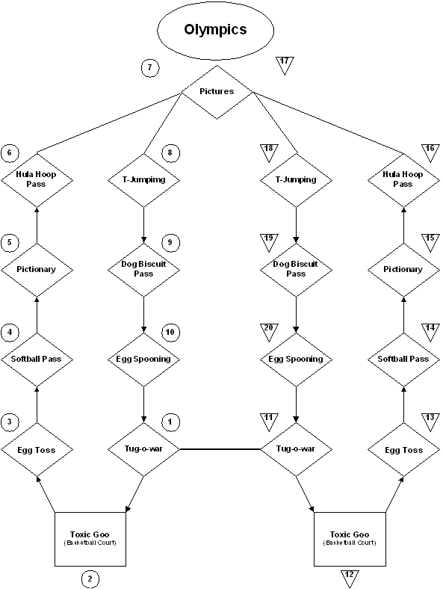

Olympics Schedule
- 12 minute events
- 3 minute passing time

RYLA Rumble #2 Instructions

Take a few minutes to let the team members introduce themselves or conduct an icebreaker to get the team members acquainted.
Objective: Put together two “strangers” and have them work together to solve a problem that requires each team member to contribute to the success.

String Disaster

Description: Begin by separating your RYLA rumble team into partners of two. Each conferee will receive a string with loops on either end. The first partner will put both their wrists through both loops. The second partner will put one of their wrists through a single loop, wrap the free end of the string around the first partners taunt string once, and then the second partner will insert their remaining wrist through the free loop.

So what's the trick? Try to get your string undone from your partner's string without untying the knots or pulling the loops over your hand!

Good Luck!!!

Wrap Session Checklist
- Sunrise Hike
  - Who went on the sunrise hike? Was it worth the early morning?
- Words of Focus
- Team Flags
- Olympics
  - What was the best station?
  - Did you work as a team at every station?
  - Was there one person leading the group ever? Was that effective?
- Team Time Activities
- Talent Show
  - Congratulations to all participants!
- Dance/Pizza Party
- Daily Evaluation
- Goal Setting
  - Set out provided candles around the room, turn lights off to give a more solemn feel
  - Now that we’ve given you all of these tools, how are you going to put them to use?
  - Give each team member an opportunity to voice goals for themselves. These can be either short term, long term, MAD goals, etc. Silence is okay! Let them think! Keep these relatively brief, don’t let them drag on and on so everyone has a chance.
- Write “Letter to Me”
- Schedule for Friday including Move Out Procedure (page 113)

Counselors: During this session, introduce the “Letter to Me” that they need to write by the last session on Friday morning. Their commitments do not have to be anything huge, or even relate to Make a Difference, but all conferees are asked to make some of commitment that matters to them. You can give them time to think about it and write their letters either in this discussion group or in the final one on Friday morning. Finally, please remind them to share these commitments with their Rotary Clubs back home, they can be very useful resources.
Then, the group is free to do whatever the counselors decide. You can go around in the circle and all the team members have time to talk about RYLA. How it affected them, what they enjoyed, how they have changed. Or just be together and have fun.
Page intentionally left blank

Letter to Me
How has RYLA changed you? What has this week meant to you? What have you learned about yourself, working with others, and the real-world? Take this time to put into words the leadership you’ve learned this week and anything you want your future self to know about right now.

Letter to Me Continued

Evaluation for Thursday

SC Word of Focus: SC name: ______________________

Disappointing | 1 | 2 | 3 | 4 | 5 | Excellent

Olympics:
Tug-o-war | Waste of time | 1 | 2 | 3 | 4 | 5 | Fun
Toxic Goo | Waste of time | 1 | 2 | 3 | 4 | 5 | Fun
Egg Toss | Waste of time | 1 | 2 | 3 | 4 | 5 | Fun
Softball Pass | Waste of time | 1 | 2 | 3 | 4 | 5 | Fun
Pictionary | Waste of time | 1 | 2 | 3 | 4 | 5 | Fun
Hula Hoop Pass | Waste of time | 1 | 2 | 3 | 4 | 5 | Fun
T-Jumping | Waste of time | 1 | 2 | 3 | 4 | 5 | Fun
Dog Biscuit Pass | Waste of time | 1 | 2 | 3 | 4 | 5 | Fun
Egg Spooning | Waste of time | 1 | 2 | 3 | 4 | 5 | Fun

Flag Presentation:

Disappointing | 1 | 2 | 3 | 4 | 5 | Worthwhile

RYLA Rumble #2:

Disappointing | 1 | 2 | 3 | 4 | 5 | Worthwhile

Team Time Activity: ______________________

Disappointing | 1 | 2 | 3 | 4 | 5 | Worthwhile

Talent Show:

Waste of time | 1 | 2 | 3 | 4 | 5 | Excellent

Dance/Pizza Party:

Disappointing | 1 | 2 | 3 | 4 | 5 | Awesome

Wrap Session:

Waste of time | 1 | 2 | 3 | 4 | 5 | Excellent

Friday July 19th

Packing Instructions
Finish packing up all your stuff and get ready to go back to life post-RYLA.
Before Breakfast:
- Strip bed and put sheets and pillow cases in the middle or the room.
- Please move all your stuff down into the conference rooms.
  - Teams 1-9 to Conference Room A, Teams 10-20 to Conference Room B
  - Remember to keep all your stuff together in one general area and as close to a wall as possible, and please do this as quickly and efficiently as possible.
- Turn in your keys to your JC or at the front desk. Each missing key is $5.00 paid immediately.

Heather Amen
“How RYLA Has Impacted My Life” heather.amen@gmail.com
RYLA sparked a fire in Heather, and has directed the majority of her life since her conferee year. How do you take RYLA away and use it for the rest of your life?

RYLA Awards
“Winning isn't everything, but the will to win is everything.” –Vince Lombardi
Find out how well your team did in all the competitions throughout the week. Find out the results of the flag and skit competitions, Olympics, as well as many others. Good luck to all!

Slideshow and RYLA Adjournment
“Now this is not the end. It is not even the beginning of the end. But it is, perhaps, the end of the beginning.” – Winston Churchill

Final Wrap session
“Don’t cry because it’s over, smile because it happened.” – Anonymous

Final Wrap Session
- Review the week
  - Briefly get their opinions on the whole experience
- Final evaluations-collect any leftovers….
  - Conferees should have ZERO yellow sheets in their binders now.
- Finish “Letter to Me”
- Words of Focus
- Heather Amen
  - Did you enjoy what she had to say?
  - What did you learn from her?
  - Did she empower you to do something differently in your life?
- Take/Give Activity: (not required, but suggested!)
  - For each group member, go around the circle and have each team member tell the person two or three things you will take away from that person and two or three things they wish to give.
  - JCs and SCs also.
  - e.g.: “I will take away your courage to be yourself no matter what and your optimistic outlook. I wish to give you confidence to be a leader and better time management.”
  - Should be very personal and based on your observations of people throughout the week.
- Talk more about the week and RYLA as a whole

**Collect the “Letter to Me” Letters. This area has slacked in the past, and we think it’s really important to continue emphasizing RYLA. Also, keep reminding the conferees to talk to their Rotary clubs when they get home. We’re really trying to foster those relationships. Evert and Ashley will email you in about 6 months reminding you to mail your kids letters to them!

Well done counselors! Let’s all head out to lunch to celebrate!

Evaluation for Friday

Heather Amen:

Disappointing 1 2 3 4 5 Great

Should they be invited back? Yes No

RYLA Picture Show:

Disappointing | 1 | 2 | 3 | 4 | 5 | Informative

Wrap Sessions Overall:

Waste of time | 1 | 2 | 3 | 4 | 5 | Excellent

Comments:

Your JC: (please print name of JC) _______________________________

Disappointing | 1 | 2 | 3 | 4 | 5 | Awesome

Comments:

Your SC: (please print name of SC) ___________________________________

Disappointing | 1 | 2 | 3 | 4 | 5 | Awesome

Comments:

RYLA Overall:

Disappointing | 1 | 2 | 3 | 4 | 5 | Best week ever

Other Comments:

What’s Your Word?

Throughout the week you have heard all of the JC’s give their Words of Focus about their journey to becoming a leader. What would your word be? Think about how you are going to inspire individuals with what you have to say and write it down. Being able to share your experience of becoming the leader you are today only strengthens and builds community amongst leaders. Challenge yourself and really put in some thought!

Problems I Observed and Potential Changes For Next Year’s RYLA Conference
This page is designed to give all counselors a chance to voice problems they saw during the week and potential changes that could be made. Your name does not need to go on this but would help if the new RYLA Chair or Head JCs want more information or clarification, it is simply a tool so that we can identify rough spots during the week and polish them up in order to better our camp! Feel free to use the front and back of this page, and please TURN INTO A HEAD JC OR THE CHAIR AT THE END OF THE WEEK!

Conferee Evaluation

Successful JCs are the cornerstone of the RYLA experience and evaluation of your team’s members as possible JC candidates is one of your most important duties. Each SC and JC has the opportunity to make recommendations for up to TWO (and no more than two) conferees from your team that you believe would make good candidates for JCs for next year’s RYLA. This will be your only opportunity to recommend your team members for RYLA JCs. In general, an ideal candidate for JC will have demonstrated the following traits:

- Excellent leadership skills
- Excellent communication skills
- Would be comfortable leading a group of their peers
- Exhibited an ability to listen and interpret the views of others
- Good organizational and time management skills

If you feel that one or two members of you team exhibited these skills and would make a great Junior Counselor, please complete the following (use the back of this page, if necessary):

1. Name: ____________________________________

Why?

2. Name: ____________________________________

Why?

I recommend the above candidate(s) for consideration as Junior Counselors at RYLA!

JC/SC Name: ___________________________________________ Team # __________
Please return to a Head JC or Chair at the end of the conference.
Page intentionally left blank

Extra Resources

Interact

Interact is Rotary International's service club for young people ages 14-18. Interact clubs are sponsored by individual Rotary clubs, which provide support and guidance, but Interact clubs are self-governing and self-supporting. Through projects, Interactors develop a network of friendships with local and overseas clubs.

Interact Program Guidelines
The following are the basic policies and procedures that govern the Interact program.
- Each Interact club must meet at least twice a month and perform at least two service projects a year.
- Each Interact club must have a Rotarian advisor who is a member of the sponsoring Rotary club. The sponsor must attend Interact club and board meetings and provide advice on organizing service projects, fundraising, and club administration.
- An Interact club can be school-based or community-based.
  - A community-based Interact club may draw members from several different schools within the territorial limits of the sponsoring Rotary club.
  - A school-based club is subject to the policies and regulations governing all other organizations of that particular school. In most instances, a faculty counselor — who may or may not be a Rotarian — is appointed to work with the Interactors.
- Interact clubs are self-supporting organizations that require little or no financial support from the sponsoring Rotary club, and dues, if any, should be minimal.
- Each Interact club must submit an Incoming Officer Data Form and an Interact Project Data Form to Rotary International annually.

Starting an Interact Club
Starting a club isn’t nearly as hard as it sounds, though it does take a solid commitment and effort.
- Contact the Interact Committee for help and resources at interact5450@gmail.com.
- First of all, keep working on a relationship with your Rotary, so they know who is interested in making this club happen and will be willing to help you.
- Find some other students who are interested in starting it with you, even if it is just friends.
- Talk with your school administration to see if it is willing to sanction an Interact Club.
- Apply for a charter from Rotary International. All forms can be found at: http://www.rotary.org/newsroom/downloadcenter/programs/interact.html

Rotary Youth Exchange

The most powerful force in the promotion of international understanding and peace is exposure to different cultures. Youth Exchange provides thousands of young people with the opportunity to meet people from other lands and to experience their cultures. This plants the seeds for a lifetime of international understanding.

About Youth Exchange
A Brazilian student makes her first snowman in Finland. A South African masters eating with chopsticks at his Japanese hosts' home. An Australian becomes part of an extended family in Russia, and a Mexican student in France raises funds to benefit homeless children in Haiti. New experiences, new "families" and friends, and new adventures can await you, too. This year, more than 8,000 teens will see the world the way it is best seen — from the inside out — through the Youth Exchange program. This could be your year.

As a Rotary Youth Exchange student, you will spend a year, or perhaps just an extended period of time, living with a host family in a country other than your own. You may learn a new language; you will learn a new way of living and a great deal about yourself. You will be helping to bring the world closer together, and you'll be making good friends in the process.

If you are ready for the challenge and the rewards of living in another land as an exchange student, then you are ready to discover new worlds through the Rotary Youth Exchange.
As the Rotary Youth Exchange program is highly selective, you should apply early - up to a year in advance of when you wish to leave, and selection usually takes place in the fall prior to the year of the exchange.

Find more information as well as stories from other students online at http://www.rotary.org/programs/youth_ex/index.html . Hopefully you can take advantage of this incredible opportunity.

The Ambassadorial Scholarships are the equivalent of the Youth Exchange Program at the college level. Find more information at http://www.rotary.org/foundation/educational/amb_scho/index.html.

Rotaract

Rotaract is a Rotary-sponsored service club for young men and women ages 18 to 30. Rotaract clubs are usually community-based or university-based and are sponsored by a local Rotary club making them true "partners in service" and key members of the Rotary family.

As one of the most significant and fastest-growing programs of Rotary service, with more than 7,600 Rotaract clubs in some 158 countries, Rotaract has become a worldwide phenomenon.

Even though you will not be eligible for Rotaract for a couple years, hopefully you’ll keep it in mind as you go onto college or into the future. Many Rylarians have gone on to create Rotaract programs at their colleges and universities. Maybe you’ll be one of them! Find more information at http://www.rotary.org/programs/rotaract/index.html.

Becoming a Junior Counselor
During the month of November, the application to become a Junior Counselor (JC) is available on the RYLA webpage at www.rmryla.org. November 30th is the ABSOLUTE deadline. The application is to serve as a Junior Counselor at either RYLA or Young RYLA (see below). JCs serve for a maximum of two years, unless they are selected to be a Head JC or sidekick and continue for a third year. JCs must attend a mandatory training weekend a few weeks prior to the conference, and must be present for the entire week of RYLA. Becoming a JC allows you to build on your leadership skills you developed here at RYLA. If you feel you have what it takes to be a JC at either camp, we encourage you to apply!

Young RYLA

You have seen what RYLA is all about, we also have Young RYLA, another leadership training program sponsored by Rotary International that promotes, encourages and rewards outstanding young people entering their 8th grade year. YRYLA has similar goals to RYLA, but done in a more age appropriate way for younger students.
YRYLA is an action-packed program of activities that help build confidence and leadership skills (like problem solving games, challenge course, zip line, skits, group discussions and teambuilding activities).

Junior Counselor Bios
Abbey Solnet
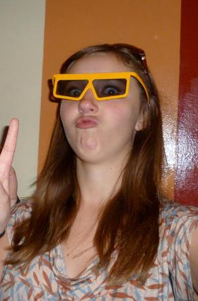
Hello to all of Abbey’s new RYLA family members! Abbey grew up in Highlands Ranch, CO, but plans to leave the ‘bubble’ and travel the world. There is so much to say in such a short bio, so instead go chat with her throughout the week; she would love to get to know each and every one of you! She loves elephants, golf, Italian food, playing piano, oboe, and guitar, and loves inspirational quotes. Above all, she loves RYLA! Have an open mind, and an amazing week! Carpe diem.

Adam Wolford 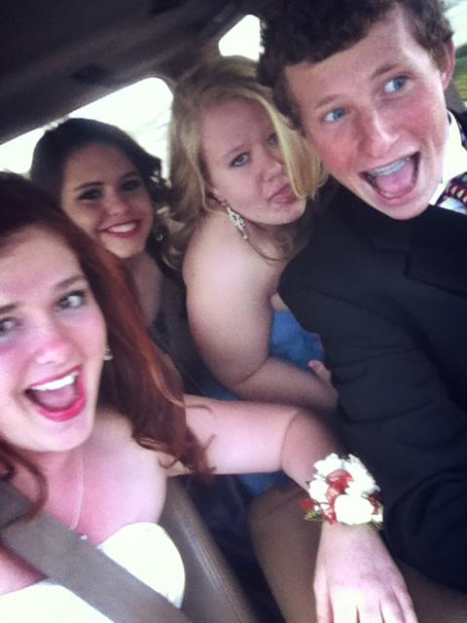
My name is Adam Wolford; I am a fun loving guy that is open to talk about anything. I love sports; I play Lacrosse and Tennis I am an outdoorsy guy who loves to camp, rock climb and be surrounded by the woods/mountains. I love skiing and snowboarding, snow is one of my favorite things in the world to play in. I was the kid in grade school who was diagnosed with ADD, I believe I have overcome a pretty serious learning disability. I was a Rotary exchange student in Sweden after my sophomore year, and it literally changed my life.

Ashleigh Feather
Hey I just met you, and this is crazy, but let’s be best friends, it’s RYLA time baby!! The name is Ashleigh Feather, but I’ll answer to Ash, Smallz, or “Hey You!” I come from the town of Sterling, Colorado and I am proud of my hometown roots. At the amazing height of 5’1”, I can successfully ride all of the “big kid” rides at Elitches and look above a counter without a step stool! For such a small body, I have a huge voice and a giant smile, so just listen for me and I’m sure you’ll hear me laughing, because I love to laugh…A LOT. I am obsessed with Earl Dibbles Jr. videos, Half-Baked, Ben and Jerry’s ice cream, and meeting new people. So tell me a good joke or a cheesy pickup line and we’ll get along great! I can’t wait to meet you all! YEE YEE!

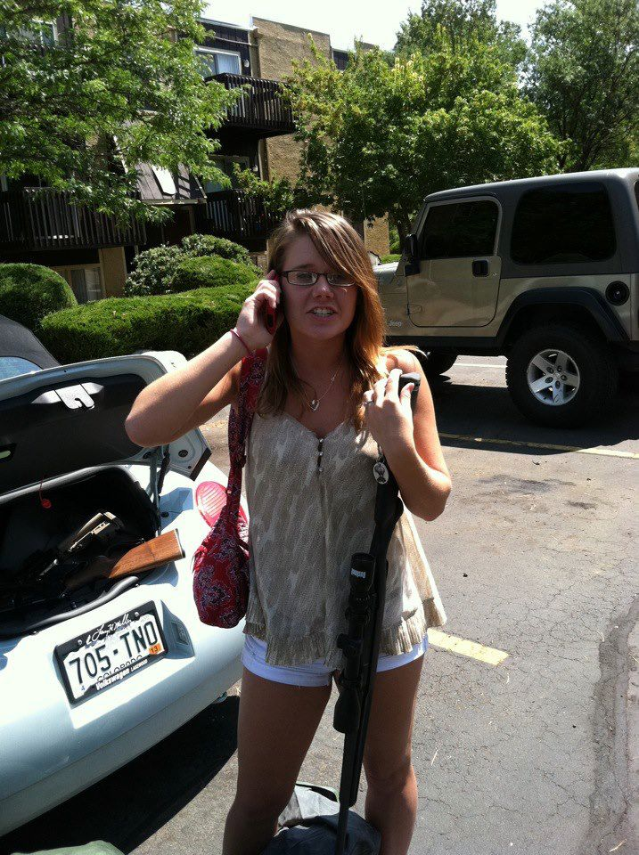

Howdy RYLA family! My name is Ashley Klingbiel and I hail from Denver, Colorado! I love everything and anything to do with friends and smiles. I play tennis and volleyball and I love the ocean. My dream job would be working for National Geographic: traveling, eating, and experiencing! I might not admit it too much, but I am the biggest nerd. I used to be a tomboy- oh yeah that means overalls and pokemon cards… awkward … all pictures mysteriously disappeared a while ago (or did theyyy?). I am a huge girly-girl and love anything with glitter. I am a sucker for awful jokes that are so bad, they turn out good. Come talk to me I am always ready to chat!

Ashley Klingbiel
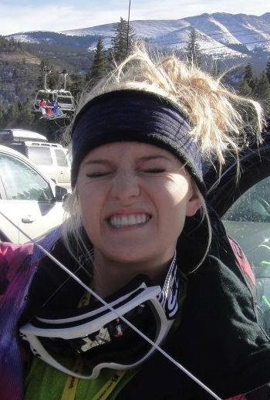

Colin Kerr
What’s up RYLA people?! I’m Colin Kerr and I’m the next best thing to sliced bread! I live in Greeley, CO and I like to party. I am a soccer fanatic, but I don’t watch it, I only ball it up on the field! I love to hang out with friends and strangers I have never met before. My favorite color is highlighter yellow and I am pretty good at thinking up handshakes so come say hi to me and we can make one! “I am the life of parties I have never attended” and “I give my guardian angel a sense of protection”. If you love to go crazy and have fun then you are my best friend and if you don’t then you can be my best friend anyway! I am way excited for RYLA and I can’t wait to spread the magic like a little fairy! Love webs to all of you!

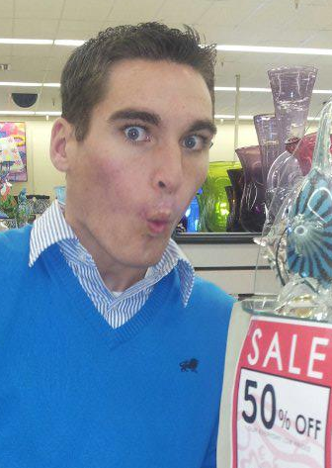

Crystal Nichols 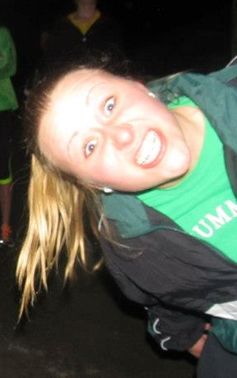
Hi RYLA! My name is Crystal! I was born in Florida and moved to Colorado in 2005. You’ll quickly know who I am because I am a little lacking in height and constantly smiling! I love meeting new people and talking so come say hello! I really love school and truly believe you must learn at least one thing every day. I am a swimmer, runner, and dancer but in reality I love doing anything that is active. I also have a huge weakness for food. I love all meats, vegetables, fruits, and of course sweets! I’m not picky at all, but if I had to choose a favorite food I would definitely choose steak, broccoli, apples or York peppermint patties. Although, what all of you really need to know about me is: I am so excited for RYLA and to get to know everyone of you! Let the RYLA magic spread!

Danny Cuadrado
Howdy Y'all!!! I'm Danny and I come from Frisco, Colorado aka. the greatest place on Earth! I LOVE to ski and to run! They are the best sports of all time, no questions asked. I love to meet new people and I can find something in common with almost anyone, so please don't be shy and come say hello! I am so excited to be at RYLA as a first year JC! I guarantee that you will all have the greatest time of your lives! If you don't . . . well we don't need to worry about that because I know you will have a blast, make friends that last a lifetime, and have your life changed forever! I know it changed mine! Welcome to RYLA 2013!!!!!

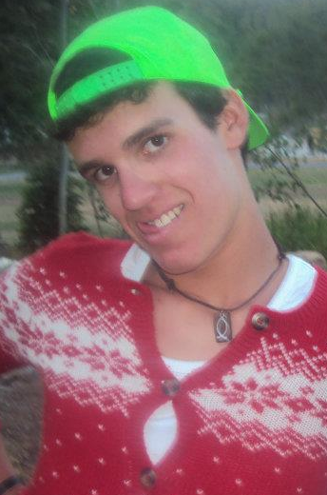

Derek Maiolo
Well hey there, RYLA buddies. My name is Derek Maiolo from the tiny town of Craig, Colorado, (Don’t worry if you’ve never heard of it, no one has!) I love anything that has to do with the outside, especially when it’s something I’ve never done before! I am now a geocaching professional, lover of all-things travel, and just an all-around pretty adventurous guy! I play the flute, guitar, and ukulele and I think all homework is bearable with a good song playing in the background! So welcome to the time of your life! I’m always looking for new friends to share this exciting adventure with so hit me up! Are you ready for an amazing week? I sure hope you brought some coffee!

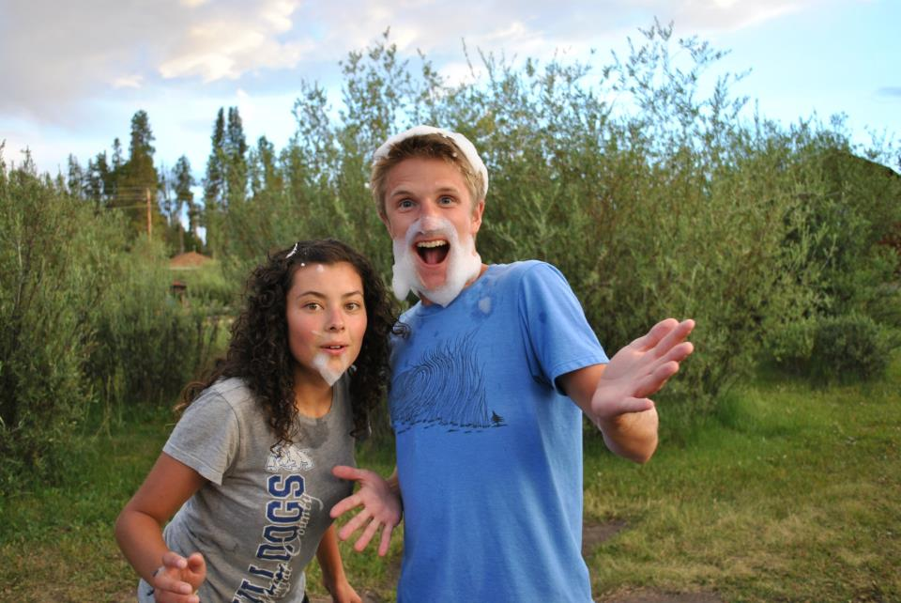
Ellie Scripps
Oh hey there! My name is Ellie Scripps, a proud Colorado native but currently residing in the beautiful state of Iowa! Woo! I am an avid volleyball player, so much so that I decided to play in college! My favorite animal is either a koala bear or an elephant! Food is my weakness… and chocolate is at the top of that list. My favorite commercials are the AT&T commercials because the kids are just so darn funny! My dream is to travel the world and make an impact in anyway I can. A smile can make anyone’s day and laughter is contagious so both should be taken full advantage of. I am super easy going and love meeting new people so please come say hi! This week is all about finding who you are and defining yourself as a leader. I hope you all enjoy RYLA as much as I do. This is honestly the best week of your life, and every one of you is here for a reason, I can't wait to get to know all of you! Lots of RYLA love!!!!!!

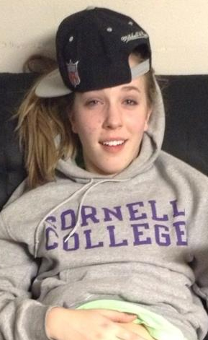

Jordan Carr
What’s up RYLA 2013?! My name’s Jordan, and I am proud to be from the beautiful Lander, Wyoming. I’m super tough, I drive a huge truck, and I have a kick start microwave (jokes, no). Honestly, I just sit around on my riding mower every day and bump Macklemore and Blue Scholars. I love hip-hop and love to discuss it, as well as create a little myself. I want to meet every single one of you so please come talk to me! Also, have a great time; this week is no ordinary one. Much Love!

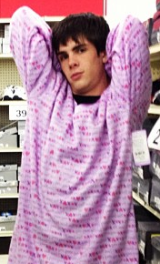

Joree Sandin

Hi! My name Joree Sandin and I love to be wild! I enjoy living life and my goal everyday is to make people laugh. I love to play sports, read, play videogames, and spend time with my friends and family. My dog is one of my best friends, and I don't know what I would do without him. I live by the words and teachings of Lord of the Rings, and I hope to one day become an astronaut and go to the moon!

Josh Mellin
Salutations friends. My name is Josh and I'm from the ever-so-famous town of Greeley. I'm tall. Well I mean not that tall, but tall enough to be set apart from a crowd. My favorite thing to do is to play the guitar and learn about music as well as explore the exciting world of math. Just kidding, but seriously... Anyways I play basketball and tennis and pretend to do high jump. Probably the most important thing you should know about me is that I kinda like the apples at the YMCA so look out for that. RYLA is the best thing in the world and is soooo sick! I can't wait to meet all of you and see you have the best week of your lives!



Katlyn Alapati

Hey all! My name is Katlyn, and I am super stoked for RYLA 2013! I recently discovered that I love the flea market, and I think writing short autobiographies is the worst task ever because I have no idea what you want to know about me. I can make my tongue do that three-leaf clover thing, and my favorite disney film is The Lion King. I take my coffee black because, if it ain't broke, why fix it? I'd love to get to know ya'll, so feel free to say 'hi.' And brace yourself for some RYLA magic!

Lyndsey Dent
Hi, I'm Lyndsey! I enjoy long walks on the beach and curling up by the fire with a good book...wait, this isn't eHarmony...oops. But in all seriousness, I'm from Highlands Ranch, Colorado and proud of it. I play tennis and I'm a joiner.... I get involved in every group I can. As a result, I have very little free time but I have fun no matter what I'm doing so it doesn't really matter. I'm loud and love making other people laugh. I hope I'll get to know all of you on some level while we share this amazing experience called "RYLA"!

Macee Jo Mueller
I’m Macee Jo Mueller!! I am a double major in Theatre Performance and Musical Theatre with a minor in Business Administration at Carthage College in Kenosha, Wisconsin! I absolutely love my school (mostly because it’s 10 yards away from the shore of Lake Michigan!) In my spare time (if/when I have any) I write songs, play my guitar, ukulele, piano, or cello! If you can’t tell, I love music. I have a passion for baby otters, anything mango, and the color turquoise. But MORE IMPORTANTLY: I love to help people. It is my everyday goal to positively affect the world around me. BE MY FRIEND!! XOXO :)



Mackenzie Tilton
From the deep depths of NoCo, is the return of the Mack…. Mackenzie that is, or you can call me Kenzie, Mack, Kenzo, whatever floats your boat! I hail from the luxurious town of Greeley; enjoy long walks up and down the aisles of Target, a good, steaming cup of Joe, hugs, and any type of ice cream! RYLA is one of the greatest things that ever happened to me and I hope it does the same for you. Prepare for a week of unlimited hugs, blossoming friendships, and the BEST experience EVER!!! We will laugh. And we will have a really really REALLY good time! I can’t wait to meet all of you! Come find me! Adios mis amigos!
1!

Madeline Azari
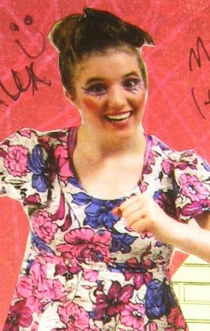
Whasssuuupp?! I’m Maddie and welcome to RYLA (a.k.a. the soon-to-be best experience of your life). Born and raised in Greeley, Colorado, you can find me hiking, camping and chillin’ with my friendly cousin, the Grizzly bear. Spontaneity is the name, and having fun is the game. I enjoy riding roller coasters, eating exotic foods, and determining the essence of life. I love my family with every fiber of my being and my dog is the most amazing creature on this planet. Make me laugh and we’ll be good friends! I’m a broncos and nuggets fan through and through with an intense love for theatre, music and slam poetry, so don’t be surprised if I break into random song and dance. RYLA changed my life and I promise it will change yours, too! Come talk to me this week! We’ll become great friends!

Madison Kerndt

Hey! I’m Madi, I’m from granola country, the hippy town of Colorado, Boulder! I love the outdoors and the mountains are my favorite place to be. I try and get up to the Rockies everyday whether it is running, hiking or boarding. The beach is the second love of my life; I actually lived in Costa Rica for three years. Besides Costa Rica I’ve also traveled to many other countries. If you ever want someone to describe the intricate details of your latest adventure with, I’m your girl! I love hearing about new places! I am so excited to meet you all! I know this is going to be the best RYLA year yet!

Nicolas Chavez
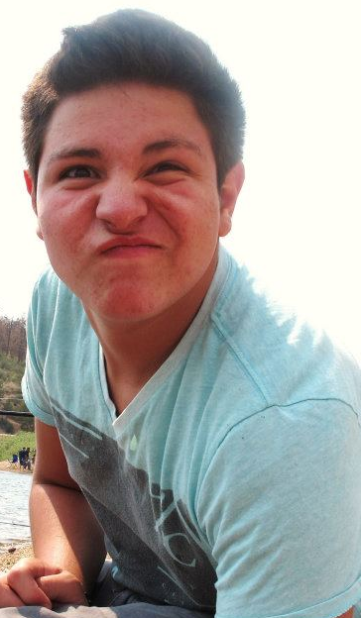
What up RYLArians?! My name is Nicolas Chavez and I am from Cheyenne, Wyoming. Here is a quick summery of me! I love hip hop, rap, and 80s music! With my free time I like to hang out with my family and friends. I am obsessed with eating Hot Cheetos and drinking lemonade. I have a sweet tooth that is always craving snickers and reeses candy. My favorite super hero is Green lantern! I always make Step Brother References and Harry Potter jokes; I hope you all are ready for my unique since of humor! I attended YRYLA and RYLA so I definitely know all about the RYLA magic. Get ready for the most amazing week of your life and I hope it changes your life as much as it changed mine!

Shannon Galligan
RYLA! I’m Shannon, from the Land of Love—Loveland, Colorado. I am so excited to be here and get to know as many of you as I possibly can! In my spare time, I love to write, read and spend time with the people that I love—unless I’m addicted to something on Netflix. Make me laugh and we’ll be great friends, make me snort and we’ll be best friends. I thrive in awkward situations, I’m often caught people watching and my favorite food is any kind of potato. Coffee shops are my favorite places to spend time, although this has led to a fairly serious caffeine dependency. I believe that love can save the world and RYLA is a testament to the existence of beautiful people, so prepare yourselves for one of the best weeks of your lives!

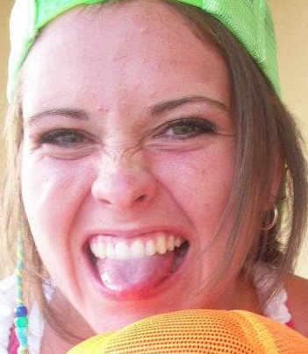

Senior Counselor Bios
Hi, I'm Phil Murphy. I have been in Rotary longer than most of you have been alive. In fact, I may be older than most of your grandparents. I was born and raised in Masachusetts on the shores of Lake Chargoggagoggmanchauggagoggchaubunagungamaugg, and, yes I know how to pronounce it. I have lived in Idaho and in Washington where I worked on the slopes of Mt. St. Helens and also harvested gooey ducks. I recently retired after 35 years with the Colorado State Forest Service, where I was a geek and now get to begin my next life of consulting, creating, crafting, carving, and coloring. I have been in Rotary 23 years and in 2014, I will become a District Governor. A fancy title that allows you to travel thousands of miles and where people are forced to listen to you talk. I am happily married, have 2 children, and 3 grandchildren, with a set of twins that I cannot tell apart. Rotary has been a huge part of my life and this will be my third year as a Senior Counselor in RYLA. I hope all of you will go easy on me and help me up off the ground. Thanks for letting me be a part or your life changing time

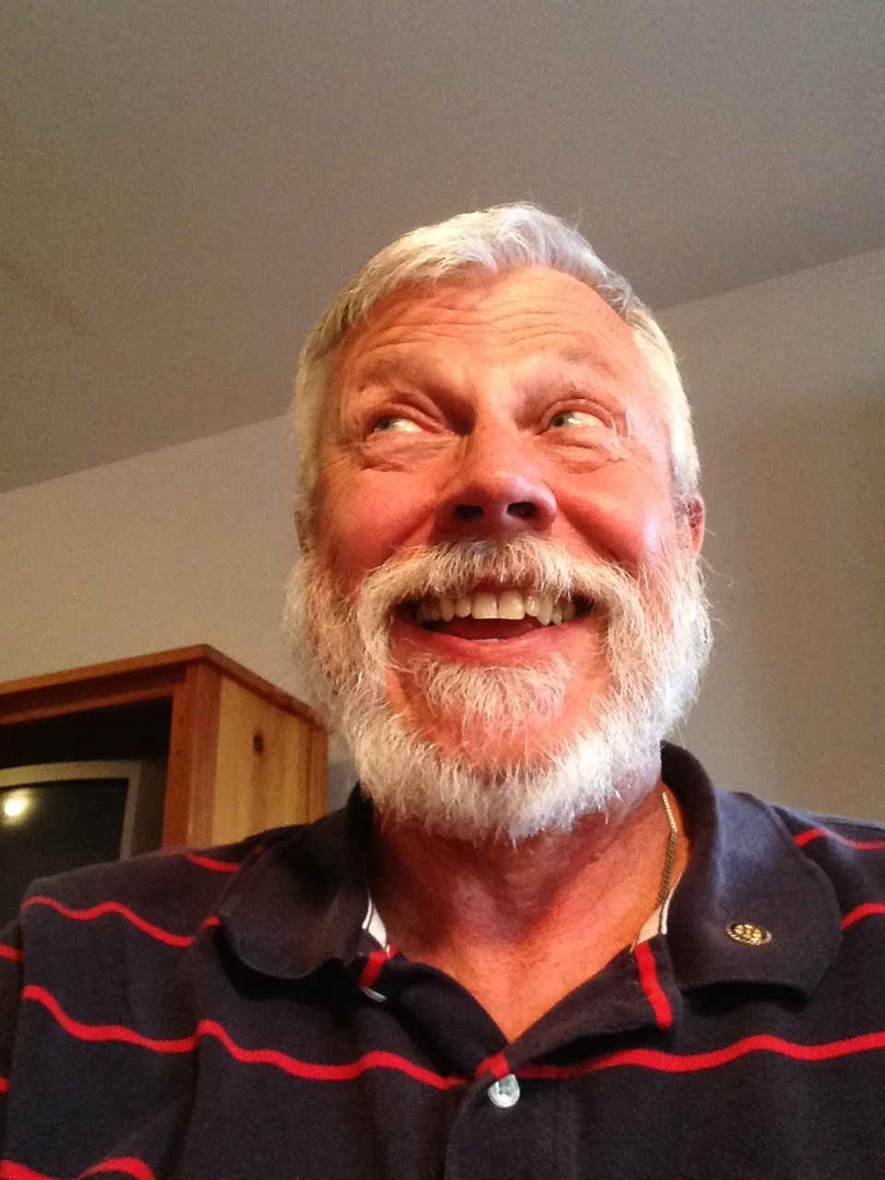
Phil
Murphy

Skye Coleman-Weisz
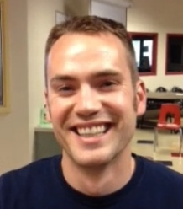
Born and raised in Wyoming, Skye is an avid outdoorsman with hobbies of pretty much anything that gets him outside. Sports are a passion of Skye, and he tries to play them all, but not all successfully. Professionally, Skye is a real estate broker for his family's company, and has been selling real estate since he was 18 years old. Look forward to meeting you!
Maria Camp Galter
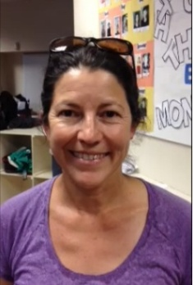
Maria Rosa Camp joined the Evergreen Rotary Club in 2008 and loves her life as a Rotarian. Her claim to fame is swimming with Idi Amin as a teenager (some swim with the dolphins...she thought swimming with Idi was more exciting). Idi Amin was the infamous, brutal and bloody dictator of Uganda, East Africa. Born in Chile, of a Spanish father and Ecuadorian mother, Maria, her father's United Nations career took them to Ecuador, Honduras, USA, Uganda, England and Switzerland. She now lives in Evergreen, Colorado with her son Luke, her dog Hugo, and her cat Bear. Maria is working on her Masters in Non-Profit Management at Regis and is the founder and Executive Director of Into Your Hands-Africa, an organization that supports youth education in rural Uganda. Her favorite quote is Margaret Meade's: "Never doubt that a small group of thoughtful, committed people can change the world. Indeed, it is the only thing that ever has."
I was born and reared in Tulsa Oklahoma. I went to Tulsa University and graduated from the University of Oklahoma School of Medicine. After completing a residency in Neurological Surgery I moved to Greeley Colorado and practiced there for twenty five years. After retirement I moved to Windsor Colorado with my wife Renee and cat Beau. I enjoy gardening and playing golf. I have been an active Rotarian for over 40 years. I became interested in RYLA when I saw how the program made a difference in the lives of young people. I decided that in order to better understand how RYLA works I would have to become more involved. So I signed up to become a Senior Counselor.
Ron Clark
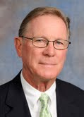
Kathy Davis
Kathy, a member of the Rotary Club of Summit County, where she has been a member for over two years and serves on the board, became involved with RYLA after hearing students speak at a Rotary meeting about their experience – and of course some nudging from Rolo! She has lived in Colorado for over 25 years and is the proud mother of a 21 year old son, Alex and a 5 month old fox red lab named Deja Vu. As a clinical therapist and director of Colorado West Mental Health in Summit and Grand County – a job that she absolutely loves – Kathy works closely with the communities that she serves to provide mental health and substance use programming and travels throughout the mountain region teaching Mental Health First Aid for adults and youth for the National Council on Behavioral Health. In her free time, Kathy enjoys riding her road bike up very steep hills, (really! she enjoys it!) hiking with her dog, attempting to grow veggies and flowers in her garden and cooking for her friends and family.



Dan Davis
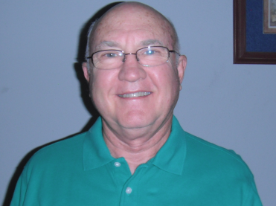
I was born October 22, 1941 in Idabel, OK and grew up on a cattle ranch in Southern Oklahoma. Southeastern Oklahoma State University was where I attended college, and I graduated in 1974. I served on the board of Sungate (a child advocacy center) from 1992 to 2002. Racquetball is a passion of mine, I am an active member and on the board of the Colorado Racquetball Association , coach Colorado juniors racquetball, and teach the game at the Trails Recreation Center in Centennial. I developed “Whisperball”, a game played on a racquetball court designed for seniors, juniors and handicapped. I am a member of the Aurora Gateway Rotary.

Bill Grady
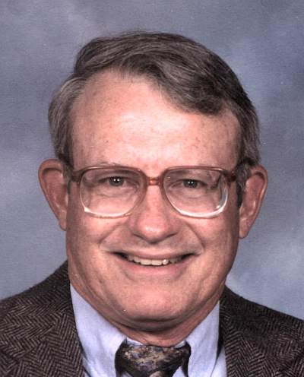
I was born in New Orleans and raised in Baton Rouge, Louisiana. I am the oldest of 7 children (good Irish Catholic parents). I graduated from University of California at Berkeley with a degree in Chemical Engineering. Judy and I attended University of Wyoming for our advanced degrees. After we both graduated, I accepted jobs at several government nuclear facilities (Yes, I do glow in the dark). I eventually accepted a job with Exxon and worked for them for a number of years at various oil and gas facilities. We then moved to Greeley. Judy and I have been married for over 40 years. My hobbies include church work, tennis, running, biking and taking care of our home and yard.
I am looking forward to another great experience being with dynamic, energetic, inquisitive young people. The past two summers I was a Senior Counselor at YRYLA and thoroughly enjoyed the exhausting pace of events, late nights and early mornings. So I am anxious to see how the energy of RYLA compares to YRYLA and the challenges of keeping up with people years younger than myself.
Spending time with others who are dedicated to Rotary's efforts to offer young people opportunities to learn about one another and improve their leadership skills seems like a great way to spend a week in the mountains. I love being in the mountains hiking and looking for good photo shots.

Mel Grusing
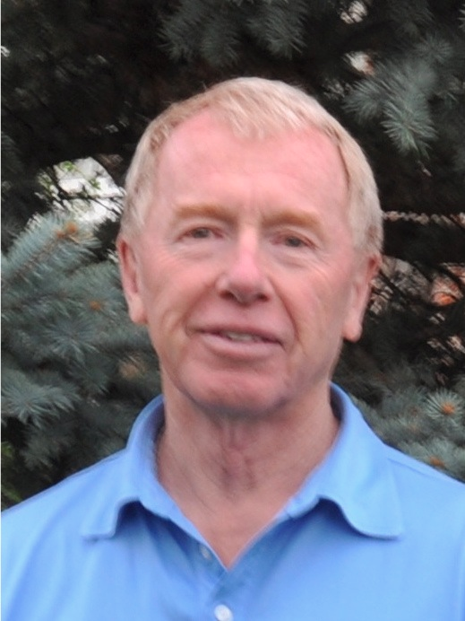
Mike
Hitchcock
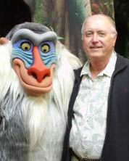
I started my journey with RYLA two years ago as a SC at Estes Park and had a great time. Last year I did Young RYLA with some old friends and made some new friends. I'm happy to be back at RYLA this year.
After becoming a professional student, I practiced neurosurgery in the South Denver area for about 25 years and retired. Then I went back to do some of the things I never had time to do like getting a degree in astronomy and volunteering at the Denver Museum of Nature and Science. Also I have been active in Rotary and recently we’ve just returned from a trip to Nepal to look at some projects and tour India a bit. I have a lovely wife Anne and a son Peter, his wife Molly and two above average and good looking grandchildren, Piper and Parker (ie. MP3). Tomorrow I’m off to a live aboard dive trip and I ride motorcycles (with a helmet) and other goofy things.
My motto in life is, “never take yourself too seriously, no one else does” .
Greg Hoskinson
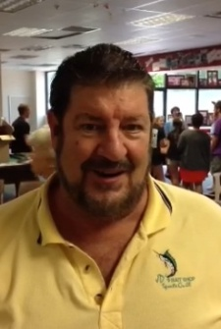
I have been married 32 years and am a father of two. I love reading and collecting fine and rare books, exploring the world of wines, fly fishing, and playing with my almost-two-year-old granddaughter. I am an entrepreneur, having built a somewhat successful business in home financing and refinancing. My company, Sterling Mortgage turns 20 years old next January. I have a sincere passion for young adults. Through Rotary I have been actively involved in Rotaract, the "branch" of Rotary for those 18-30 years old. For 15 years I have held weekly senior high school forum discussions covering almost every topic imaginable. Also, for 15 years I have been involved with annual high school retreats as a "small group" leader.
Maud Huey Kenyon

Giving drops of polio vaccine to kids in Nigeria led me to join Rotary in 2005. I am a licensed psychotherapist, mother of three 20-somethings and wife of a long-time active Rotarian. RYLA is an opportunity to experience another part of the Rotary world. A Boulder Valley Rotarian, I plan programs for meetings and work on play grounds at local preschools for community service projects. A long way from Nigeria, I enjoy what Rotary offers: an opportunity to look for commonalities in communities, clubs and kids around the world. The enthusiasm of former senior counselors motivated me to take the plunge and join the 2012 camp experience.

Stacy Kiehl
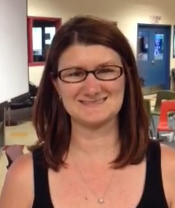
Stacy (Harris) Kiehl is the mother of her 2 year old daughter (Lauren), along with being a teacher of middle school students with special needs. She is also the daughter of Curt Harris! Stacy has been an SC with RYLA and Young RYLA for 6 years! She has also volunteered with many other organizations including the Platte Valley Youth Detention Facility, her school, and teens needing assistance with social skills. Stacy loves to be outdoors, ski, quilt, read, and hike. Most importantly, Stacy loves to be a part of the RYLA team!
Norm Lyster
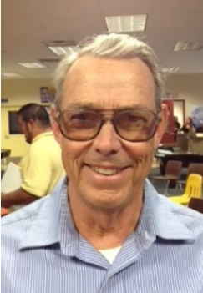
Norm was born in Greeley and worked on the family farms through high school. After graduation from Greeley High School he attended the University of Colorado graduating in 1959. Frontier Airlines and Katzke Paper Company employed him until he enlisted in the U. S. Army. After basic training at Ft. Carson in Colorado Springs. He spent six months of schooling at Ft. Devens, Massachusetts. He was stationed in Germany. He was there when the Berlin Wall went up and his enlistment was indefinitely extended. Upon returning to Colorado, he completed a masters degree in Geography and obtained teacher certification. He taught in Jefferson County for five years. He received his Doctorate at the University of Massachusetts. Teaching continued at Hartwick College in Oneonta, NY. He completed a second masters degree in Computer Science at Evansville, Indiana. He remained at Hartwick teaching programming languages and systems analysis. After retirement, he returned to Colorado where he manages the family farm operation.
Hi! My name is Donna Martemucci and I can’t tell you how excited I am about being an SC for RYLA again this year! I had such a blast last year and am sooooooo looking forward to this year! Can’t wait to meet you all!
For work, I just recently joined Education and Life Training Center (ELTC) as Operations Manager. My efforts will support agency efforts towards the successful implementation of high-impact strategies which address poverty. Prior to being hired, I was engaged in ELTC’s mission for more than three years by serving as a volunteer. Before that, I worked for Eastman Kodak for 31 years, retiring in 2012.
I love Fort Collins and serve as Membership Chair for two organizations – Rotary Club of Fort Collins-Breakfast and WomenGive. I am passionate about Financial Literacy and am volunteering as Co-Chair on the Leadership Team for Circles® Larimer County and am a member of the MakeChange NoCo Volunteer team. I also love to run and completed my 5th marathon last fall in Cape Cod.
I am very blessed to be married to a great guy, Mike, and we live in the foothills north of Fort Collins with three horses (Streak, Cody Joe, and Honey) and two kitties (Doodles and Sissy Sue), all of whom we adore!

Donna Martemucci
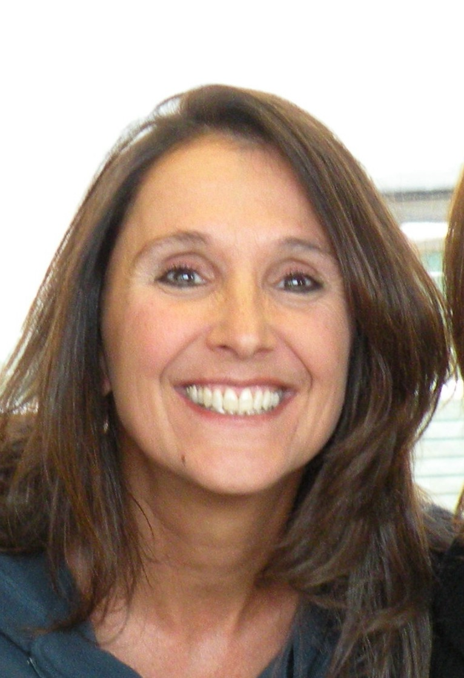

Brent Morris
Brent Morris grew up in San Jose, CA, and moved to CO to finish college at CSU. For the past 15 years, he has been happy to call Ft. Collins his home. Although his mom and younger brother still live in CA, Brent’s dad, step-mom and step-brother, also became infected to what CO is about and now live nearby. One of Brent’s long time passions is his career. He is a veterinarian, helping dogs and cats, from their first steps through their geriatric years. Brent also has many other passions, which include fly fishing, snowboarding, mountain biking, and trail running. When not engrossed in any of these activities, with or without his dog, Brent can be found exploring CO, in his garden, hiking, playing ice hockey, reading or assisting the WOLF sanctuary. Brent is a newer Rotarian, who will have been with the Windsor Club for a year in July. This year marks the first time attending the RYLA camp. Brent was introduced to RYLA through a couple of last years participants. Their inspirational stories hooked Brent in to wanting to help keep the camp going, so future participants could experience their own positive life changing events.

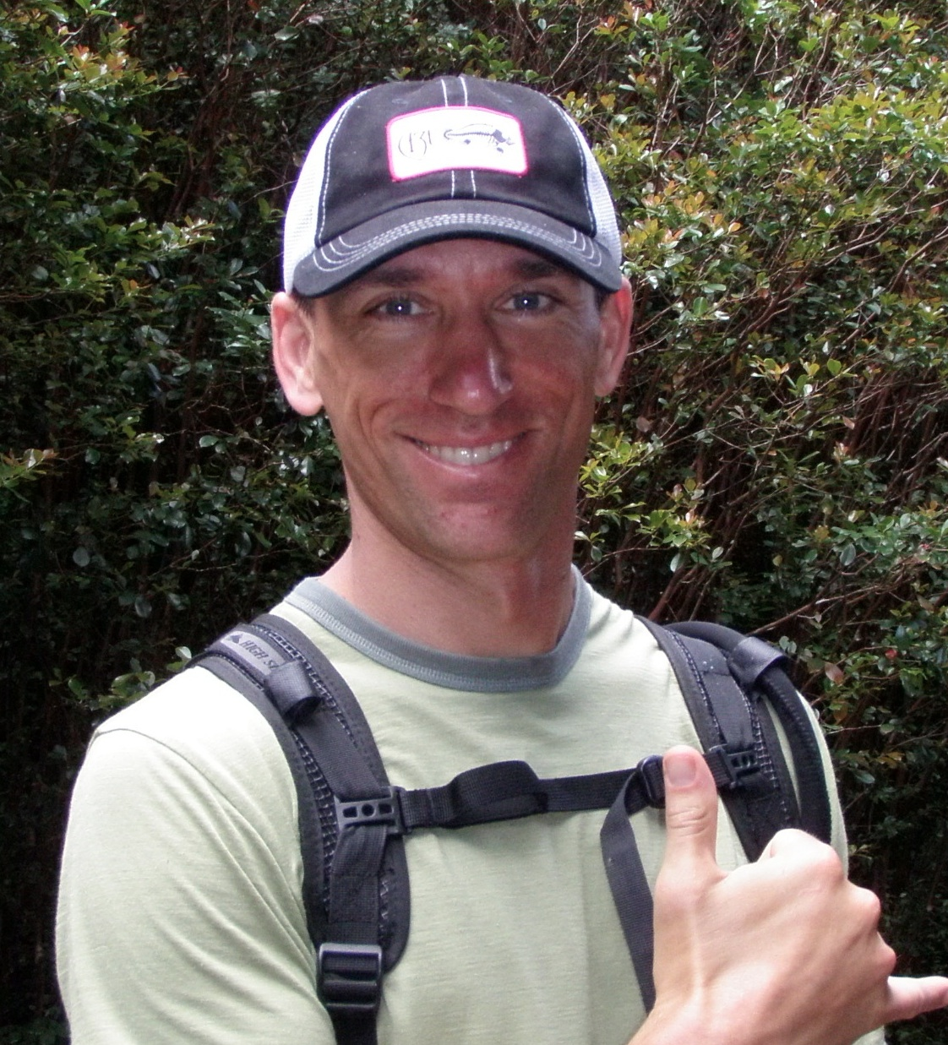

Vicky Opipari
Hi my name is Vicky Opipari and I am part of the Aurora Southlands Rotary Club. I am a mom to two awesome high schoolers, Lauren and Alex, who attend Cherokee Trail High School. I've been married for almost 22 years to my husband, Chris, and we also have a dog named Yogi (a Puggle) and my daughter Lauren has a Canine Assistant named Parti (a Golden Doodle). Our family has lived in many different states but once we moved to Colorado we felt like we found our permanent home! I enjoy traveling with my family - especially on road trips! I also enjoy my job as Realtor and helping people find their dream homes!
I recently became a part of myTeam Triumph Rocky Mountain Chapter. What’s awesome about mTT-RM is we open up doors for people with disabilities to experience participating in road races. My daughter, Lauren, participated in her first 5K run in April and she had a blast and can’t wait to do it again!



The quote that best describes me is E. B. White’s statement (author of Charlotte’s Web): “But I wake up each morning torn between a desire to save the world and a desire to savor the world. This makes it very hard to plan the day.” On the saving side, I am committed to saving life forms on earth from the ravages of global warming. As a lawyer of nearly 40-years, I limit my legal practice to advocating for renewable energy and energy efficiency and opposing the use of fuels that contribute to global warming. I represent solar and wind clients and help change the legal policies that keep us from taking action. I want to buy a fast and futuristic electric car (Tesla)!
On the savoring side, I love the natural world, a good conversation over a fine meal, singing along with the radio while I’m driving, dancing with my dog, thinking about quantum physics and being enthralled by theories of the universe, and being a part of a larger whole that is embracing life in all its aspects. I also want to buy a fast and futuristic electric car (Tesla)!


Susan Perkins

Rawnda Pierce
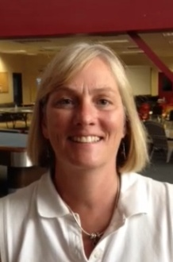
Rawnda is in her second year as a Senior Counselor and is ready for this year's challenge. She has been working on getting in shape for the climb up the mountain with the RYLA group!! Last year, she was asked to bring up the back of the group and she's hoping to move more to the middle of the pack this year. Rawnda wants to help RYLA participants explore their full potential as young leaders and young adults. Rawnda is the Executive Director of an Economic Development group called Twin Cities Development in Scottsbluff, Nebraska. Her work entails recruitment of new businesses to the community as well as retention and expansion of existing companies and recruitment of workforce to the area. Rawnda enjoys golf, boating, water skiing and jet skiing, and pretty much all sports activites. Rawnda is the President of the Scottsbluff/Gering, Nebraska Rotary Club this year and thoroughly enjoys her involvement in Rotary and the community. She has two sons -- Michael age 23 and Brannon age 20.
Barb Scripps
I am President of Scripps, Taylor & Associates, P.C., a CPA firm in Evergreen, Colorado. I have over 35 years of experience as a CPA in both public and private practice. I started my own firm in Evergreen in 1992. Today we employ a staff of 8.
I received a B.S. degree in accounting from C.U. – Boulder and have completed graduate work at the D.U. Masters of Tax program. In addition to my professional work I am also on the board of Center for the Arts - Evergreen and Evergreen Country Day School.
I am married to Tom Scripps and we have 3 children: Jason (28), Will (23), and Ellie (19). Ellie will be a 2nd-year JC at RYLA this summer. This is a major reason I applied to be an SC this year – to share the RYLA experience with Ellie.
I am the President Elect of the Evergreen Rotary – a club known for fun! I have Rotary in my blood as my father and grandfather were active Rotarians in Freeport, IL. My mother and grandmother were active “Rotary Ann’s” (before women could join the club!). I’m excited to be part of RYLA 2013!

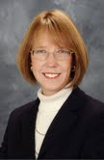

Marc Solnet
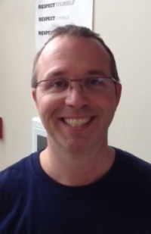
Marc has had a very remarkable year and is excited to share some of his
stories, philosophy, enthusiasm, and positive attitude with each and every one of you! Born in Brooklyn New York, Marc has lived in New York, Florida, Texas, and England all before settling in Highlands Ranch Colorado with his wife Julie and two daughters Abbey & Sarah. Marc bleeds Orange and Blue as a loyal Florida Gator graduate in Engineering. Currently Marc is in Sales working for a global software company and loves it! Previously Marc has led numerous teams in various roles as an Information Technology professional for over 24 years. Marc is an active Rotarian for 14 years and will enjoy spending his second RYLA with you this week, also serving as the RYLA assistant registrar during spare time. Marc is an avid snowboarder, golfer, runner, father, brother, son, friend, and mentor and can't wait to share his pashion for Rotary, leadership, and LIFE!

Staff Bios

Rolo Cuadrado- Chair
I’m delighted to be here at RYLA! All three of my kids have been to RYLA or Young RYLA, and my wife thinks we’re all crazy. I love to travel, and recently have been to Thailand, Vietnam, and Colombia. My many RYLAs and Young RYLAs have taught me that I really enjoy working with teenagers, so much that I have recently made a career change to spend more time with students. Starting this fall I will be teaching in Denver. I’m excited about this move, and I hope to learn a lot from my students. RYLA has become one of the most important things I do, and as you will learn by the end of the week, it’s “All For You.”

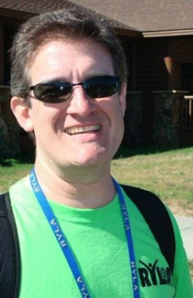

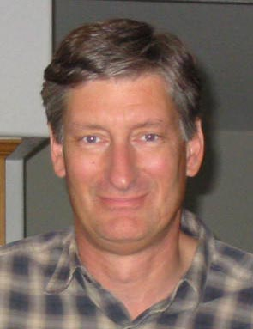
Curt Harris- Assistant Chair
Harris was born and raised in Sioux Falls, South Dakota. Curt and his family escaped to Colorado in 1977 where he began his career as a banker. He retired over ten years ago and began the real work of volunteering for Rotary projects and pursuing a Master’s degree at the University of Denver (where he was often mistaken for a member of the faculty rather than a student). He has been very active in the Rotary Club of Evergreen’s International Service Committee and has visited Rotary projects in Haiti, Uganda, Kenya, Tanzania, Guatemala and Nepal. He is also past President of Evergreen Rotary. When not involved with Rotary projects, he enjoys backpacking, mountain climbing, sports and skiing and endures golf. His wife Barb has tolerated him for over 38 years. They have three adult children, three granddaughters and two spoiled dogs. This will be Curt’s twelfth year being involved with RYLA/YRYLA and currently serves as the RYLA Treasurer.

Bill Manning
Bill is one of the usual suspects in the Evergreen Mafia at RYLA. This will be his lucky number 13th RYLA including a few International RYLA runs. By day, Bill is a mild mannered investment advisor, but RYLA brings out Brother Bill’s “True Colors”. Brother Bill has been occasionally sited on mountain golf courses and bike trails. He most certainly overachieved in marriage with Dr. Marsha and their dreams & aspirations to explore more exotic lands together. Brother Bill at RYLA lives by the creed that young people don’t care how much you know until they know how much you care. Each day we strive to do our best to become the best that we are capable of becoming. RYLA ROCKS!
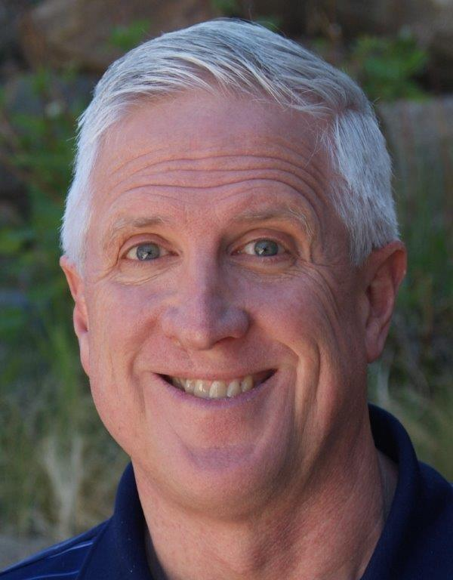

Ashley Packard- Head JC
Hello RYLA 2013! My name is Ashley Packard! I am a junior honors student at Colorado State University studying Anthropology with a concentration in Archaeology. Come ask me how I discovered my passion for this major! I have always loved working with horses…especially show jumpers! The minute I fall into the saddle I feel all my stress melts away! Something I have come to realize about myself is that I am happiest when I am by the ocean. I recently was scuba certified and cannot wait to start exploring reefs around the world! If I could offer any advice for this week it would be to allow yourself to become inspired by those around you.

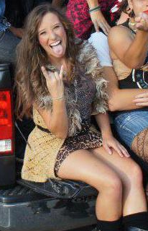

Evert E. Justice Finger- Head JC
Howdy y’all :) The name is Evert and this will be my fourth year at RYLA! As head counselor, this year’s camp is my baby, and I will do absolutely anything and everything to make sure that you have the best experience possible. I go to school at Brown University in Providence, Rhode Island and I am double concentrating in Sociology and Urban Studies. I believe that anything is possible if you’re willing to work for it, I think that happiness is a choice, and that memories are one of the most beautiful creations on this earth. I believe that RYLA will change your life if you let it, so put your guard down, and embrace this next week!!!
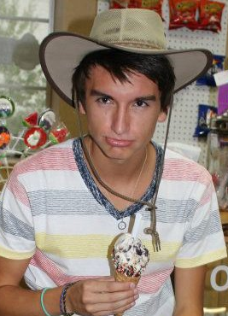
Hi wonderful RYLA family! I'm Annie, a RYLA (and Rotary) enthusiast and globe-trotter. I don't love summarizing that which makes me tick into a short paragraph. I'll do my best, but I would much rather have a conversation with you (yes, YOU!) and share stories. I am a Boulder native, but I've spent the last year in South America, Southeast Asia and India exploring all (er, a small portion) that this world of ours has to offer! I'm a vegetarian at home, but I did eat congealed blood (on accident, I thought it was tofu), dog meat (knowingly), and a scoripion-on-a-stick popsicle (even I can't really explain that one)! Rotary has become a worldwide family: opening doors to homes, cultures, and a new way of living. In high school, I started an Interact club at Fairview, cofounded an Interact District 5450 committee, taught peer education regarding depression awareness & suicide prevention and most recently, led a "RYLA for Peace" workshop at Rotary's Global Peace Forum. I am passionate about exploring and learning in unconventional ways. I aspire to live a life of unconditionality, and am pretty stoked to be alive and back in action at RYLA!
Annie Casey- Trusty Sidekick
